# Salinity Levels that Optimize Nekton Community Structure in the lower Barataria Estuary, Louisiana

Prepared by:

J. Brian Alford

Louisiana Department of Wildlife and Fisheries

Fisheries Management Section

2000 Quail Dr.

Baton Rouge, LA 70808

(225)- 765-2332

balford@wlf.la.gov

Executive summary iv

Introduction 1

Study Area 1

Sampling Methodology 3

Marine Gill Nets 3

Inland Gill Nets 5

Seines 5

16-ft. Trawls 6

Electrofishing 6

Statistical Analyses 7

Canonical Correspondence Analysis 7

Species Response Curves 8

Optimal salinity levels for diversity and species richness 8

Community structure before and after Davis Pond

Diversion 9

Results 9

Spring-summer months 9

Relationship between salinity and

nekton community structure 7

Salinity levels that optimize species abundances 19

Salinity levels that optimize biodiversity 26

Changes in community structure following

Davis Pond freshwater diversion 31

Fall months 35

Relationship between salinity and

nekton community structure 35

Salinity levels that optimize species abundances 44

Salinity levels that optimize biodiversity 52

Changes in community structure following

Davis Pond freshwater diversion 56

ADDENDUM: Influence of hard and soft bottom substrate on

nekton community structure………………………………………….…………………....60

ADDENDUM: Inland gill net and electrofishing analysis with Lake

Cataouatchie and Lake Salvador stations 70

References 75

Appendix A 76

Appendix B 78

Appendix C 80

**EXECUTIVE SUMMARY**

The purpose of this project was to determine the salinity levels that are predicted to optimize species’ abundances in the lower Barataria estuary in southeastern Louisiana. Using 20 years (1991-2011) of monthly/semi-monthly fishery-independent monitoring data collected by the Louisiana Department of Wildlife and Fisheries (LDWF), multivariate canonical correspondence analysis (CCA) was used to determine the relationship between species optima (i.e., maximum attainable relative abundance) and salinity. In addition, generalized additive models (GAM) of individual species catch and biodiversity indices (Shannon-Wiener index and richness) were generated for four gear types: 1) marine gill nets, 2), inland gill nets, 3) bag seines, and 4) 16-ft. otter trawls. Finally, an attempt was made to provide some insight into the future changes in community structure based on comparisons of data from before and after the Davis Pond freshwater diversion near New Orleans. The results of this project will provide a decision support tool for assessing the impact of various operating regimes at the newly proposed freshwater diversion at Myrtle Grove. Given salinity regime predictions from the hydrological and hydrodynamic models, structural changes in the nekton community can be predicted. **See Appendices B and C for a qualitative generalization of species optima with respect to arbitrarily chosen salinity categories.**

During the spring-summer period (April-July), which coincides with normal high river flows, there tended to be a greater number of predators and benthic invertivores that were positively related to salinity (CCA, T-value biplots, *P*≤0.05). In contrast, there were fewer predators and benthic invertivores as salinity decreased. This indicated a slight trophic shift in the community towards omnivores and planktivores as freshwater increased. Optimal salinities for some economically important fishery species were ≥11 ppt for adult Spotted seatrout (gill net), 6 ppt for Brown shrimp collected from seines (mean total length [TL] = 59 mm) and 11 ppt for Brown shrimp collected from trawls (mean TL = 80-85 mm), 2-6 ppt for juvenile Gulf menhaden (seine and trawl = 48 mm and 55-59 mm, respectively), ≥18 ppt for adult Gulf menhaden (gill net mean TL = 184 mm ), 2-6 ppt for White shrimp and Atlantic croaker (trawl), <1-6 for Red drum and Black drum (gill net), and ≥32 ppt for juvenile Striped mullet and White mullet (seine). Blue crab optimal salinity was <1 ppt from trawl gear (mean TL = 80-85 mm), but ≥32 ppt for the gill net and seine gear (mean TL = 146 and 59 mm, respectively). Atlantic bumper, Southern kingfish and Florida pompano were optimal at ≥32 ppt for all gear types. Shannon-Wiener diversity indices and richness tended to be optimized at moderate salinities (5-20 ppt), with the exception of richness from seine and gill net samples (35 ppt), likely as a result from rare, transient marine species entering the estuary. As salinity increased, the Shannon-Wiener diversity trend essentially remained a straight line, even though an optimal salinity value was detected. Essentially, there is no biologically meaningful relationship between diversity and salinity during spring-summer, but there is a decline in the total number of species as salinity decreases.

During the fall period (September-December), which coincides with normal low river flows, there also tended to be a greater number of predators and benthic invertivores that were positively related to salinity relative to the number of omnivores and planktivores that were related to salinity. In contrast to the spring-summer samples, however, water temperature had the strongest influence on community structure in all gear types except for the inland gill nets. Nonetheless, optimal salinities for the primary fishery species during fall were 7 ppt for adult Spotted seatrout (gill net mean TL = 319 mm) and <1 ppt for juvenile Spotted seatrout (seine mean TL =101 mm), 7 ppt for Brown shrimp (seines and trawls), 6 ppt for White shrimp from trawls (mean TL = 110-114 mm) but 14 ppt for White shrimp from seines (mean TL = 63 mm), 6 ppt for juvenile Gulf menhaden (trawl mean TL = 115-119 mm), 17 ppt for adult Gulf menhaden (gill net mean TL = 184 mm), <1 ppt for Atlantic croaker (trawl), and <2 ppt for Red drum and Black drum (gill net). For adult Striped mullet (gill net mean TL = 267 mm) the optimal salinity was <2 ppt, but fur juvenile Striped and White mullet it was ≥32 ppt (seine mean TL = 77 mm and 75 mm, respectively). Blue crab optimal salinity was ≤5 ppt for all gears. Bluefish, Southern kingfish and Florida pompano were optimal at ≥32 ppt for all gear types. Small-bodied estuarine residents like Inland silverside, Gulf killifish, Bay anchovy, Sailfin molly, and Naked goby were optimal at 2-7 ppt (seines). Shannon-Wiener and richness indices were optimal at 3-22 ppt, depending on gear type. However, the relationship between salinity and diversity is extremely weak. Nonetheless, there is a slight decrease in diversity from gill net and trawl samples as salinity declines. In contrast, diversity of seine samples increased as salinity rose, likely as a result of greater abundances of juvenile, estuarine transients recruiting to the small-mesh gear during fall.

Following the Davis Pond diversion, there were statistically significant shifts in nekton community structure (Multi-response Permutation Procedure [MRPP]; T > 17.0; *P* < 0.0001 for all gear types). However, the strength of the changes in species composition was very weak (MRPP; A ≤ 0.01 for all gear types, where values near 0 reflect a weak relationship). Of the three gear types analyzed for spring-summer samples, marine gill nets showed the most obvious changes in community structure. For example, Channel catfish increased in gill net abundance following the diversion, and was associated with lower salinity and higher turbidity conditions. Atlantic stingray also increased in abundance after the diversion, but this was mostly in habitats with lower turbidity, as opposed to salinity. These two species were the major drivers in the shift in community structure, followed by relatively weaker increases in Alligator gar, Spotted gar and Black drum in lower salinity, higher turbidity habitats. Conversely, there were slight decreases in Leatherjacket, Silver seatrout, Sand seatrout, Bluefish, Pinfish, Harvestfish, Spanish mackerel, Southern kingfish, Silver perch, Atlantic bumper, Florida pompano, and Gulf butterfish as salinity decreased after the diversion. For fall seine samples, Xanthid mud crabs increased significantly in post-diversion period, while Florida pompano and Southern kingfish showed significant decreases. For trawls, the Grass shrimp, an estuarine resident, increased significantly after the diversion. Southern hake, a marine transient, decreased significantly in post-diversion trawl samples.

Identifying optimum salinity ranges for euryhaline species is difficult and the exact threshold for when conditions no longer support these species is often unclear. The results of this study show that in Barataria Bay there is a weak relationship between diversity and salinity, with most species present showing ontogenetic shifts in salinity preference. Changes in community structure occurred primarily through the presence or absence of a few species at either end of the salinity spectrum. One important variable not included in the scope of this study is the duration of high and low salinity periods, which can have significant impacts to species assemblages and associated habitats. The Davis Pond diversion is currently operated in an attempt to maintain a specific salinity gradient throughout the estuary, allowing pulses of freshwater to enter the estuary as needed in order to mimic historic seasonal flooding. In addition, the operational strategy for the Davis Pond diversion has been inconsistent and at a lower discharge (10,650 maximum cfs) than that for the proposed Myrtle Grove diversion (50,000 maximum cfs). The Myrtle Grove diversion is proposed to allow a continuous flow of freshwater and sediment into the estuary, and unlike the Davis Pond diversion, the sample sites in this study will be in a more direct path of freshwater and sediment flow. While the occurrence of wind and lunar tides would maintain natural daily salinity changes, the Myrtle Grove diversion would substantially decrease average salinities within Barataria Bay and shift the salinity gradient towards the Gulf of Mexico. This will increase the area of low salinity nursery habitats within Barataria Bay, and eventually increase the area of intermediate and brackish marsh communities and the abundance of nekton species that prefer lower salinities (e.g., Channel catfish, Spotted gar, Atlantic croaker). Nekton species that prefer higher salinities (e.g., Southern kingfish, Atlantic bumper, Florida pompano) would eventually shift gulf-ward.

**Introduction**

Freshwater diversions of the Mississippi River are part of the restoration strategy employed by the state of Louisiana and the U.S. Army Corps of Engineers (USACE) to offset saltwater intrusion and slow coastal erosion (CPRA 2012). In the northern Barataria Basin, the Davis Pond structure has been diverting river water since 2002, and a new diversion structure has been proposed at Myrtle Grove on the eastern side of the basin. It is hypothesized that environmental changes brought about by freshwater will alter the amount of suitable habitat for estuarine fish and shellfish (i.e., nekton), for example, by changing salinity and water temperature regimes, and/or physical habitat (Piazza and Le Peyre 2011, de Mutsert and Cowan 2012).

Riverine discharge of freshwater to estuaries is known to enhance ecosystem production during periods of seasonal flooding (Odum et al. 1995), especially in estuaries draining the Mississippi River Basin (Grimes 2001, de Mutsert and Cowan 2012). Changes to coastal fisheries production is thought to be caused by fluctuations in the extent, timing, and duration of seasonal floods to coastal wetlands and bays. Degradation of fisheries habitat, which may be natural (e.g., saltmarsh subsidence) or anthropogenic (e.g., levee construction, dredging), can influence population dynamics (e.g., larval survival) and community interactions (e.g., predator-prey dynamics). In Breton Sound, Louisiana, restoration of fisheries habitat through riverine diversion has led to increases in available nursery habitats and refugia (e.g., submerged aquatic vegetation, salt marsh development) that are important to early life stages of finfish (e.g., Largemouth bass) and shellfish (e.g., Brown shrimp) (Piazza and Le Peyre 2011, de Mutsert and Cowan 2012). It is though that these critical habitats are maintained and/or enhanced by lowering salinity regimes and supplementing nutrients and sediments to these estuarine environments.

The purpose of this project was to model the relationship between nekton community structure and salinity and to determine the salinity levels that will optimize species abundances (i.e., those that are predicted to give the maximum abundance or catch of a species). Using 20 years of monthly/semi-monthly fishery-independent monitoring data from several gear types, linear and nonlinear models of species catches and biodiversity were generated. These models were used to find the optimal salinity level for species that showed a significant relationship with salinity during spring-summer months (April-July) as well as the fall months (September-December). These two seasonal periods were chosen because they coincide with recruitment phases of various estuarine-transients, as well as the high and low flow stages of the Mississippi River. Finally, an attempt was made to provide some insight into the potential changes in community structure based on comparisons of data from before and after the Davis Pond diversion.

The results of this project will provide a decision support tool for assessing the impact of variety operating regimes at the proposed Myrtle Grove diversion. Given salinity regime predictions from hydrological and hydrodynamic models, structural changes in the nekton community (e.g., species compositions, abundance shifts) can be predicted. Information from this study could also be used to develop or refine habitat suitability models required for environmental impact assessments needed for USACE coastal restoration projects.

**Study Area**

Nekton and water quality data were collected from the lower Barataria estuary (Figure 1) in southeastern Louisiana. The northern most sites were in water bodies such as the “Pen”, Bayou Rigolettes and Bayou Perot. Other inshore sample stations occurred in Little Lake, Round Lake, Hackberry Bay, Barataria Bay, and Caminada Bay. Southern most stations occurred on the beaches and offshore areas of Grand Isle and Grand Terre Island. Some sites were located up-estuary or offshore because data from these stations were used to get the full range of salinities that a species was likely to encounter (0-42 ppt in these samples). These salinity extremes are necessary from an analytical standpoint, because they enable models to find the salinity level that gives the peak (i.e., optimal) abundance for a species, as opposed to modeling a shorter portion of the expected salinity range (e.g., 5-18), which may yield biased or incomplete relationships between species optima and the predictor variable.

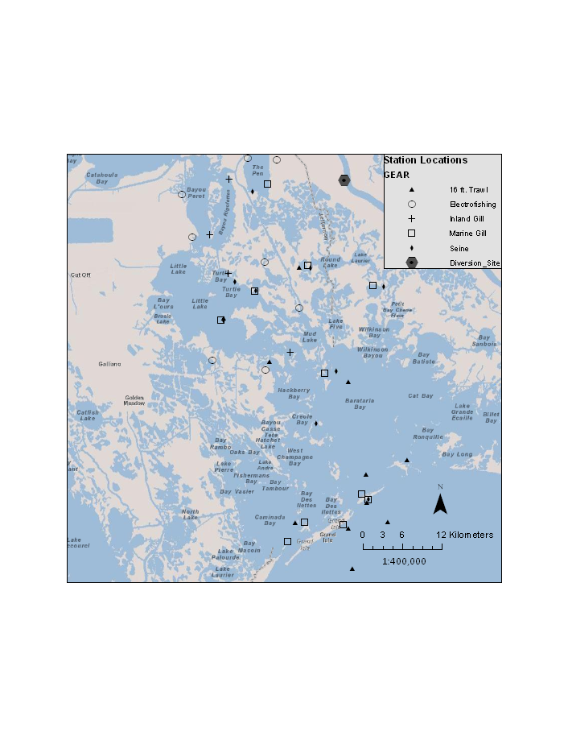

Figure 1a. Sampling locations for LDWF fishery-independent monitoring stations in the lower Barataria Estuary. Nekton abundance and water quality data for this project were collected during 1991-2011 for trawl, marine gill net, and seine stations. Inland gill net and electrofishing data were taken during 1998-2011.

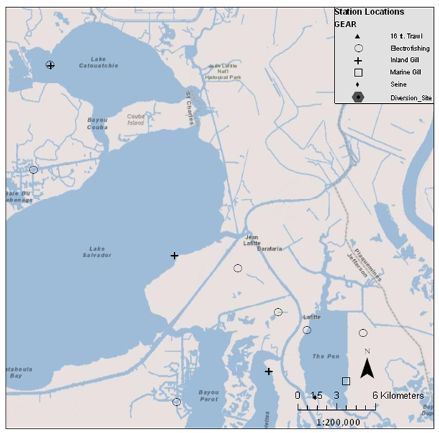

Figure 1b. LDWF Sampling locations associated with Lake Cataouatche and Lake Salvador. Data from LDWF’s Inland sampling program (electrofishing and gill nets) were used to assess optimal salinities relative to the Davis Pond diversion structure.

**Sampling Methodology**

*Marine Gill Net*

A 750 ft. experimental monofilament gill net is used for the primary purpose of sampling finfish to obtain indices of stock abundance, size distribution, and ancillary life history information. Secondarily, all fish and shellfish species encountered by the gear are counted and measured for length and weight for long-term nekton community monitoring.

Large floats and anchor weights are attached to the ends of the float line and lead line, respectively. Gill net deployment begins with the 1 in. bar mesh end. After the float and weight are tossed overboard adjacent to or on a shoreline or reef, the gill net is deployed over the transom of the net well. Net configuration or distance from shoreline or reef varies because of water depth, presence of obstructions, or physical space limitations. The net may be set parallel to the shoreline or reef or in a crescent shape. Enough room is left on one side of the net to allow the net skiff to enter and then maneuver within the net. Fish are forced to strike the net by running the net skiff around both the inside and outside of the net a minimum of two or three times in gradually tightening circles. The net is then retrieved and pulled aboard from the downwind or downcurrent end.

Each net is comprised of nylon monofilament and consists of succession of five (5) panels. The panels have the following mesh sizes:

Panel 1 – 150 ft. X 8 ft., 1 in. bar, 2 in. stretched mesh, and composed of #6 twine size with a diameter of 0.40 millimeters and break test strength of 17 pounds.

Panel 2 -- 150 ft. X 8 ft., 1 1/4 in. bar, 2 1/2 in. stretched mesh, and composed of #10 twine size with a diameter of 0.52 millimeters and minimum break test strength of 26 pounds.

Panel 3 -- 150 ft. X 8 ft., 1 1/2 in. bar, 3 in. stretched mesh, and composed of #10 twine size with a diameter of 0.52 millimeters and minimum break test strength of 26 pounds.

Panel 4 -- 150 ft. X 8 ft., 1 3/4 in. bar, 3 1/2 in. stretched mesh, and composed of #10 twine size with a diameter of 0.52 millimeters and minimum break test strength of 26 pounds.

Panel 5 -- 150 ft. X 8 ft., 2 in. bar, 4 in. stretched mesh, and composed of #10 twine size with a diameter of 0.52 millimeters and minimum break test strength of 26 pounds.

Sampling frequency was monthly during January-March and October-December and semi-monthly during April-September (Table 1). Data from each panel are combined and are reported as number of fish/net for a particular station on a particular date.

## Table 1. Sample frequencies for each gear type during a typical year. Each box represents one week in a month. For example, if a particular month has two boxes checked, then that means that month is sampled twice with that gear type. Likewise, a month with a single box checked means that it is sampled once during that month. NOTE: Seine sample frequency was changed to quarterly in October 2010. Inland gill nets were set during 1998-2011.

|  |  |  |  |  |  |  |  |  |  |  |  |  |  |  |  |  |  |  |  |  |  |  |  |  |  |  |  |  |  |  |  |  |  |  |  |  |  |  |  |  |  |  |  |  |  |  |
| --- | --- | --- | --- | --- | --- | --- | --- | --- | --- | --- | --- | --- | --- | --- | --- | --- | --- | --- | --- | --- | --- | --- | --- | --- | --- | --- | --- | --- | --- | --- | --- | --- | --- | --- | --- | --- | --- | --- | --- | --- | --- | --- | --- | --- | --- | --- |
|  | **Jan** | | | | | | **Feb** | | | | | | | | **Mar** | | | | | | | | **Apr** | | | | | | | | **May** | | | | | | | | **Jun** | | | | | | | |
| 16’ Trawl | X |  | X | |  | | X | |  | | X | |  | | X | |  | | X | |  | | X | | X | | X | | X | | | X | X | | X | | X | | X | | X | | X | | X | | |
| Marine Gill net | X |  |  | |  | | X | |  | |  | |  | | X | |  | |  | |  | | X | |  | | X | |  | | | X |  | | X | |  | | X | |  | | X | |  | | |
| Seine | X |  |  | |  | | X | |  | |  | |  | | X | |  | |  | |  | | X | |  | |  | |  | | | X |  | |  | |  | | X | |  | |  | |  | | |
| Inland Gill Net |  |  |  | |  | | X | |  | |  | |  | |  | |  | |  | |  | |  | |  | |  | |  | | | X |  | |  | |  | |  | |  | |  | |  | | |
| Electro  Fishing |  |  |  | |  | |  | |  | | X | |  | |  | |  | |  | |  | |  | |  | |  | |  | | |  | X | |  | |  | |  | |  | |  | |  | | |
|  | **Jul** | | | | | | | **Aug** | | | | | | | | **Sep** | | | | | | | | **Oct** | | | | | | | **Nov** | | | | | | | **Dec** | | | | | | | |
| 16’ Trawl | X | X | | X | | X | | X | |  | | X | |  | | X | |  | | X | |  | | X | |  | | X | |  | | X |  | X | |  | | X | |  | | X | |  | |
| Marine Gill net | X |  | | X | |  | | X | |  | | X | |  | | X | |  | | X | |  | | X | |  | |  | |  | | X |  |  | |  | | X | |  | |  | |  | |
| Seine | X |  | |  | |  | | X | |  | |  | |  | | X | |  | |  | |  | | X | |  | |  | |  | | X |  |  | |  | | X | |  | |  | |  | |
| Inland Gill Net |  |  | |  | |  | | X | |  | |  | |  | |  | |  | |  | |  | |  | |  | |  | |  | | X |  |  | |  | |  | |  | |  | |  | |
| Electro  fishing |  |  | |  | |  | |  | | X | |  | |  | |  | |  | |  | |  | |  | |  | |  | |  | |  | X |  | |  | |  | |  | |  | |  | |

*Inland Gill Net*

Inland gill net sets are comprised of four (4) separate monofilament gill nets, each with one mesh size. Each net is 100 ft. long and 6 ft. deep. The four mesh sizes are 2.5-, 3.0-, 3.5-, and 4-in. bar mesh. The nets are set perpendicular to the shoreline and are fished passively overnight. Set duration ranges 12-17 hrs, but is mostly 12 hrs. Sample frequency is quarterly (Table 1), and fixed station locations (see Figure 1) for this project were selected in 1998 to assess long-term trends in fish species composition associated with the Davis Pond freshwater diversion.

This sampling gear was chosen because it tends to capture large-bodied predators (e.g., bull sharks, alligator gar) and migratory species, due to the gear’s larger mesh size (compared to marine gill nets) and passive sampling scheme. For example, organisms must swim into the nets on their own, unlike marine gill nets, which capture a snapshot of the organisms that are currently at that particular location. Data from these samples are reported as weight/net-set. In most cases, single large-bodied predators could be captured (e.g., bull shark, or black drum >700 mm TL) in addition to large numbers of smaller-bodied animals (e.g., gizzard shad). These nets typically sample adult stages of fishes. In order to prevent underrepresentation of the larger species, weight was chosen for the analyses of these samples.

*Seine*

A bag seine is used primarily to sample juvenile finfish, shellfish, and other marine organisms to monitor relative abundance, size distribution, seasonal/long-term trends and community structure. The seine measures 50 ft. in length, 6 ft. in depth and has a 6-ft. X 6-ft. bag in the middle of the net. Mesh size throughout the seine is ¼-in. bar mesh (½-in. stretched mesh) and composed of heavy delta #44 knotless mesh. The ends of the seine are held open with 6-ft. poles which are attached to the float and lead lines. Seine sampling techniques can be subdivided into two general types ‑ soft bottom and hard bottom. Sampling methodology utilized at each station is identified. Seine samples collected over soft bottom areas are accomplished by attaching 100-ft. lengths of ½-in. diameter nylon or polydac rope to each seine pole bridle. The line is anchored to the shoreline by tying the end to a push‑pole, paddle, anchor or other structure. The boat is quietly reversed until the line is fully extended. At this point the boat is turned 90° astern (parallel to the shoreline) and the seine is fed out over the boat's bow while making sure the cork line and bag are not tangled. As the end of the seine is placed overboard, the boat proceeds shoreward and is anchored or tied to the bank. The seine is hauled in by the two tow lines, with care being taken to keep the lead line on the bottom. The catch in the wings of the net is shaken down to the bag, and removed. Seine samples collected over hard bottom areas are taken in a more conventional manner. The seine is stretched out and pulled parallel to the shoreline for a distance of 75‑100 ft. The outside end is then swept in toward the shoreline and the net is drawn ashore. Contents are then removed using methods described earlier.

All organisms collected in seine samples are identified to species and counted. Data were reported as fish/haul for analyses. Sample frequency was monthly from 1991-September 2010, then quarterly from October 2010 through 2011 (Table 1).

### *16 ft.-Trawl*

A 16-ft. flat otter trawl is used primarily to sample penaeid shrimp, blue crabs, finfish (groundfish), and other marine organisms in the larger inshore bays and seaward into Louisiana's outside territorial waters. The objectives are to determine relative abundance, size distribution, and seasonal/long-term trends. The trawl is attached to a ½-in. diameter nylon rope or stainless steel tow line and bridle. The length of the bridle is 2‑3 times the trawl width. The four-seam flat otter trawl body is constructed of ¾-in. bar mesh (1½-in. stretched mesh). The netting is composed of #9 (86 lb. test) nylon. The bag is constructed of ¼-in. bar mesh (½-in. stretched mesh) and consists of #44 heavy delta webbing. The bag length measures 54-60 in. Tow line length is normally at least 4‑5 times the maximum depth of water. The trawl is towed for ten minutes (timed from when the trawl first begins to move forward to when it stops forward movement) at a constant speed and in a weaving or circular track to allow the prop wash to pass on either side of the trawl.

All organisms are identified by species and counted. Data for analyses were reported as fish/10-min trawl. Sampling frequency was semi-monthly during January-March and August-December and weekly during April-July (Table 1).

*Electrofishing*

The Inland Section of LDWF conducted boat-mounted electrofishing during daylight along shorelines with a prod pole and a dip net with 3/16-in. nylon mesh. There were 12 fixed stations located from a canal off of Lake Cataouatche down to the top of Barataria Bay. Samples were collected quarterly (generally February, May, August, November) during 1998-2009. A 7.5 GPP Smith-Root© electrofisher was used to send a pulsated direct current into the water with the amperage adjusted for given conductivities to maximize electrofishing efficiency. Each station was electrofished for 15 minutes. Small and medium-bodied fishes (e.g., 100-1,000 mm TL) are most susceptible to stunning (e.g., sub-adult or adult largemouth bass, juvenile-adult sunfishes, shad, and minnows). Large-bodied fishes that are demersal or have strong swimming power may be able to escape the current.

**Statistical Analyses**

*Canonical Correspondence Analysis*

Multivariate, direct gradient analysis and bivariate, nonlinear regression models were used to examine associations between environmental variables and community structure of species sampled from 1991 to 2011. Analyses were conducted separately for each gear type and season, where April-July was considered spring-summer and September-December was fall. Using CANOCO version 4.5 software (ter Braak and Smilauer 2002), canonical correspondence analysis (CCA) was used to detect patterns in nekton species composition by gear type. A CCA is analogous to multiple linear regression with the exception that CCA incorporates multiple response variables (i.e., a matrix of response variables representing species abundances) instead of just one response variable. For each gear type, a CCA was run on a Bray-Curtis dissimilarity matrix of species abundances, using three environmental variables as a secondary predictor matrix. The three independent variables were taken concurrently with the fish samples were surface salinity (ppt), surface water temperature (°C), and surface turbidity (NTU).

The species abundances were ln-(x + 1) transformed prior to analysis. This transformation reduced the potential bias of uncommon species (i.e., observations with zeros representing a species that was not captured) and species with very large abundances in particular samples (usually schooling species like Gulf menhaden). In addition, species that occurred in < 1% of the samples were removed from the analysis, because these infrequent species could have biased the results of the CCA. In most cases, species that were not sampled efficiently by certain gears were removed (e.g., large-bodied species in seine samples).

After the species abundance data were transformed and infrequent species removed from the matrix, a unimodal model was chosen to run the CCA. A unimodal model was chosen for the analysis in order to maximize the species optima. The unimodal model finds the point on an environmental gradient where the abundance of a species is at its optimum after weighted averaging of the species and environmental data. A Monte Carlo randomization test was used with 1,000 runs to calculate an F-statistic and a *P*-value for canonical axes produced by the CCA. The CCA was considered statistically significant if *P* < 0.05 for the F-statistic. Only the first two axes calculated by the CCA were examined for the patterns in community structure, because these two axes explained >60% of the variation in the community data for all gear types.

Species dominance is determined by the distance the species is located from the centroid of the ordination. That is, species that are located towards the ends of the arrows are predicted to dominate the assemblage and be at their optimal abundance at the extreme ends of the range of the environmental variable. Species located at the centroid of the ordination are optimized near the center of the range of the environmental data (analogous to the average of the environmental variable). **For this study, a species’ optimal abundance is equivalent to its predicted maximum attainable relative abundance at the point on the environmental gradient on which it lies.** This ecological definition differs from the traditional use of the term “optimal” as it pertains to optimal sustained yield (OSY) in fisheries management, which is an arbitrarily set estimate of an exploited stock’s yield that is lower than the stock’s estimated maximum sustained yield (MSY). The closer species are distributed in environmental space on the joint plots, the more similar their abundances relative to the environmental gradient. Species located farther away on the plots are more dissimilar to each other with respect to their relationship with the environmental gradient.

Using the CCA output, t-value biplots (ter Braak and Smilauer 2002) were constructed in CANOCO software to isolate the effect of each environmental variable on species abundances. For each gear type and season, the t-value biplot shows arrows, representing species abundances, along with van Dobben circles. If the arrow tip is positioned inside the van Dobben circle, then that species is considered to have a statistically significant association with that particular environmental variable. These species have t-values (which are analogous to *t*-values for independent variables in multiple linear regressions) that are ≥ 2.0, and are considered to represent statistically significant relationships (ter Braak and Smilauer 2002). Arrows that point from the centroid to the farthest end of the circle represent species with the strongest associations with salinity. Species with arrows positioned outside the circles do not exhibit a statistically significant relationship with that particular environmental variable. The red circle in the t-value biplots indicates a positive relationship between the species and the environmental variable, while the blue circle indicates a negative relationship.

*Species Response Curves*

Species response curves were estimated using the CANOCO software. These curves are used to find the value of the predictor variable at which a species attains its optimal (i.e., maximum) relative abundance. They are also indicative of the predictor’s influence on the species’ magnitude, direction, and degree of linearity or nonlinearity. The software utilize several types are modeling options with the ability to evaluate model diagnostics (i.e., accuracy and precision). For example, several types of models were explored for this project. Each model differs with respect to assumptions regarding distribution of errors, linearity and normality of the data. Generalized linear models (GLM) and generalized additive models (GAM) were evaluated. For each of these model types, two different types of error distributions were used to evaluate performance of the models: (1) Gaussian (which is used in traditional linear regression) and (2) Poisson (which can assume both linear and nonlinear error distribution). Diagnostic tests for each model included F-tests and associated *P*-values, Akaike Information Criterion values (AIC), and residual plots. Based on these diagnostic tests, the GAM with a Poisson error distribution was the most accurate and precise model for finding the optimal environmental condition for each species’ abundances. Two related environmental predictors were used in the GAM models. These were (1) the sample scores calculated from the CCAs, and (2) the raw salinity values for each sample. The CCA sample scores represent an environmental gradient, primarily salinity, but the scores also account for similarities in species abundance trends that may be caused by other environmental factors (e.g., seasonal recruitment patterns, temperature, wind or tidal influences).

*Optimal salinity levels for diversity and species richness*

Biodiversity indicators were calculated for each sample by gear type and season. The metrics chosen were the Shannon-Wiener uncertainty index (H’) and species richness (*r*). Larger values of H’ indicate greater biodiversity (which includes an evenness component, that is, it accounts for dominant species). Larger *r* values simply represent a greater number of species, regardless of their abundances. These metrics were calculated for each sample, which is represents the alpha diversity of the region, or a localized snapshot of diversity at a particular point in the region. The diversity and richness values for each sample were then used as response variables in GAM species response curves, with salinity as the predictor variable. These models were used to determine the salinity level that would achieve the greatest amount of biodiversity.

*Community structure before and after Davis Pond Diversion*

A CCA was used to examine species composition changes in the region following the operation of the Davis Pond diversion for each gear type and season. Albeit the Davis Pond structure has a smaller discharge capacity than the proposed Myrtle Grove diversion, and it is located farther up-estuary, this analysis should give some insight as to expected changes in community structure in the Barataria Basin, relatively to salinity changes. For this analysis, data from April-July 1991-2001 were categorized as the pre-diversion data, while data from April-July 2002-2011 were categorized as post-diversion data. Convex hulls were drawn around the distribution of samples for each joint plot in order to help visualize any potential differences in community structure between diversion periods. These CCA plots were created using PC-Ord version 6.0 software (McCune and Grace 2002). To further elucidate differences before and after diversion, a pair-wise multi-response permutation procedure (MRPP) was used in PC-Ord to test for significant differences in community structure among years.

**Results**

*Spring-summer months*

Relationship between salinity and nekton community structure: Marine gill net samples

A total of 1,126 marine gill net samples were analyzed for the spring-summer periods, during which 21,950 individuals from 89 species were collected (Table 2). Of these species, 36 occurred frequently enough (≥1% of samples) to be included in the gill net CCA (Figure 2). Scores for the first canonical axis were statistically significant (Total inertia [TI] = 6.3; Eigenvalue [EV] = 0.15; F = 27.0; *P* = 0.002). Salinity had a strong negative correlation with axis 1 (species-environment correlation [SEC] = -0.60; cumulative % variance of species-environment relationships [%CV] = 76.2).

As the t-value biplots shows (Figure 2), species that exhibited significant positive relationships with salinity were composed mostly of predators or benthic invertivores (12 of 15 species). These predatory species included members of the Carangidae (jacks and pompanos), Sciaenidae (weakfish and croakers), Scombridae (mackerels), and Stromateidae (butterfishes) families. Of the carangid species, Florida Pompano (*Trachinotus carolinus*), Leatherjacket (*Oligoplites saurus*), and Atlantic bumper (*Chloroscombrus chrysurus)*were optimized at higher salinities during spring-summer. Five predatory sciaenid species attained their greatest abundances in higher salinities, including the Spotted seatrout (*Cynoscion nebulos*us), Sand seatrout (*C. arenarius*), Silver seatrout (*C. nothus*), Silver perch (*Bairdiella chrysoura*) and Southern kingfish (*Menticirrhus americanus*). Two voracious predators, the Spanish mackerel (*Scomberomorus maculates*) and the Bluefish (*Pomatomus saltatrix*) were also positively related to salinity. In the butterfish family, two species were related to high salinity conditions, including the Harvestfish (*Peprilus alepidotus*) and the Gulf butterfish (*Peprilus burti*). Three forage species were optimized at higher salinities. These included two planktivorous schooling species in the family Clupeidae, the Gulf menhaden (*Brevoortia patronus*) and Scaled sardine (*Harengula jaguana*). Lastly, one omnivore from the porgy family (Paridae), the Pinfish (*Lagodon rhomboides*), was positively associated with salinity.

Species associated with fresher conditions were still comprised mostly of predators and benthic invertivores (8 out of 15 species). However, abundances of omnivores and planktivores species increased, indicating a minor trophic shift in the nekton community away from predators and invertivores. Five omnivores that were optimized in fresher habitats were the striped mullet (*Mugil cephalus*), Channel catfish (*Ictalurus punctatus*), Sea catfish (*Arius felis*), White shrimp (*Litopenaeus setiferus*)and Blue crab (*Callinectes sapidus*). Two pelagic planktivores that are common freshwater residents were optimized in low salinity habitats, the clupeids Threadfin shad (*Dorosoma petenense*) and Gizzard shad (*D. cepedianum*). Three of the four predators that were optimized in low salinity environments were also common freshwater residents. These species were the Largemouth bass (*Micropterus salmoides*), Alligator gar (*Atractosteus spatula*)and Spotted gar (*Lepisosteus oculatus*). An offshore spawning predator as an adult, the Ladyfish (*Elops saurus*), whose leptocephalus larvae are known to develop in brackish environments, was also optimized in lower salinity habitats. Three sciaenid benthic invertivores were most abundant in fresher habitats, including the Red drum (*Sciaenops ocellatus*), Black drum (*Pogonias cromis*), and Atlantic croaker (*Micropogonias undulatus*). One benthic invertivore from the porgy family (Sparidae), the Sheepshead (*Archosargus probatocephalus*), was also associated with low salinity conditions.

Table 2. Summaries of the number of gill net, seine, and trawl samples, individual organisms, and number of species taken during spring-summer months by LDWF (1991-2011) in the lower Barataria Basin. Electrofishing samples are from all months of the year. The minimum, maximum and mean surface salinities (ppt) are shown for each gear type.

|  |  |  |  |  |  |  |
| --- | --- | --- | --- | --- | --- | --- |
| Gear | Samples | No. organisms | No. species collected | Min. Salinity | Max. Salinity | Mean Salinity |
| Marine Gill Net | 1,126 | 21,950 | 89 | 0 | 36.0 | 12.7 |
| Inland Gill Net | 51 | 3,668 | 27 | 0 | 17.3 | 3.2 |
| Seine | 532 | 97,707 | 115 | 0 | 33.0 | 9.3 |
| 16-ft. Trawl | 1,314 | 99,931 | 138 | 0 | 37.6 | 15.9 |
| Electrofishing | 468 | 15,071 | 38 | 0 | 27.4 | 3.7 |

Table 3. Minimum, maximum and mean total lengths (mm) of commercially and recreationally important nekton species sampled from various LDWF gear types during April-July 1991-2011 in the lower Barataria estuary.

|  |  |  |  |  |
| --- | --- | --- | --- | --- |
| Gear | Species | Minimum | Maximum | Mean |
| Marine Gill Net | Atlantic croaker | 86 | 286 | 181 |
|  | Blue crab | 24 | 452 | 150 |
|  | Brown shrimp | 75 | 149 | 112 |
|  | Gulf menhaden | 58 | 398 | 188 |
|  | Largemouth bass | 232 | 306 | 270 |
|  | Red drum | 160 | 984 | 357 |
|  | Southern flounder | 146 | 420 | 262 |
|  | Spotted seatrout | 1 | 624 | 316 |
|  | Striped mullet | 124 | 398 | 248 |
|  | White shrimp | 98 | 193 | 143 |
| Inland Gill Net | Atlantic croaker | 183 | 227 | 211 |
|  | Blue crab | -- | -- | -- |
|  | Brown shrimp | -- | -- | -- |
|  | Gulf menhaden | 100 | 276 | 195 |
|  | Largemouth bass | -- | -- | -- |  |
|  | Red drum | 14 | 976 | 531 |
|  | Southern flounder | -- | -- | -- | -- |
|  | Spotted seatrout | 17 | 506 | 356 |
|  | Striped mullet | 205 | 534 | 353 |
|  | White shrimp | -- | -- | -- |  |
| Seine | Atlantic croaker | 13 | 234 | 77 |
|  | Blue crab | 5 | 290 | 64 |
|  | Brown shrimp | 13 | 142 | 59 |
|  | Gulf menhaden | 11 | 226 | 48 |
|  | Largemouth bass | 29 | 260 | 91 |
|  | Red drum | 24 | 790 | 234 |
|  | Southern flounder | 27 | 444 | 92 |
|  | Spotted seatrout | 29 | 333 | 142 |
|  | Striped mullet | 17 | 402 | 80 |
|  | White shrimp | 16 | 180 | 65 |
| 16-ft. Trawl | Atlantic croaker | 10 | 245 | 89 |
|  | Blue crab | <5 | 230 | 86 |
|  | Brown shrimp | 10 | 230 | 78 |
|  | Gulf menhaden | 20 | 235 | 69 |
|  | Largemouth bass | 35 | 135 | 78 |
|  | Red drum | 20 | 355 | 196 |
|  | Southern flounder | 25 | 295 | 96 |
|  | Spotted seatrout | 40 | 240 | 143 |
|  | Striped mullet | 25 | 210 | 108 |
|  | White shrimp | <5 | 190 | 104 |
| Electrofishing | Atlantic croaker | 10 | 213 | 109 |
|  | Blue crab | -- | -- | -- |
|  | Brown shrimp | -- | -- | -- |
|  | Gulf menhaden | 25 | 239 | 66 |
|  | Largemouth bass | 67 | 304 | 209 |
|  | Red drum | 14 | 680 | 329 |
|  | Southern flounder | 17 | 322 | 152 |
|  | Spotted seatrout | 10 | 355 | 286 |
|  | Striped mullet | 88 | 334 | 280 |
|  | White shrimp | -- | -- | -- |

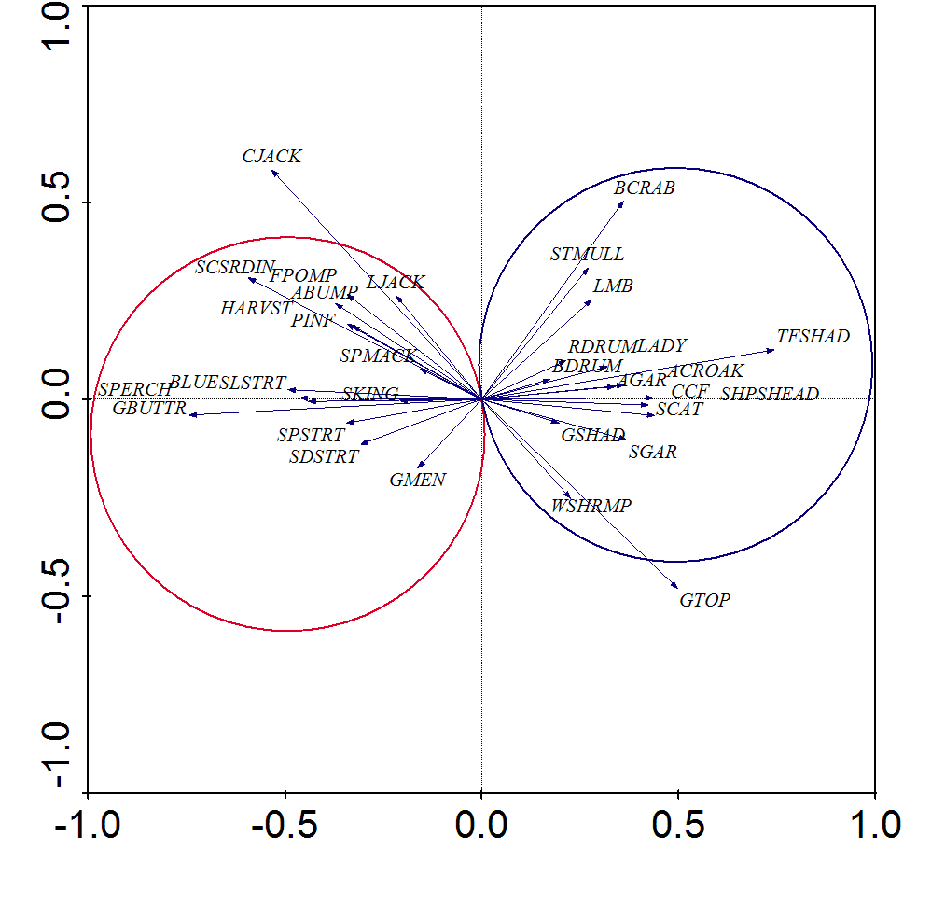

Figure 2. T-value biplots from a canonical correspondence analysis (CCA) depicting statistically significant (T>2.0, *P*≤0.05) relationships between species abundances and salinity from LDWF **marine gill nets sampled May-July 1991-2011**. Magnitude and direction of salinity-species relationships are represented by arrowheads. Arrows that point in the same direction and are close to each other represent species whose abundance trends are similar to each other. Only arrows within the van Dobben circles are statistically significant. Species in the red circle are those that are related positively to salinity, while those in the blue circle exhibit a negative relationship. T- and *P*-values were calculated from 1,000 randomized Monte Carlo simulations. Species abbreviations are explained in Appendix A.

Relationship between salinity and nekton community structure: Inland gill net samples

A total of 51 inland gill net samples were analyzed for the 1998-2011 spring-summer periods, during which 3,668 individuals from 27 species were collected (Table 1). Of these species, 25 occurred frequently enough (≥1% of samples) to be included in the CCA (Figure 3). Scores for the first canonical axis were statistically significant but the CCA was relatively weak, likely due to small sample size (TI = 1.9; EV = 0.15; F = 4.0; *P* = 0.002). Salinity had a strong positive correlation with axis 1 (SEC = 0.84; %CV = 54.0).

There were similarities observed between the marine gill net and inland gill net T-value biplots. This is surprising given that the mesh sizes and fishing techniques used for these gears are vastly different. Nonetheless, species from both gear types that showed a significant positive relationship with salinity were the Spotted seatrout, Southern kingfish and Gulf menhaden. Species from both gear types that were more abundant in fresher sites were Red drum, Ladyfish, and Spotted gar. One difference between the two gears is that Sea catfish in the inland gill nets was positively associated with salinity. Also, some other species in inland gill nets that were not captured frequently in marine gill nets that showed significant positive relationships to salinity. These were the Cownose ray (*Rhinoptera bonasus*) and Bull shark (*Carcharhinus leucas*). A common freshwater species that had optimal abundance in the low salinity, inland gill net sites was the Blue catfish (*Ictalurus furcatus*). Regardless of salinity level, the majority of species that showed significant relationships with salinity were predators. This is mostly due to the passive, overnight sampling technique for this gear type, which tends to capture large-bodied predatory fishes or schooling forage fishes (e.g., Gulf menhaden) that move nocturnally.

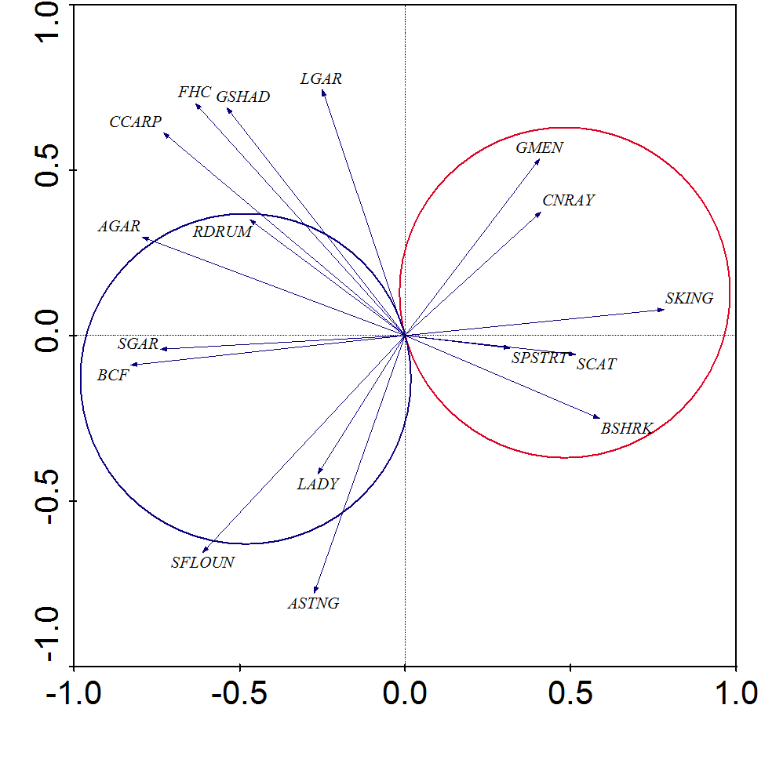

Figure 3. T-value biplots from a canonical correspondence analysis (CCA) depicting statistically significant (T>2.0, *P*≤0.05) relationships between species abundances and salinity from LDWF **inland gill nets sampled April-July 1998-2011**. Magnitude and direction of salinity-species relationships are represented by arrowheads. Arrows that point in the same direction and are close to each other represent species whose abundance trends are similar to each other. Only arrows within the van Dobben circles are statistically significant. Species in the red circle are those that are related positively to salinity, while those in the blue circle exhibit a negative relationship. T- and *P*-values were calculated from 1,000 randomized Monte Carlo simulations. Species abbreviations are explained in Appendix A.

Relationship between salinity and nekton community structure: Seine samples

A total of 532 seine samples were analyzed for the 1991-2011 spring-summer periods, during which 97,707 individuals from 115 taxa were collected (Table 1). Of these taxa, 43 occurred frequently enough (≥1% of samples) to be included in the CCA (Figure 4). Scores for the first canonical axis were statistically significant (TI = 7.4; EV = 0.12; F = 8.7; *P* = 0.001). Salinity had a strong negative correlation with axis 1 (SEC = -0.53; %CV = 62.4).

There was a large proportion of predator-invertivore species (10 out of 13 species) associated with higher salinity habitats from seines (Figure 4). Four sciaenid species preferred higher salinities, including Southern kingfish, Gulf kingfish (*Menticirrhus littoralis*), Spot (*Leiostomus xanthurus*), and Banded drum (*Larimus fasciatus*). Other predator-invertivores that exhibited positive relationships with salinity were Florida Pompano and Sea catfish. Three estuarine residents were associated positively with salinity, including the Darter goby (*Ctenogobius boleosoma*), Longnose killifish (*Fundulus similis*), and Sailfin molly (*Poecilia latipinna*). Two omnivore species were associated with higher salinities, including Striped mullet, and the Lesser blue crab (*Callinectes similis*). One planktivore species that showed a positive relationship to salinity was the Striped anchovy (*Anchoa hepsetus*).

Unlike the gill net samples, a large proportion of species that were associated with low salinity habitats were classified as predators or invertivores (6 out of 9) from seine samples (Figure 4). However, only one predator species, the Sand seatrout, preferred lower salinities. Four of the invertivore taxa were estuarine residents, the Naked goby (*Gobiosoma bosc*), Rainwater killifish (*Lucania parva*), unidentified Xanthidae mud crabs and unidentified non-Xanthidae mud crabs. Abundance of a transient benthic invertivore, the Atlantic croaker, was also related to lower salinity habitats. There was one resident omnivore taxa that was optimized in fresher conditions, the Daggerblade grass shrimp (*Paleomonetes pugio*). One other resident whose abundance was related to lower salinity environments was the planktivorous Inland silverside (*Menidia beryllina*). Finally, one transient planktivore was optimized in low salinity habitats, the Gulf menhaden, which is a clupeid that is known to rely on low salinity areas in estuaries as nursery habitat.

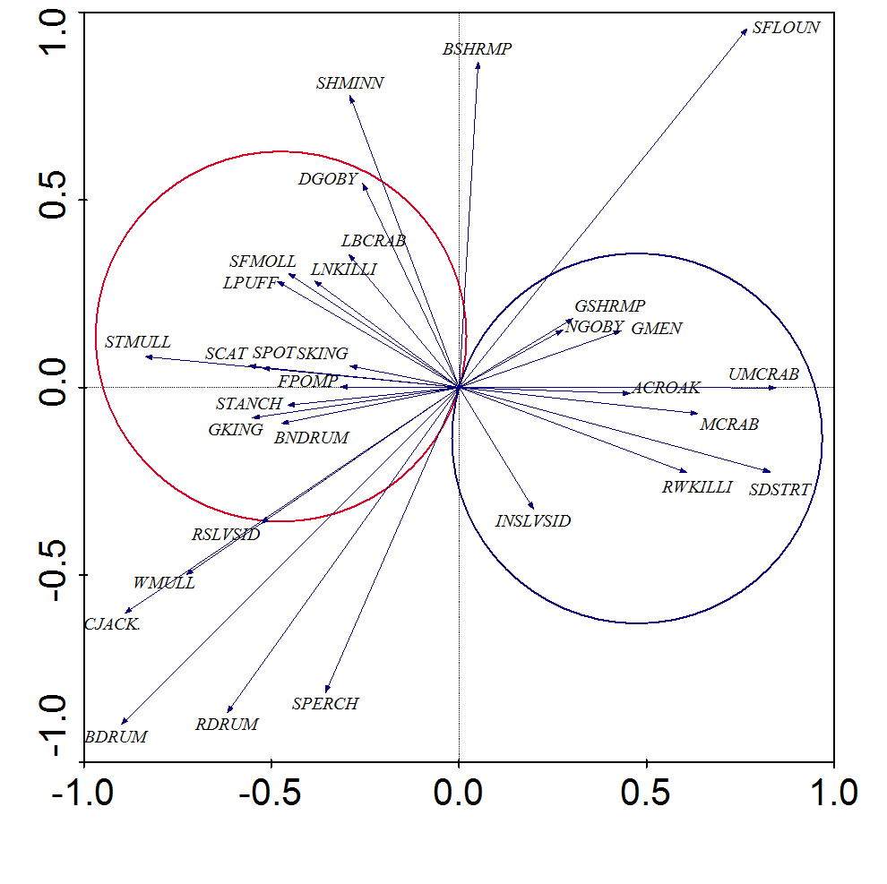

Figure 4. T-value biplots from a canonical correspondence analysis (CCA) depicting statistically significant (T>2.0, *P*≤0.05) relationships between species abundances and salinity from LDWF **seines sampled April-July 1991-2011**. Magnitude and direction of salinity-species relationships are represented by arrowheads. Arrows that point in the same direction and are close to each other represent species whose abundance trends are similar to each other. Only arrows within the van Dobben circles are statistically significant. Species in the red circle are those that are related positively to salinity, while those in the blue circle exhibit a negative relationship. T- and *P*-values were calculated from 1,000 randomized Monte Carlo simulations. Species abbreviations are explained in Appendix A.

Relationship between salinity and nekton community structure: 16-ft. Trawl samples

A total of 1,314 trawl samples were analyzed for the 1991-2011 spring-summer periods, during which 99,931 individuals from 138 taxa were collected (Table 1). Of these taxa, 59 occurred frequently enough (≥1% of samples) to be included in the CCA (Figure 5). Scores for the first canonical axis were statistically significant (TI = 4.6; EV = 0.07; F = 19.2; *P* = 0.001). Salinity had a strong negative correlation with axis 1 (SEC = -0.54; %CV = 57.9).

Predators and benthic invertivores comprised most of the species (9 out of 15) that showed positive relationships between abundance and salinity in trawl samples (Figure 5). These species were the Gulf butterfish, Bighead searobin (*Prionotus tribulus*), Mantis shrimp (*Squilla* spp.), Atlantic brief squid (*Lolliguncula brevis*), Banded drum, Southern kingfish, Atlantic bumper, Offshore tonguefish (*Symphurus civitatium*), and Star drum (*Stellifer lanceolatus*). Four species were omnivorous crustacean species, including Pink shrimp (*Farfantepenaeus duorarum*), Seabob (*Xiphopenaeus kroyeri*), Roughneck shrimp (*Rimapenaeus constrictus*), and Lesser blue crab. Two schooling planktivorous species were associated positively with salinity. These were the Bay anchovy (*Anchoa mitchilli*) and Striped anchovy.

A slightly smaller proportion of predators and benthic invertivores made up the species that were optimized in lower salinity habitats (6 out of 12). The abundances of three sciaenid predators, Spotted seatrout and Sand seatrout, were optimal at lower salinities, as was the invertivore Atlantic croaker. Two invertivore flatfishes were associated with fresher conditions, including the Bay Whiff (*Citharichtyes spilopterus*) and the Hogchoker (*Trinectes maculatus*). Crevalle jack, a carangid predator, was also related to lower salinity environments. Three omnivorous estuarine residents were most abundant in low salinity habitats, including the Blue crab, Daggerblade grass shrimp, and other unidentified grass shrimp species (*Paleomonetes* spp.). Lastly, two omnivorous transients were optimized in lower salinity habitats, the White shrimp (*Litopenaeus setiferus*) and Gafftopsail catfish.

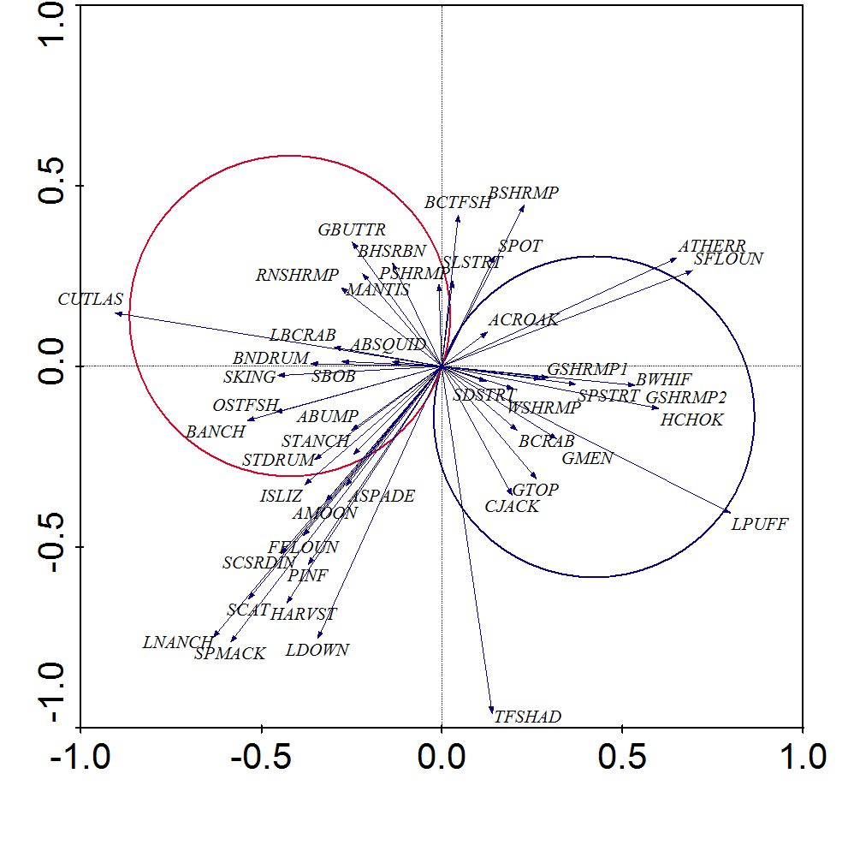

Figure 5. T-value biplots from a canonical correspondence analysis (CCA) depicting statistically significant (T>2.0, *P*≤0.05) relationships between species abundances and salinity from LDWF **16-ft. trawls sampled May-July 1991-2011**. Magnitude and direction of salinity-species relationships are represented by arrowheads. Arrows that point in the same direction and are close to each other represent species whose abundance trends are similar to each other. Only arrows within the van Dobben circles are statistically significant. Species in the red circle are those that are related positively to salinity, while those in the blue circle exhibit a negative relationship. T- and *P*-values were calculated from 1,000 randomized Monte Carlo simulations. Species abbreviations are explained in Appendix A.

Salinity levels that optimize species abundances: Marine gill nets

The nonlinear species response curves tended to agree with results from the multivariate CCA for marine gill nets sampled during spring-summer months (Figure 6). When ln(x*i*+1)-transformed catch was modeled using a GAM with CCA axis 1 scores as a predictor variable, Spotted seatrout, Sand seatrout Leatherjacket, Pinfish, Southern kingfish, and Spot were optimized at the highest position on the salinity gradient, while Spanish mackerel and Gulf menhaden were optimal at moderately high positions on the gradient. Notice that these species are left of the centroid in the top graph in Figure 6, the point on the x-axis intersected by the vertical grey line, which corresponds to being inside the red van Dobben circle in Figure 2. Black drum, White shrimp, Gizzard shad, and Atlantic croaker had optimal abundances at moderately low positions on the salinity gradient, while Blue crab and Ladyfish were optimized at the lowest levels of the gradient. However, it is worth noting that Blue crab and Ladyfish response curves were U-shaped, indicating that the highest salinity habitats were nearly as optimal as the freshest habitats, whereas medium salinity levels were the least optimal for these species. In addition, the GAM for Spotted seatrout showed the greatest rate of change, suggesting a very strong positive relationship between marine gill net catch and salinity.

Bivariate GAMs that incorporated salinity as the predictor variable resulted in similar species response curves as those that used CCA axis 1 scores as the predictor, with a few exceptions (Figure 6, bottom graph). During spring-summer, Spotted seatrout, Sand seatrout, Leatherjacket, Southern kingfish, Spot, Pinfish and Bluefish were optimized at the highest salinities (≥32 ppt). Again, Spotted seatrout showed a very strong positive relationship with salinity, in addition to Leatherjacket. Unlike the GAM that used the CCA gradient as a predictor, Gulf menhaden and Blue crab were at their optimal abundances when salinity was at its highest level, suggesting that there are biotic influences (e.g., food availability, predation risk) or other environmental factors (e.g., temperature) that may interact with salinity to create these differences in the species response curves for these species. Spanish mackerel was optimized in habitats with salinity ≥19 ppt, while Sea catfish, White shrimp, Gizzard shad, and Atlantic croaker had optimal abundances at salinities between 2 ppt and 6 ppt. Black drum was optimal at approximately 1 ppt, and Ladyfish was most abundant at salinities <1 ppt.

See **Appendix B** for a more generalized, qualitative breakdown of optimal salinities for these species.

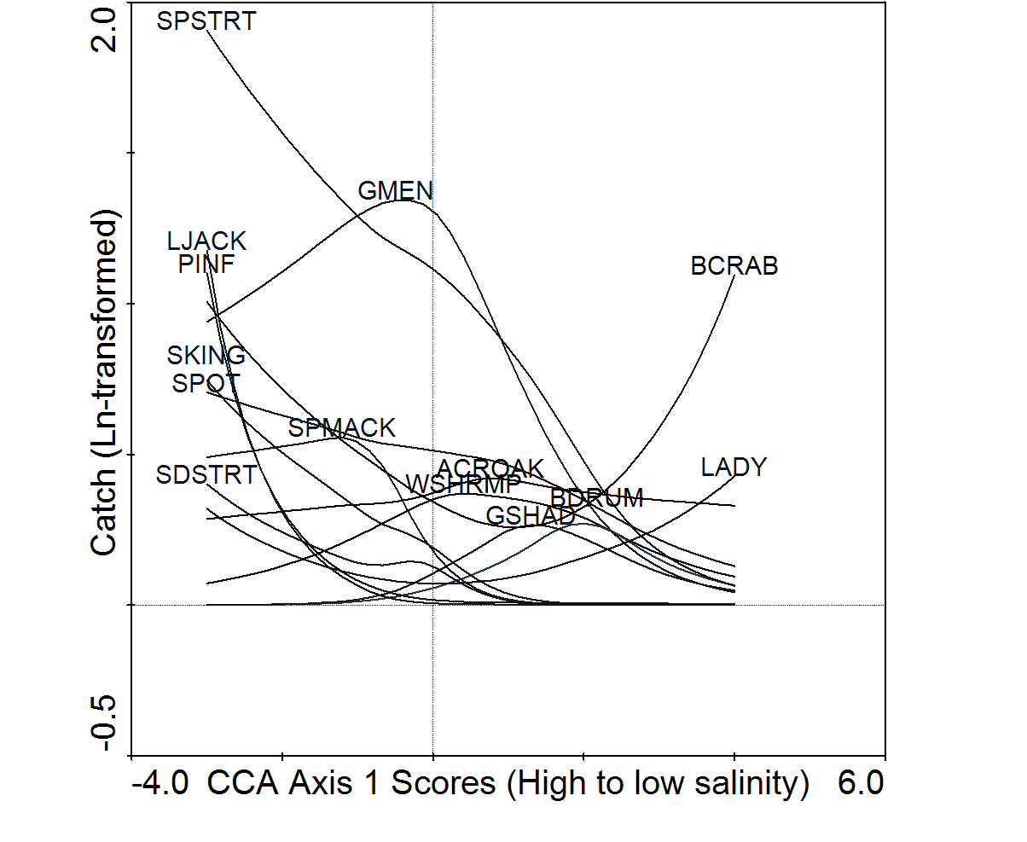

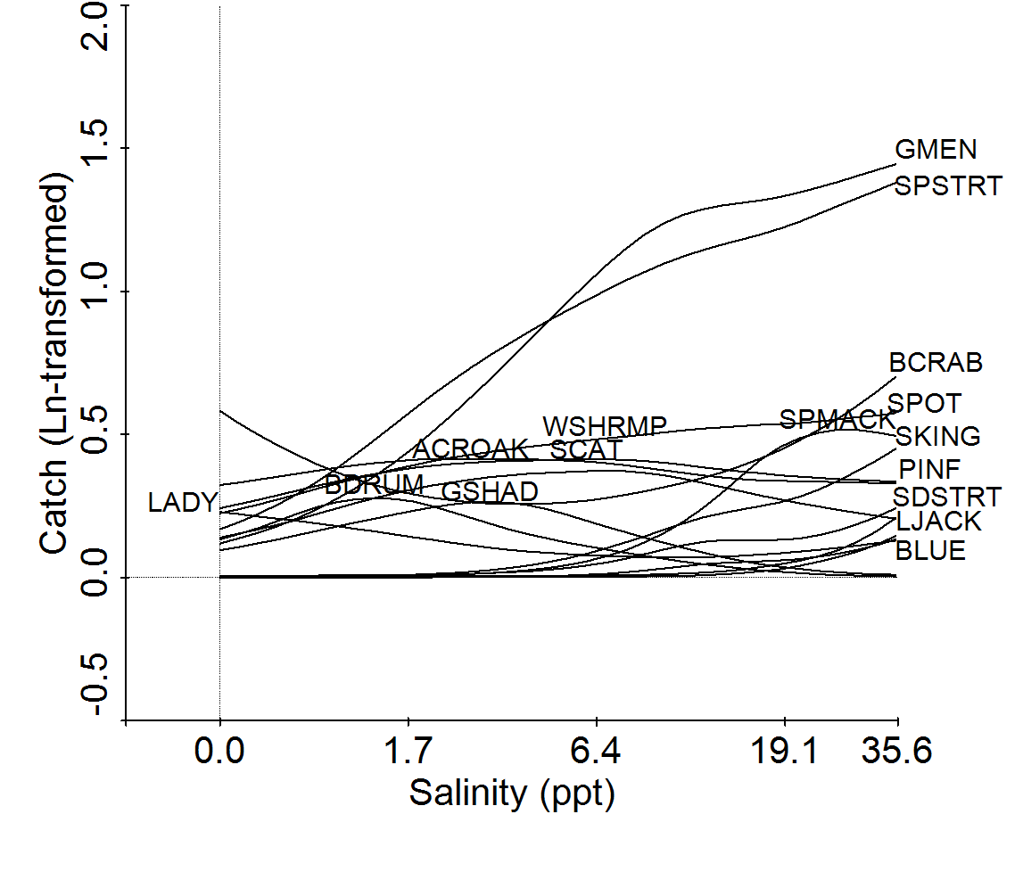

Figure 6. Results of generalized additive models (GAM) showing the optimal salinity conditions for species abundances in the Barataria Estuary (point where species name is). The top graph shows the optimal point on an environmental gradient (CCA axis 1 scores) that accounts for salinity and multivariate community structure. The bottom graph shows the optimal salinity level (ppt) for a species without the influence of multivariate community structure. Only species that were significantly related to the predictor variables are shown (*P*≤0.05). Catch and salinity data were log(x +1)-transformed prior to analysis. Data are from **marine gill nets sampled May-July 1991-2011**. Abbreviations for species names are explained in Appendix A.

Salinity levels that optimize species abundances: Inland gill nets

Species response curves developed from the spring-summer inland gill net data showed similar results to the CCA T-value biplots (Figure 7). When CCA axis 1 scores were used as the predictor variable, Spotted seatrout weight (ln[x+1]-transformed) had a strong positive relationship with salinity and was optimized at the high end of the salinity gradient, in addition to the Cownose ray and Southern kingfish. Sand seatrout and Sea catfish were most abundant at the moderately high position on the salinity gradient. Species that were optimal at the moderately low end of the salinity gradient were the Alligator gar, Longnose gar, Spotted gar, Ladyfish, Atlantic croaker, Red drum, Blue catfish and Common carp. Lastly, Flathead catfish and Gizzard shad weight from inland gill net samples were optimized in near freshwater conditions.

When species response curves were developed using salinity as the predictor variable, the GAM results were very similar to those using the CCA axis 1 scores as the predictor, with a few exceptions. Spotted gar, Common carp, and Ladyfish weights were optimal in freshwater, and the Flathead catfish model was not statistically significant. Like the previous model showed, Gizzard shad was also optimal in near freshwater habitats. Red drum, Atlantic croaker, Blue catfish, Alligator gar, and Longnose gar were most abundant at 0-1 ppt. Sand seatrout and Sea catfish were optimized at around 7 ppt, and Spotted seatrout, Southern kingfish and Cownose ray were optimal at salinities of 11-14 ppt.

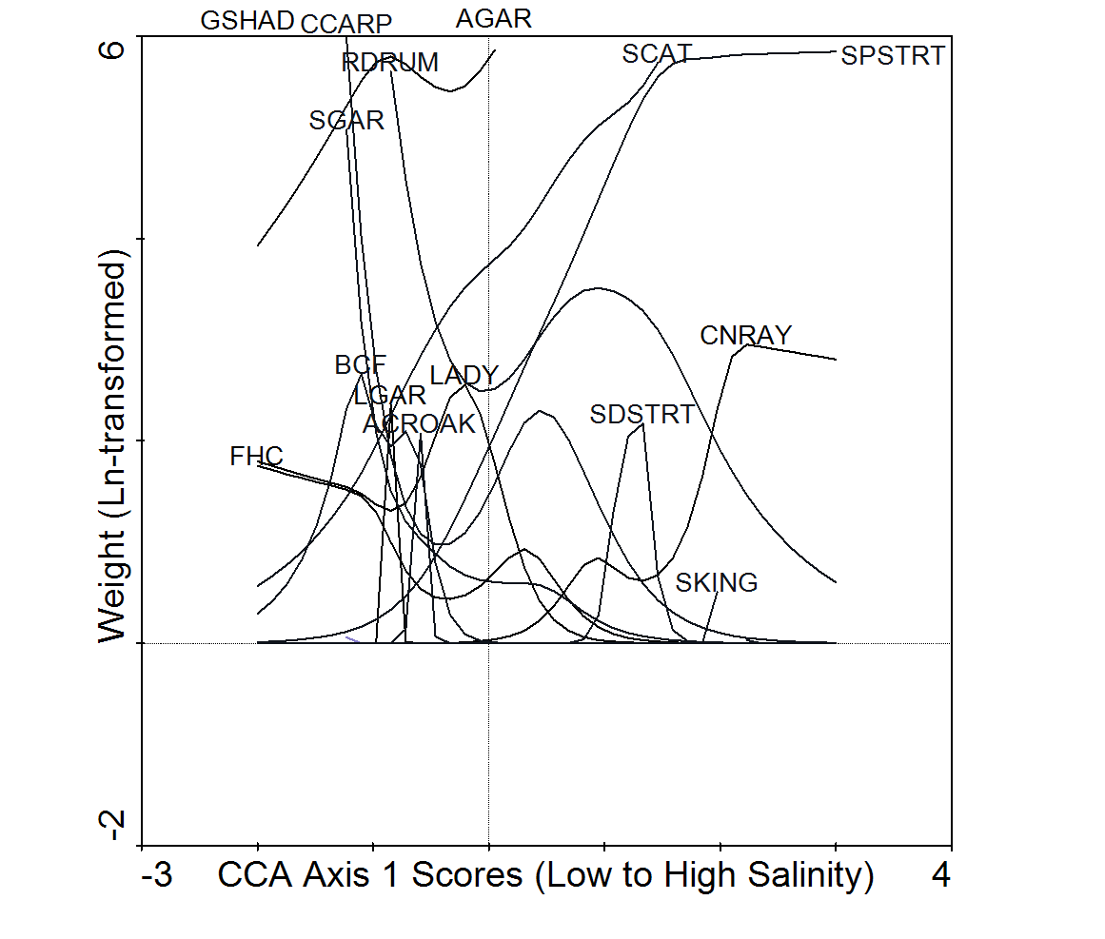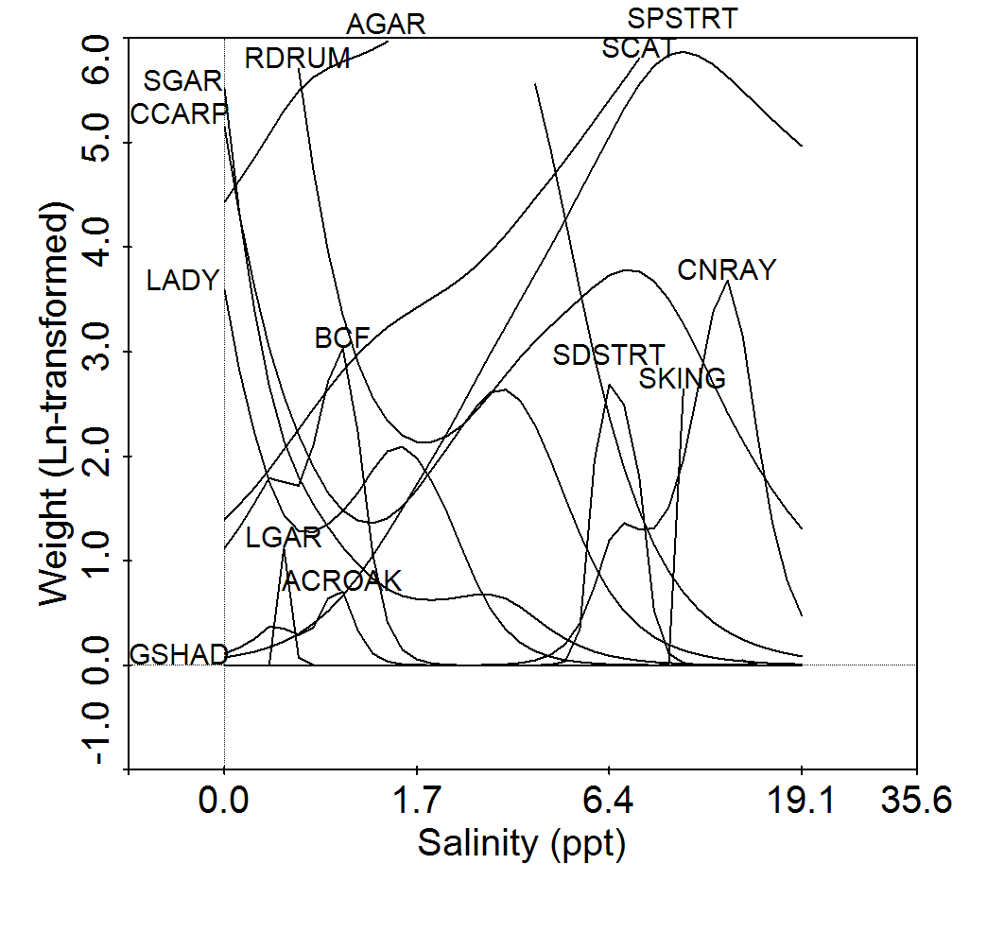

Figure 7. Results of generalized additive models (GAM) showing the optimal salinity conditions for species abundances in the Barataria Estuary (point where species name is). The top graph shows the optimal point on an environmental gradient (CCA axis 1 scores) that accounts for salinity and multivariate community structure. The bottom graph shows the optimal salinity level (ppt) for a species without the influence of multivariate community structure. Only species that were significantly related to the predictor variables are shown (*P*≤0.05). Some species are above the graph frame because their optimal abundances were greater than the y-axis rang shown. This was done to allow the results of all species models to be shown. Catch and salinity data were log(x +1)-transformed prior to analysis. Data are from **inland gill nets sampled April-July 1998-2011**. Abbreviations for species names are explained in Appendix A.

Salinity levels that optimize species abundances: Seines

Species response curves for spring-summer seine samples agreed with the results of the CCA T-value biplots (Figure 8). A host of species had optimal catches (ln[x +1]-transformed) at the highest position on the salinity gradient that comprised the CCA axis 1 scores, including Florida Pompano, Gulf kingfish, Southern kingfish, Striped anchovy, Rough silverside, Striped mullet, White mullet, Banded drum, Spot and Blue crab. Of these species, Florida pompano exhibited the strongest relationship with the salinity gradient. Bay anchovy catch was optimized at a moderately high position on the gradient, while Brown shrimp, Grass shrimp spp., Atlantic croaker, and Gulf menhaden were most abundant at moderate-moderately low salinities. Xanthid mud crab spp. were the only species from seine samples that were optimized in near freshwater conditions along the CCA gradient.

There were some slight differences in the species response curves when using salinity as the predictor variable in the GAMs. Spotted seatrout, White shrimp, Sea catfish and Darter goby catches were found to be optimal at the highest salinities (≥32 ppt). Although Spotted seatrout had a significant positive relationship with salinity from a bivariate standpoint, it did not contribute significantly to community structure (i.e., it was not related to salinity in the CCA). Meanwhile, Inland silverside catch was optimized at the lowest salinity (≤1 ppt), but it also did not contribute significantly to community structure. Also in contrast to the CCA, Xanthid mud crabs were most abundant at 2 ppt, as opposed to freshwater conditions. **This suggests that other factors influence the optimal salinity for juvenile Spotted seatrout, Inland silverside, and mud crabs during spring-summer months (e.g., physical habitat, tidal forcing, prey availability, predation risk, temperature, turbidity).** Other species that had marginally significant response curves to salinity were Sand seatrout, Least Puffer, Brown shrimp, and Grass shrimp spp., Atlantic croaker and Gulf menhaden, which were optimized at a salinity of approximately 6 ppt. Finally, the Bay anchovy had its optimal abundance in spring-summer seine samples at around 9 ppt.

See **Appendix B** for a more generalized, qualitative breakdown of optimal salinities for these species.

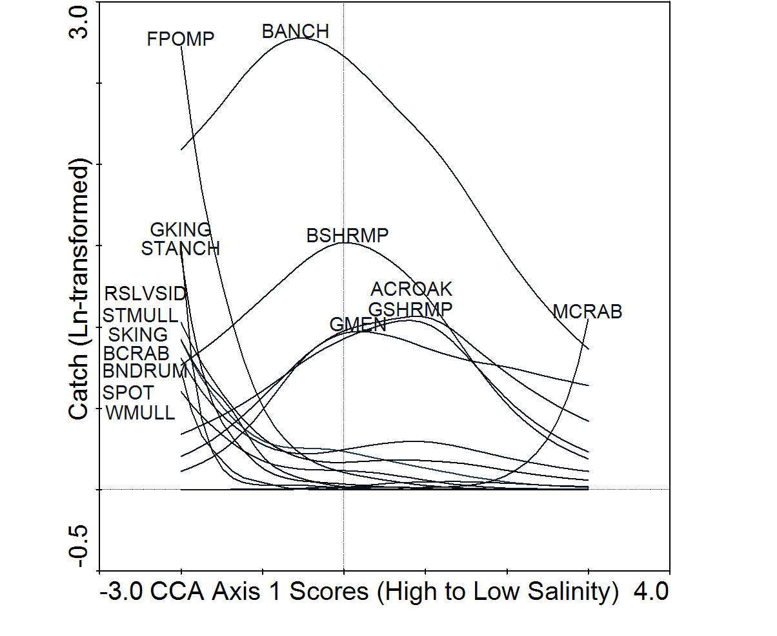

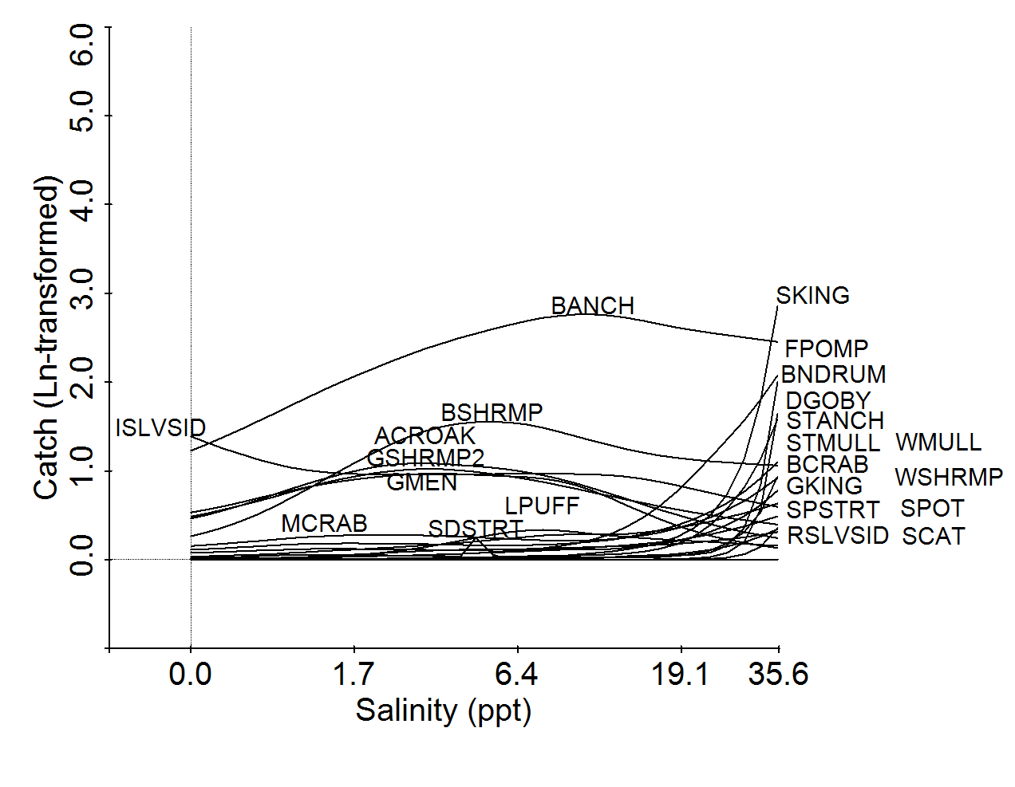

Figure 8. Results of generalized additive models (GAM) showing the optimal salinity conditions for species abundances in the Barataria Estuary (point where species name is). The top graph shows the optimal point on an environmental gradient (CCA axis 1 scores) that accounts for salinity and multivariate community structure. The bottom graph shows the optimal salinity level (ppt) for a species without the influence of multivariate community structure. Only species that were significantly related to the predictor variables are shown (*P*≤0.05). Catch and salinity data were log(x +1)-transformed prior to analysis. Data are from **seines sampled April-July 1991-2011**. Abbreviations for species names are explained in Appendix A.

Salinity levels that optimize species abundances: 16-ft. Trawls

Species response curves using CCA axis 1 scores as the predictor variable in GAMs gave similar results to the CCA T-value biplots (Figure 9). Species that had trawl catches (ln[x+1]-transformed) that were optimized the highest positions along the salinity gradient were the Striped anchovy, Lesser blue crab, and Star drum. Atlantic brief squid was optimal at a moderately high position on the gradient, while Brown shrimp, Bay anchovy, Spot, Least puffer and Bighead searobin were optimized at moderate-moderately low salinities. Species that were most abundant at the lowest end of the salinity gradient were the Blue crab, Atlantic croaker, Sand seatrout, Gafftopsail catfish, White shrimp and Bay whiff. Blue crab and Atlantic croaker showed a very strong relationship towards the freshwater end of the salinity gradient.

There were slight differences between the species response curves using the CCA axis 1 scores as the predictor and those that used salinity as the predictor. Optimal salinity for Gulf menhaden was approximately 2 ppt. Banded drum catch was optimal at 21 ppt, and Atlantic spadefish and Seabob were optimized at 32 ppt. Catches for these species showed no significant relationship to the CCA axis 1 scores. Similar to the other species response curves, however, the species that were optimal at 32 ppt were the Striped anchovy, Lesser blue crab, and Star drum. Atlantic brief squid was optimized at 26 ppt, and Bighead searobin was most abundant at 19 ppt. Brown shrimp, Least Puffer and Spot were had their optimal catches at 6-8 ppt. As was the case with the GAM using CCA axis 1 scores as a predictor, the species that were most abundant in salinities ≤1 ppt were the Blue crab, Atlantic croaker, Sand seatrout, Gafftopsail catfish, White shrimp and Bay whiff.

See **Appendix B** for a more generalized, qualitative breakdown of optimal salinities for these species.

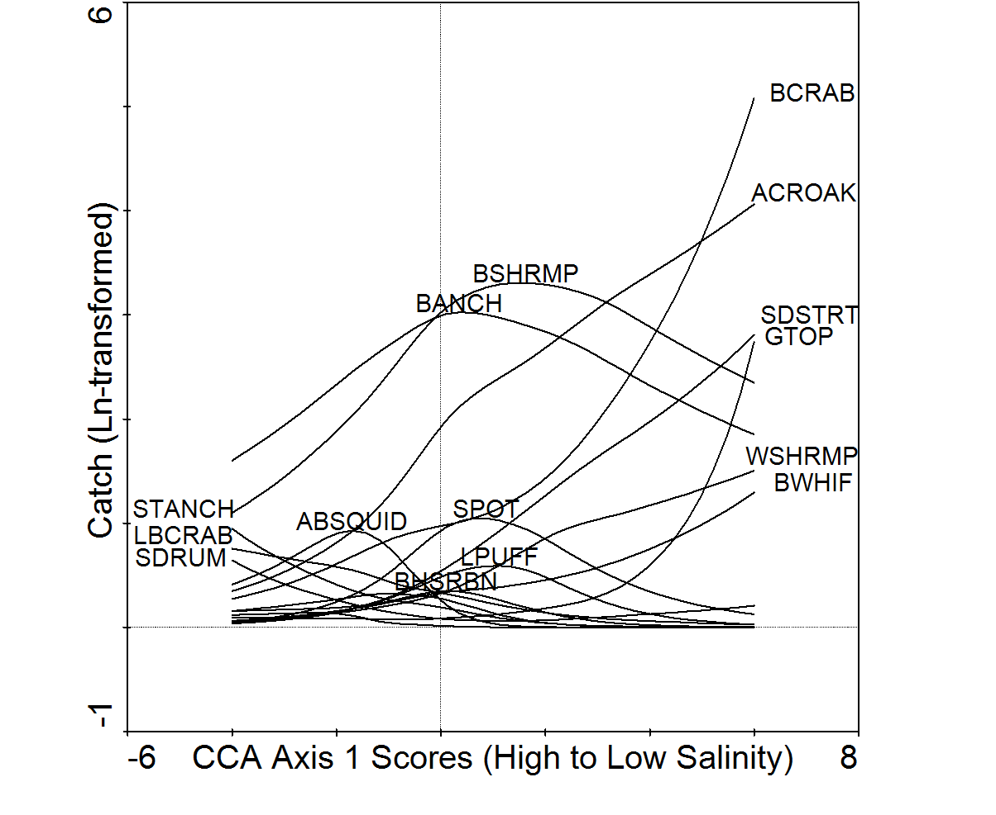 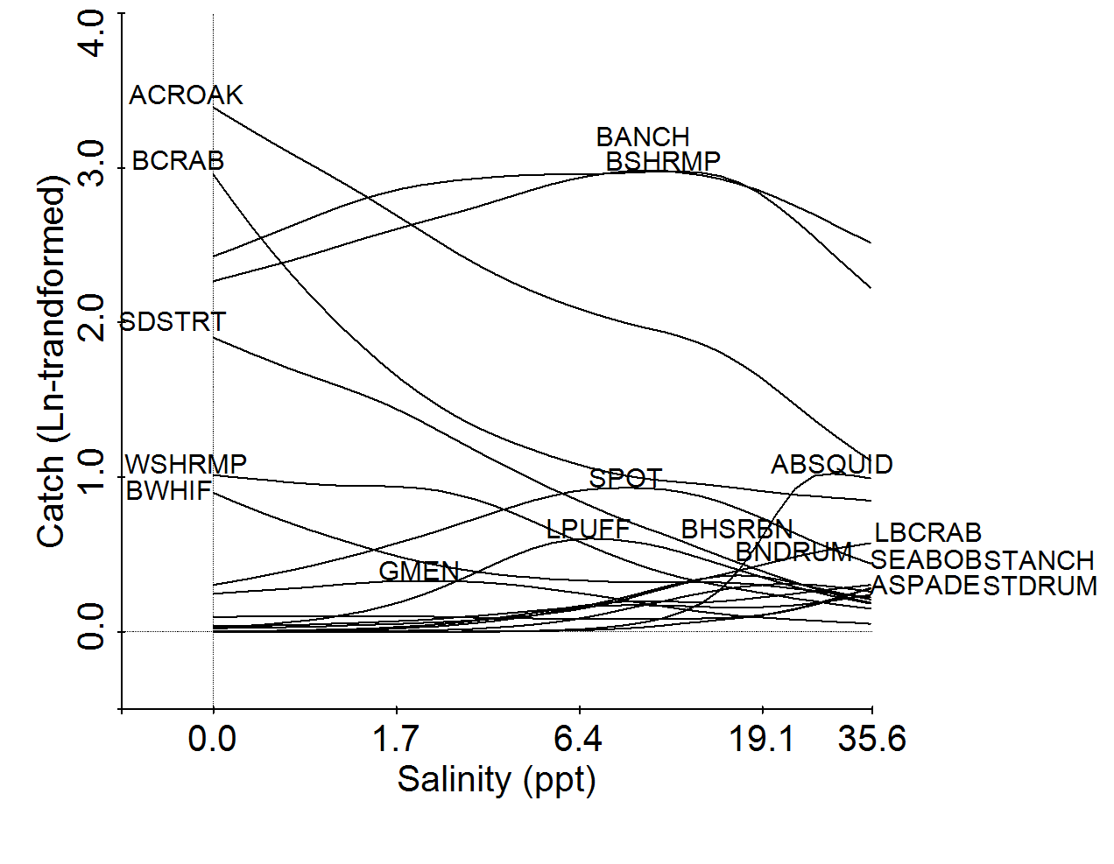

Figure 9. Results of generalized additive models (GAM) showing the optimal salinity conditions for species abundances in the Barataria Estuary (point where species name is). The top graph shows the optimal point on an environmental gradient (CCA axis 1 scores) that accounts for salinity and multivariate community structure. The bottom graph shows the optimal salinity level (ppt) for a species without the influence of multivariate community structure. Only species that were significantly related to the predictor variables are shown (*P*≤0.05). Catch and salinity data were log(x +1)-transformed prior to analysis. Data are from **16-ft. trawls sampled May-July 1991-2011**. Abbreviations for species names are explained in Appendix A.

Salinity levels that optimize biodiversity

For all gear types except inland gill nets, optimal salinity levels for maximum biodiversity were different for Shannon-Wiener diversity and species richness. Richness tended to be optimized at a higher salinity than diversity. For marine gill net samples (Figure 10), species richness was maximized at nearly 35 ppt, while diversity was maximized at a salinity of approximately 14 ppt. Richness and diversity for inland gill nets (Figure 11) had an optimal salinity at approximately 11 ppt, which is the intermediate point in the salinity range (0-20 ppt) for the inland gill net sites. Seine species richness was optimized at 35 ppt, while richness was optimal at 21 ppt (Figure 12). For trawl samples, species richness was optimized at a lower salinity of 12 ppt, and diversity was optimal at a much lower salinity of 4 ppt during spring-summer (Figure 13).

Shannon-Wiener diversity tends to be a more informative index of biodiversity, compared to richness, because it takes into account the evenness of the species abundances. For any given richness value, if one or a few species dominate the species composition of the community, then this dominance will be reflected by lower Shannon-Wiener index values. In contrast, if all species have equal abundances, then Shannon-Wiener values will be higher. In the case of the spring-summer lower Barataria estuary nekton community, Shannon-Wiener diversity tends to be optimal at low or brackish salinities (4-20 ppt). However, the relationship between salinity and diversity is extremely weak. In all gear types examined for this project, as salinity increased, the Shannon-Wiener diversity trend essentially remained a straight line.

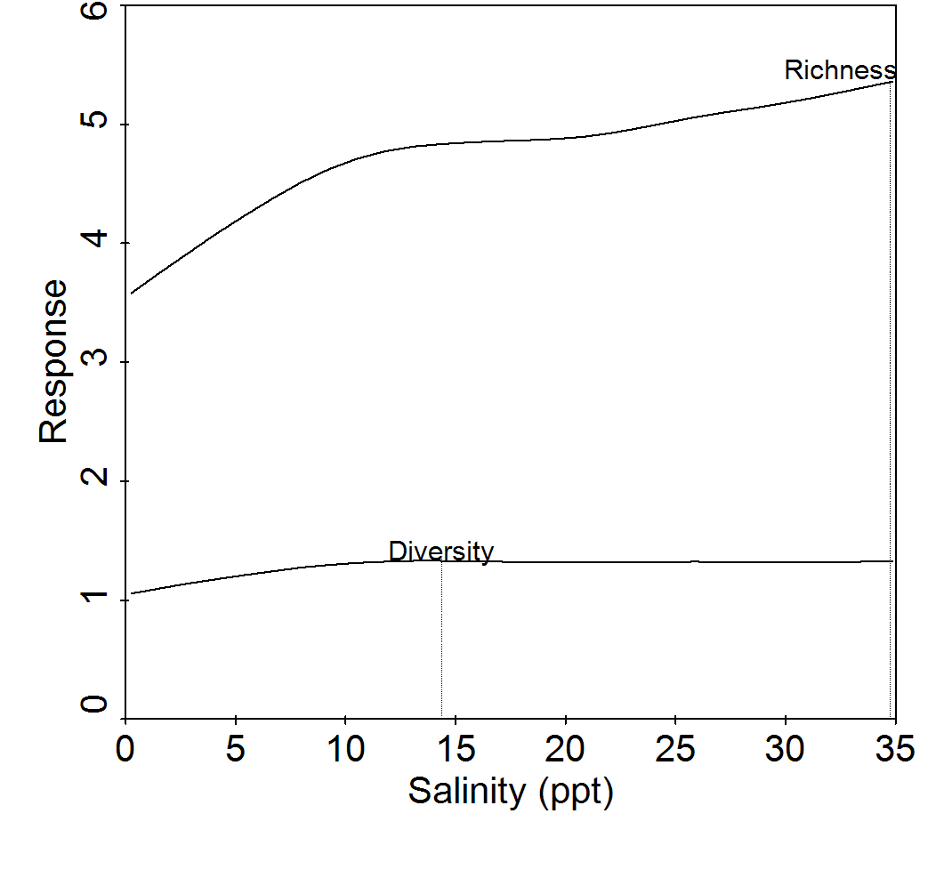

Figure 10. Results of generalized additive models (GAM) showing the salinity level that optimizes nekton biodiversity in the Barataria Estuary (vertical line). Diversity is the Shannon-Wiener uncertainty index, which is unitless, and richness is the number of species. Data are from **marine gill nets sampled during May-July 1991-2011**.

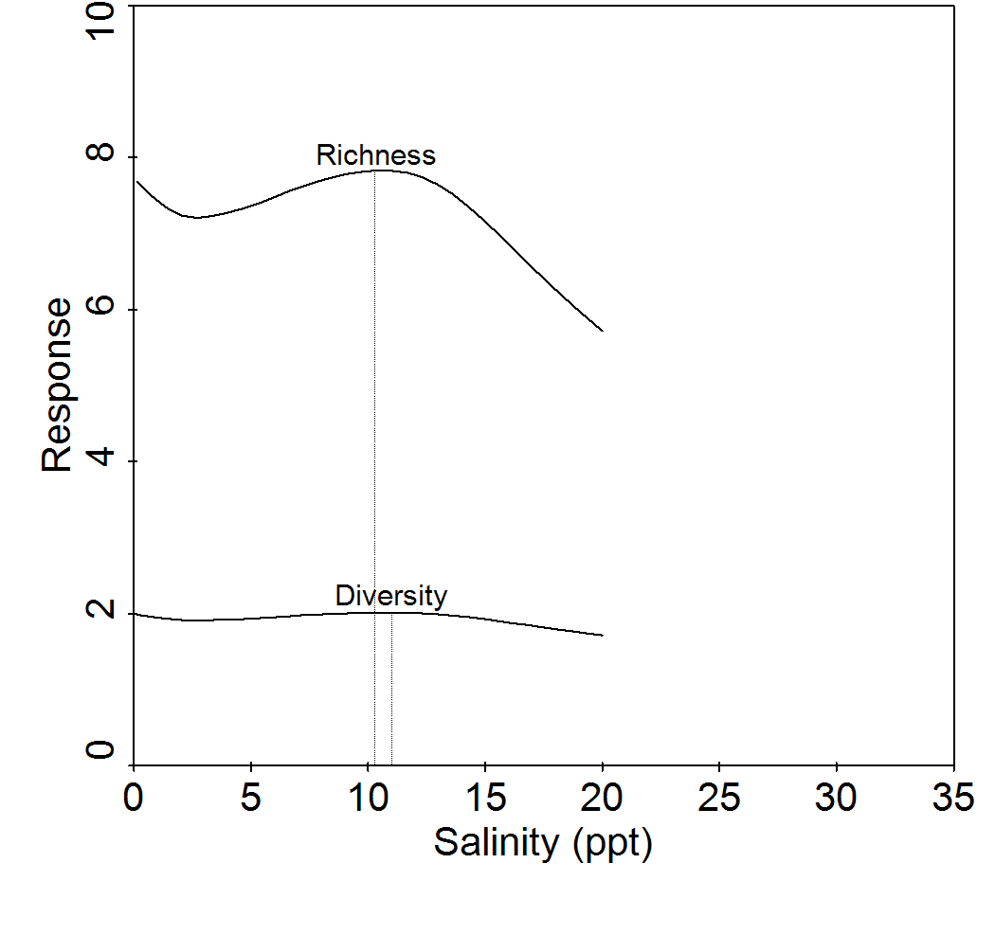

Figure 11. Results of generalized additive models (GAM) showing the salinity level that optimizes nekton biodiversity in the Barataria Estuary (vertical line). Diversity is the Shannon-Wiener uncertainty index, which is unitless, and richness is the number of species. Data are from **inland gill nets sampled during April-July 1998-2011**.

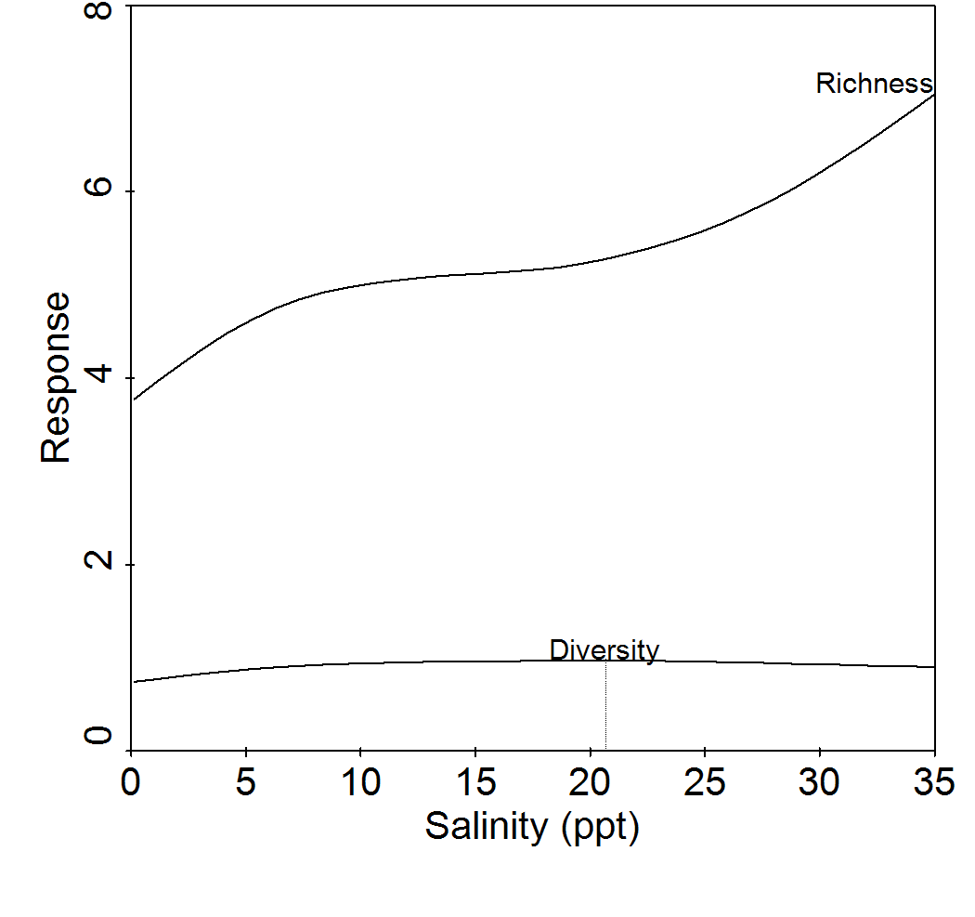

Figure 12. Results of generalized additive models (GAM) showing the salinity level that optimizes nekton biodiversity in the Barataria Estuary (vertical line). Diversity is the Shannon-Wiener uncertainty index, which is unitless, and richness is the number of species. Data are from **seines sampled during April-July 1991-2011**.

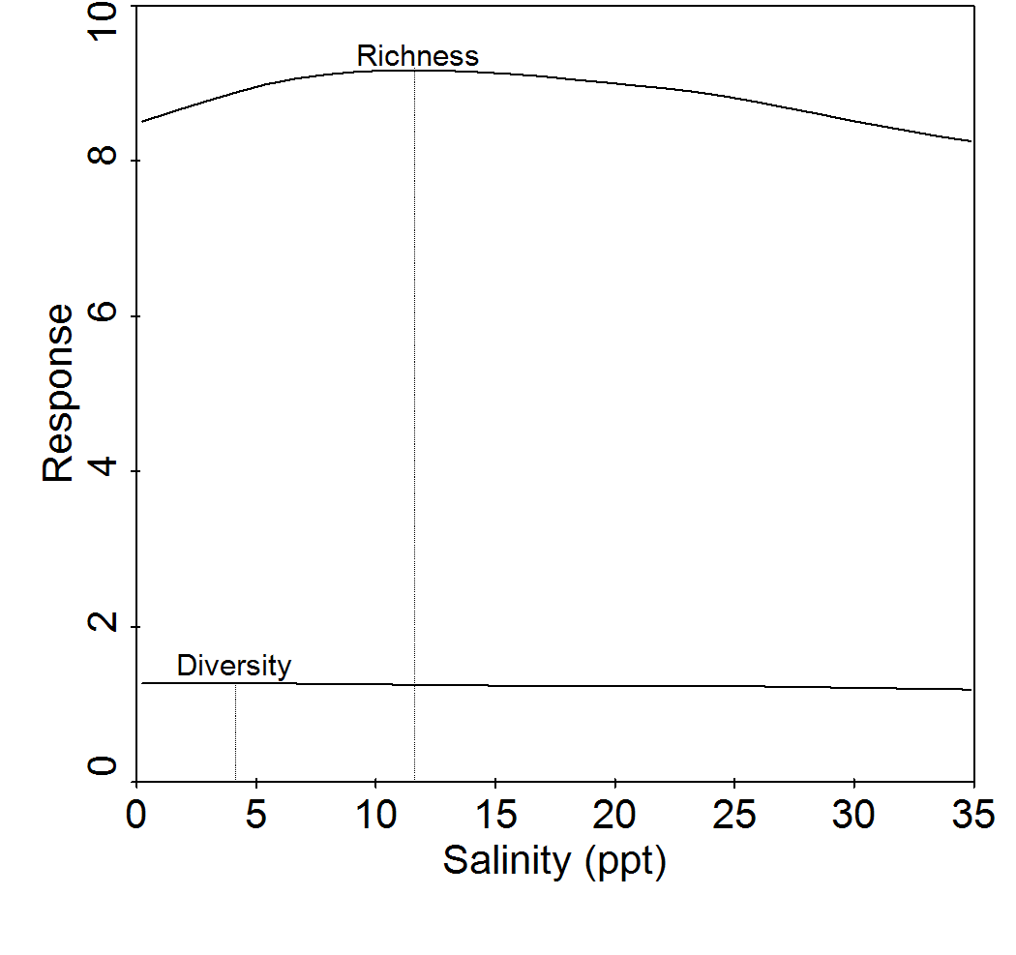

Figure 13. Results of generalized additive models (GAM) showing the salinity level that optimizes nekton biodiversity in the Barataria Estuary (vertical line). Diversity is the Shannon-Wiener uncertainty index, which is unitless, and richness is the number of species. Data are from **16-ft. trawls sampled during May-July 1991-2011**.

Changes in community structure following Davis Pond freshwater diversion

Following the Davis Pond diversion, there were statistically significant shifts in nekton community structure during spring-summer months in the lower Barataria estuary (MRPP; T > 17.0; *P* < 0.0001 for all gear types). However, the strength of the changes in species composition was very weak (MRPP; A ≤ 0.01 for all gear types). These relatively minor but significant changes likely result from having large samples sizes for each gear type (inland gill net samples were excluded from this analysis because there were so few samples for each treatment group). Pairwise comparisons of community structure by year seemed to indicate that the Davis Pond diversion likely had an effect on changes in the marine gill net assemblage (MRPP; T = 28.1; *P* < 0.0001). This is because 40-70% of the comparisons of pre-diversion years versus post-diversion years showed significantly different community structure (MRPP; *P* < 0.05). When only pre-diversion years were compared with each other and post-diversion years compared with each other, 0-30% of the years had significantly different community structure. This was not so much the case with the seine and trawl samples. The number of pre-diversion years that were significantly different from each other, as well as post-diversion years compared to one another, was approximately the same as the number of pre- versus post-diversion comparisons.

A few species were significantly responsible for the observed changes in community structure following the diversion. The species are those on the CCA joint plots (Figures 14-16) that are at the extreme ends of axes 1 and 2, which represent gradients in salinity (axis 1) and turbidity/temperature (axis 2, arrow not shown). Of the three gear types analyzed, marine gill nets showed the most obvious changes in community structure following the diversion at Davis Pond (Figure 14). For example, Channel catfish increased in gill net abundance following the diversion, and was associated with lower salinity and higher turbidity conditions. Atlantic stingray also increased in abundance after the diversion, but this was mostly in habitats with lower turbidity, as opposed to salinity. These two species were the major drivers in the shift in community structure, followed by relatively weaker increases in Alligator gar, Spotted gar and Black drum in low salinity, high turbidity habitats. Conversely, there were slight decreases in Leatherjacket , Silver seatrout, Sand seatrout, Bluefish, Pinfish, Harvestfish, Spanish mackerel, Southern kingfish, Silver perch, Atlantic bumper, Florida pompano, and Gulf butterfish as salinity decreased. However, there was no relationship with changes in turbidity and abundances of these marine species.

There were significant changes in seine community structure following the Davis Pond diversion, but it was primarily due to species composition changes in a small number of samples (notice the post-diversion samples located outside the convex hull that defines the boundary of the pre-diversion samples in Figure 15). Species that tended to drive the relatively small shift in community structure were Mud crabs, which increased in these post-diversion samples, and their abundances were positively correlated decreases in salinity gradient (their species scores are located at the positive extreme of axis 1, which is negatively correlated with salinity). The estuarine residents Rainwater killifish and Naked goby increased as well in the post-diversion samples. Conversely, species that tended to decrease following the diversion were the Florida pompano and White mullet. These two species also showed declines with increasing turbidity (which was positively correlated axis 2, arrow not shown). Striped anchovy, Southern kingfish, Gulf kingfish, and Banded drum also showed a decrease in catch with respect to a decline in salinity in the post-diversion samples, but only minor changes with respect to increasing turbidity.

Finally, there were significant changes in the trawl nekton community in the years after the Davis Pond diversion, but like the seine samples, it was primarily due to species composition changes in a small number of samples (Figure 15). Species that tended to increase after the diversion and were negatively related to the salinity gradient were Grass shrimp spp., and to a lesser extent White shrimp, Gulf menhaden, Sand seatrout, Southern flounder and Hogchoker. Those that decreased after the diversion were Atlantic brief squid, Offshore tonguefish, Mantis shrimp, and to a lesser extent, Seabob, Iridescent swimming crab, and Roughneck shrimp. Unlike turbidity in the gill net and seine CCA, temperature was negatively correlated with axis 2 (arrow not shown), but the strength of the relationship was very weak.

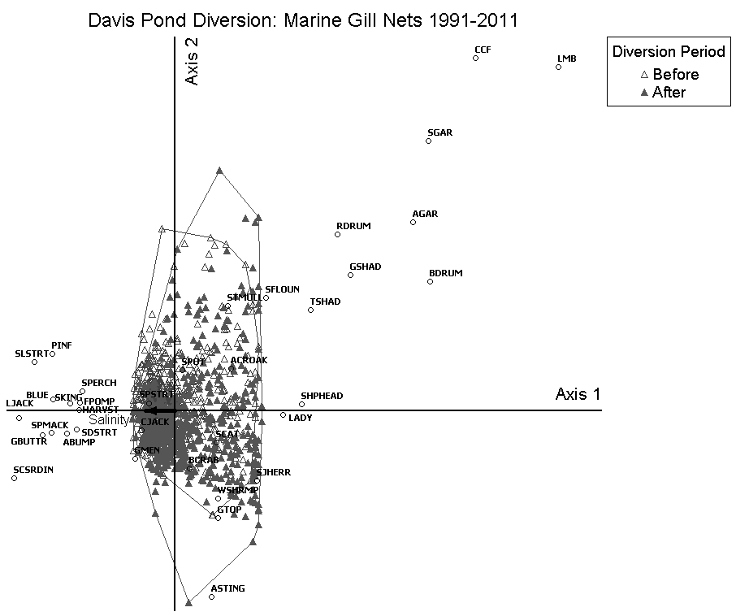

Figure 14. A CCA joint plot with convex hulls outlining the distribution of sample scores on axes 1 and 2. The two distributions shown (open and closed triangles) are samples taken before and after the operation of the Davis Pond freshwater diversion structure (March 2002) in the upper Barataria estuary. Salinity was the independent variable (black arrow). Samples were taken twice per month during May-July each year.

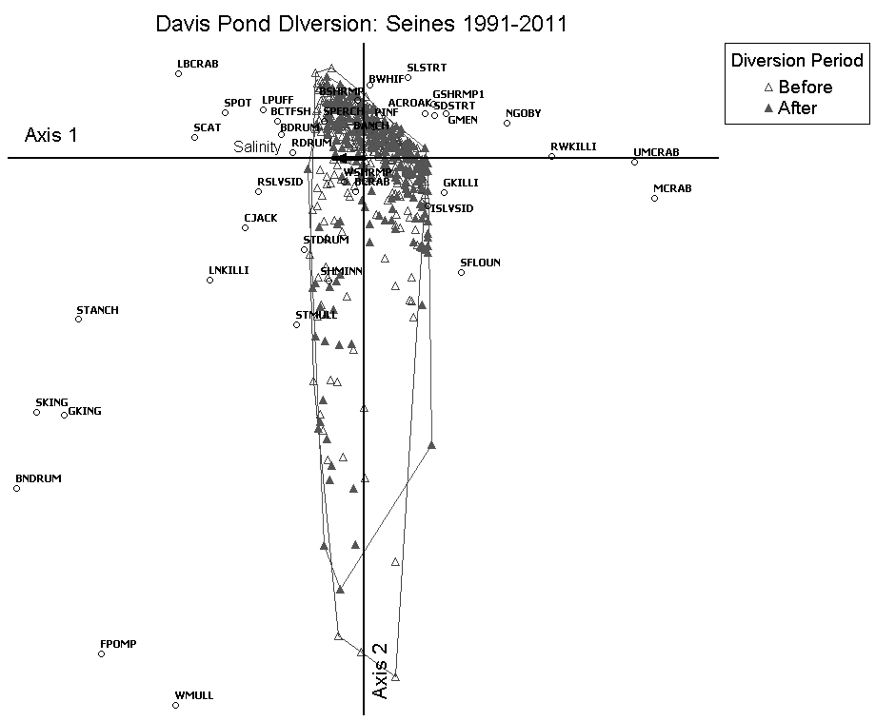

Figure 15. A CCA joint plot with convex hulls outlining the distribution of sample scores on axes 1 and 2. The two distributions shown (open and closed triangles) are samples taken before and after the operation of the Davis Pond freshwater diversion structure (March 2002) in the upper Barataria estuary. Salinity was the independent variable (black arrow). Samples were taken monthly During April-July each year.

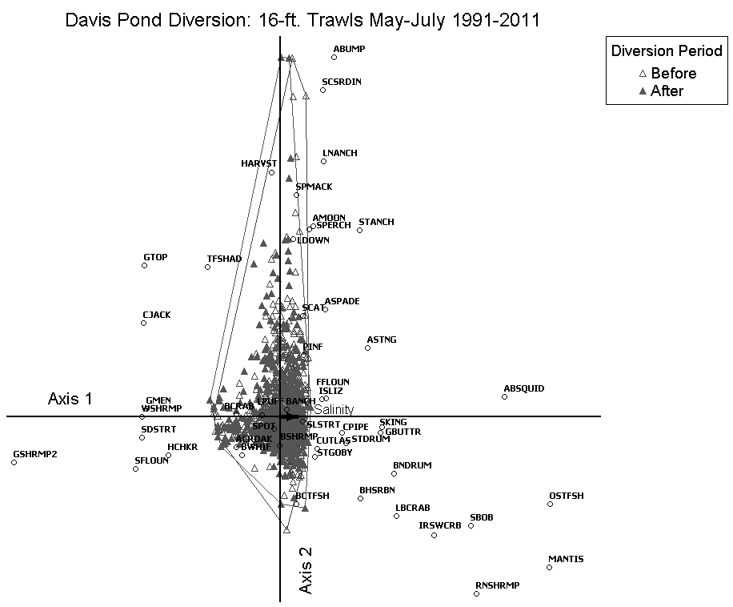

Figure 16. A CCA joint plot with convex hulls outlining the distribution of sample scores on axes 1 and 2. The two distributions shown (open and closed triangles) are samples taken before and after the operation of the Davis Pond freshwater diversion structure (March 2002) in the upper Barataria estuary. Salinity was the independent variable (black arrow).

*Fall months*

Relationship between salinity and nekton community structure: Marine gill nets

A total of 706 marine gill net samples were analyzed for the 1991-2011 fall periods, during which 18,192 individuals from 73 species were collected (Table 4). Of these species, 36 occurred frequently enough (≥1% of samples) to be included in the CCA (Figure 17). Scores for the first canonical axis were statistically significant (TI = 6.2; EV = 0.17; F = 19.9; *P* = 0.001). Salinity had a strong negative correlation with axis 1 (SEC = -0.58; %CV = 63.4).

The T-value biplot of the fall marine gill net CCA (Figure 17) is similar to the biplot for spring-summer months. Most species with abundances optimized in higher salinity habitats were predators or benthic invertivores (8 out of 11). These were Bluefish, Atlantic bumper, Southern kingfish, Spanish mackerel, Florida pompano, Gulf butterfish, Harvestfish, and Sand seatrout. One of the differences from the spring-summer biplot is that Spotted seatrout abundance is related to lower salinity habitats in the fall, and Silver seatrout abundance does not show a relationship to salinity during these months. Two omnivorous species were associated positively with salinity, which were the Gafftopsail catfish and Sea catfish. One planktivorous species was optimized in higher salinity conditions, the Gulf menhaden.

Commercially and recreationally important species showed a trend in abundance towards lower salinity habitats. Of these, most were predators or benthic invertivores (7 out of 11), and they included the Spotted seatrout, Red drum, Black drum, Sheepshead, Largemouth bass, Alligator gar, and Spotted gar. The omnivorous Blue crab, Striped mullet and Channel catfish were also most abundant in fresher waters during the fall. Lastly, the planktivorous Gizzard shad showed a positive relationship to lower salinity levels.

Table 4. Summaries of the number of samples, individual organisms, and number of species taken during fall months by LDWF (1991-2011) in the lower Barataria Basin. The minimum, maximum and mean surface salinities (ppt) are shown for each gear type.

|  |  |  |  |  |  |  |
| --- | --- | --- | --- | --- | --- | --- |
| Gear | Samples | No. organisms | No. species collected | Min. Salinity | Max. Salinity | Mean Salinity |
| Marine Gill Net | 706 | 18,192 | 73 | 0 | 34.5 | 17.0 |
| Inland Gill Net | 55 | 5,377 | 25 | 0 | 23.8 | 5.8 |
| Seine | 704 | 96,752 | 126 | 0 | 36.3 | 12.6 |
| 16-ft. Trawl | 965 | 74,671 | 140 | 0 | 36.6 | 23.1 |

Table 5. Minimum, maximum and mean total lengths (mm) of commercially and recreationally important nekton species sampled from various LDWF gear types during September-December 1991-2011 in the lower Barataria estuary.

|  |  |  |  |  |
| --- | --- | --- | --- | --- |
| Gear | Species | Minimum | Maximum | Mean |
| Marine Gill Net | Atlantic croaker | 134 | 348 | 189 |
|  | Blue crab | 29 | 203 | 147 |
|  | Brown shrimp | 125 | 142 | 134 |
|  | Gulf menhaden | 74 | 287 | 180 |
|  | Largemouth bass | 179 | 421 | 269 |
|  | Red drum | 219 | 1020 | 423 |
|  | Southern flounder | 225 | 380 | 301 |
|  | Spotted seatrout | 135 | 511 | 318 |
|  | Striped mullet | 109 | 422 | 262 |
|  | White shrimp | 85 | 178 | 134 |
| Inland Gill Net | Atlantic croaker | 162 | 280 | 232 |
|  | Blue crab | 128 | 128 | 128 |
|  | Brown shrimp | -- | -- | -- |
|  | Gulf menhaden | 106 | 282 | 205 |
|  | Largemouth bass | 395 | 413 | 404 |
|  | Red drum | 136 | 1065 | 611 |
|  | Southern flounder | 262 | 553 | 411 |
|  | Spotted seatrout | 178 | 607 | 368 |
|  | Striped mullet | 355 | 355 | 355 |
|  | White shrimp | -- | -- | -- |
| Seine | Atlantic croaker | 7 | 295 | 43 |
|  | Blue crab | 2 | 180 | 23 |
|  | Brown shrimp | 15 | 141 | 58 |
|  | Gulf menhaden | 17 | 216 | 98 |
|  | Largemouth bass | 20 | 358 | 246 |
|  | Red drum | 7 | 723 | 81 |
|  | Southern flounder | 16 | 315 | 86 |
|  | Spotted seatrout | 10 | 332 | 81 |
|  | Striped mullet | 16 | 490 | 99 |
|  | White shrimp | 5 | 188 | 58 |
| 16-ft. Trawl | Atlantic croaker | 5 | 235 | 83 |
|  | Blue crab | 0 | 215 | 77 |
|  | Brown shrimp | 15 | 150 | 77 |
|  | Gulf menhaden | 20 | 225 | 97 |
|  | Largemouth bass | 145 | 145 | 145 |
|  | Red drum | 15 | 455 | 139 |
|  | Southern flounder | 40 | 425 | 127 |
|  | Spotted seatrout | 10 | 325 | 123 |
|  | Striped mullet | 25 | 315 | 142 |
|  | White shrimp | 5 | 180 | 87 |
| Electrofishing | Atlantic croaker | 162 | 241 | 202 |
|  | Blue crab | -- | -- | -- |
|  | Brown shrimp | -- | -- | -- |
|  | Gulf menhaden | 51 | 120 | 97 |
|  | Largemouth bass | 83 | 365 | 186 |
|  | Red drum | 254 | 757 | 474 |
|  | Southern flounder | 203 | 473 | 348 |
|  | Spotted seatrout | 64 | 377 | 148 |
|  | Striped mullet | 76 | 352 | 168 |
|  | White shrimp | -- | -- | -- |

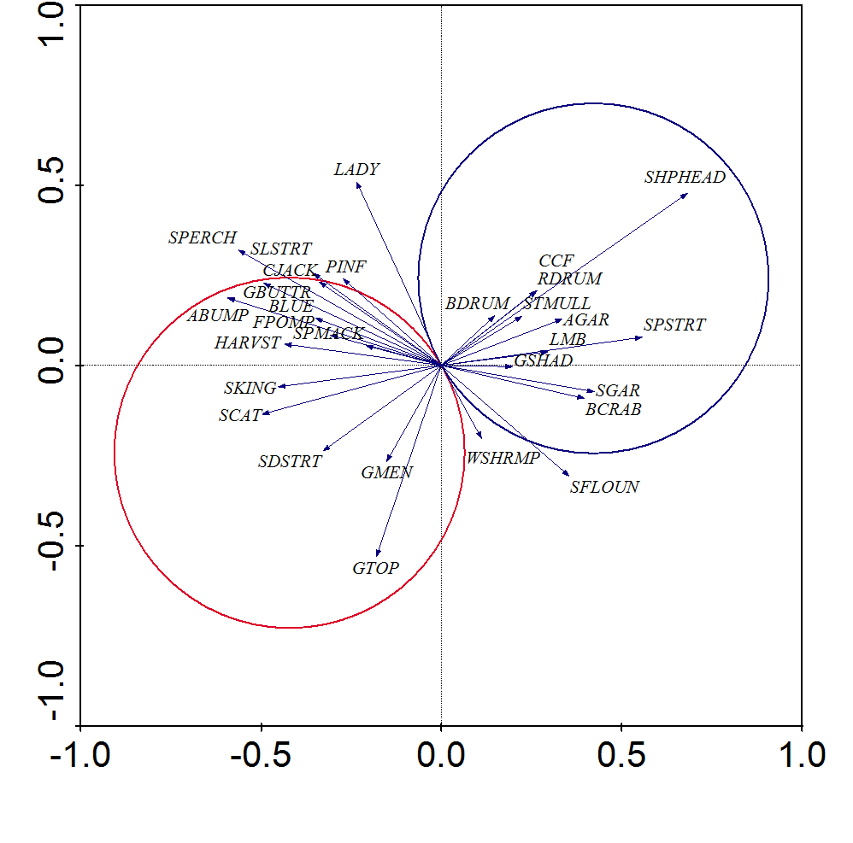

Figure 17. T-value biplots from a canonical correspondence analysis (CCA) depicting statistically significant (T>2.0, *P*≤0.05) relationships between species abundances and salinity from LDWF **marine gill nets sampled October-December 1991-2011**. Magnitude and direction of salinity-species relationships are represented by arrowheads. Arrows that point in the same direction and are close to each other represent species whose abundance trends are similar to each other. Only arrows within the van Dobben circles are statistically significant. Species in the red circle are those that are related positively to salinity, while those in the blue circle exhibit a negative relationship. T- and *P*-values were calculated from 1,000 randomized Monte Carlo simulations. Species abbreviations are explained in Appendix A.

Relationship between salinity and nekton community structure: Inland gill nets

A total of 55 inland gill net samples were analyzed for the 1998-2011 fall periods, during which 5,377 individuals from 25 species were collected. Of these species, 21 occurred frequently enough (≥1% of samples) to be included in the CCA (Figure 17). Scores for the first canonical axis were statistically significant (TI = 1.6; EV = 0.16; F = 5.6; *P* = 0.001). Axis 1 (which explains most of the variation in the community data) was correlated with water temperature (SEC = -0.71; %CV = 58.1). Salinity had its strongest correlation with axis 2 (SEC = -0.52; %CV = 29.3). Together, these two axes explained a cumulative 87.4% of the community data. Small sample size for this gear type may have caused the relative weakness in the explanatory power of salinity.

Only seven species showed statistically significant correlations with salinity (Figure 18) during fall inland gill net sampling. Sand seatrout, Sea catfish, and Gulf menhaden abundances were optimized in more saline habitats. Flathead catfish, Blue catfish, Red drum, and Common carp were most abundant in lower salinity areas.

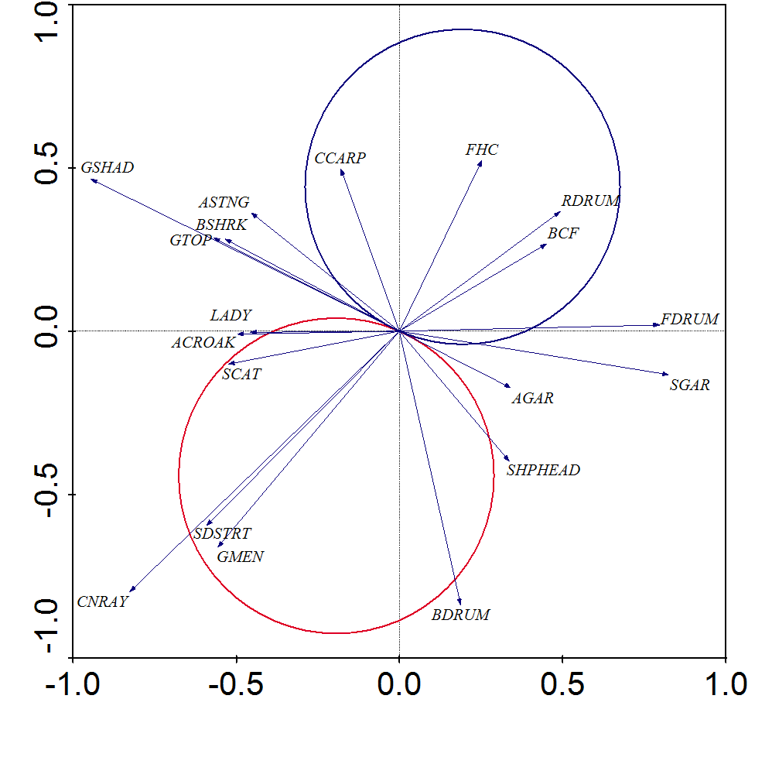

Figure 18. T-value biplots from a canonical correspondence analysis (CCA) depicting statistically significant (T>2.0, *P*≤0.05) relationships between species abundances and salinity from LDWF **inland gill nets sampled September-December 1998-2011**. Magnitude and direction of salinity-species relationships are represented by arrowheads. Arrows that point in the same direction and are close to each other represent species whose abundance trends are similar to each other. Only arrows within the van Dobben circles are statistically significant. Species in the red circle are those that are related positively to salinity, while those in the blue circle exhibit a negative relationship. T- and *P*-values were calculated from 1,000 randomized Monte Carlo simulations. Species abbreviations are explained in Appendix A.

Relationship between salinity and nekton community structure: Seines

A total of 704 seine samples were analyzed for the 1991-2011 fall periods, during which 96,752 individuals from 126 species were collected. Of these species, 43 occurred frequently enough (≥1% of samples) to be included in the CCA (Figure 17). Scores for the first canonical axis were statistically significant (TI = 9.0; EV = 0.13; F = 10.1; *P* = 0.001). Axis 1 (which explains most of the variation in the community data) was correlated with water temperature (SEC = -0.48; %CV = 51.3). Salinity had its strongest correlation with axis 2 (SEC = -0.39; %CV = 36.9). Together, these two axes explained a cumulative 88.2% of the community data.

Most of the species that showed a positive relationship with salinity were benthic or epipelagic invertivores (8 out of 10; Figure 19). These species included Red drum, Florida Pompano, Spot, Bay whiff, Least puffer, Southern kingfish, Longnose killifish, and Rough silverside (*Membras martinica*). There were two omnivores that were optimized in higher salinity habitats, the Sea catfish and Striped mullet.

Species associated with low salinity environments included four invertivores, the Naked goby, Sailfin molly, Xanthid mud crabs, and Sheepshead minnow (*Cyprinodon variegates*). The omnivorous Blue crab and the planktivorous Bay anchovy were also related to fresher habitats during fall seine samples.

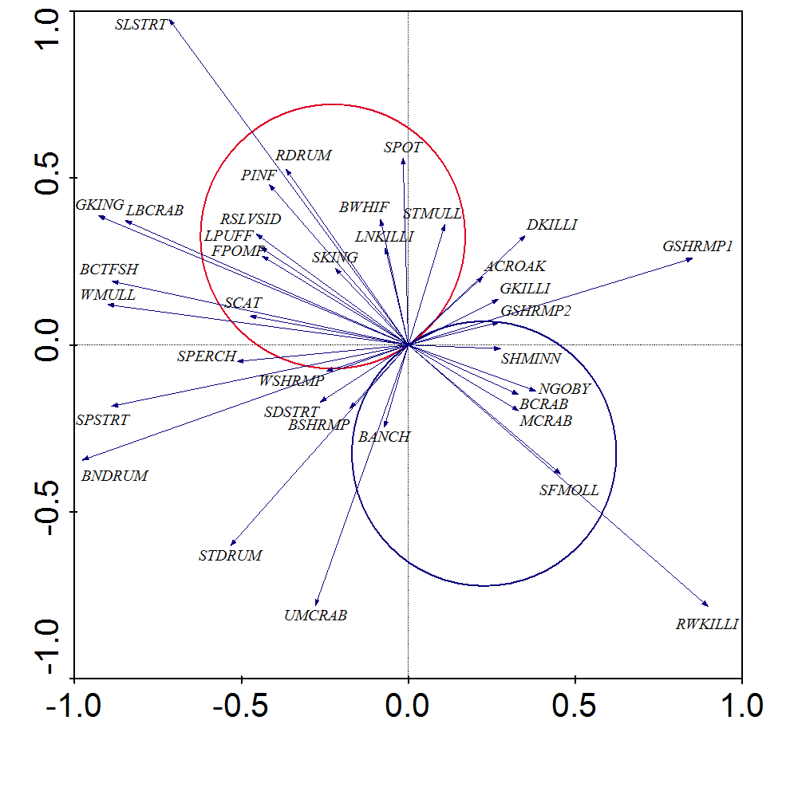

Figure 19. T-value biplots from a canonical correspondence analysis (CCA) depicting statistically significant (T>2.0, *P*≤0.05) relationships between species abundances and salinity from LDWF **seines sampled September-December 1991-2011**. Magnitude and direction of salinity-species relationships are represented by arrowheads. Arrows that point in the same direction and are close to each other represent species whose abundance trends are similar to each other. Only arrows within the van Dobben circles are statistically significant. Species in the red circle are those that are related positively to salinity, while those in the blue circle exhibit a negative relationship. T- and *P*-values were calculated from 1,000 randomized Monte Carlo simulations. Species abbreviations are explained in Appendix A.

Relationship between salinity and nekton community structure: 16-ft. Trawls

A total of 965 trawl samples were analyzed for the 1991-2011 fall periods, during which 74,671 individuals from 140 species were collected. Of these species, 60 occurred frequently enough (≥1% of samples) to be included in the CCA (Figure 17). Scores for the first canonical axis were statistically significant (TI = 4.7; EV = 0.10; F = 20.6; *P* = 0.001). Axis 1 (which explains most of the variation in the community data) was correlated with water temperature (SEC = -0.57; %CV = 55.7). Salinity had its strongest correlation with axis 2 (SEC = -0.48; %CV = 32.1). Together, these two axes explained a cumulative 87.8% of the community data.

Most of the species from fall trawl samples that are associated positively with salinity are predators or benthic invertivores (10 out of 13). These species include the Gulf butterfish, Banded drum, Star drum, Silver seatrout, Silver perch, Mantis shrimp, Atlantic brief squid, Atlantic Cutlassfish (*Trichiurus lepturus*), Southern hake (*Merluccius australis*), and the Iridescent swimming crab (*Portunus gibbesii*). The remaining three species that had optimal abundances in higher salinity waters were the omnivores Seabob, Roughneck shrimp, and Lesser rock shrimp (*Sicyonia dorsalis*).

Proportionately fewer species that were associated with low salinity habitats were predators or benthic invertivores (7 out of 15) in favor of more omnivores and planktivores. Four sciaenid predator-invertivore species were related to lower salinity in the fall, including Spotted seatrout, Sand seatrout, Spot, and Atlantic croaker. The other three predator-invertivore species were flatfishes, specifically Bay whiff, Hogchoker and Blackcheek tonguefish (*Symphurus plagiusa*). Omnivores that were most abundant in low salinity waters were Gafftopsail catfish, Blue crab, Pink shrimp, Grass shrimp spp., and Brown shrimp (*Penaeus aztecus*). Three planktivores were optimized in low salinity conditions, including Gulf menhaden, Bay anchovy and Threadfin shad.

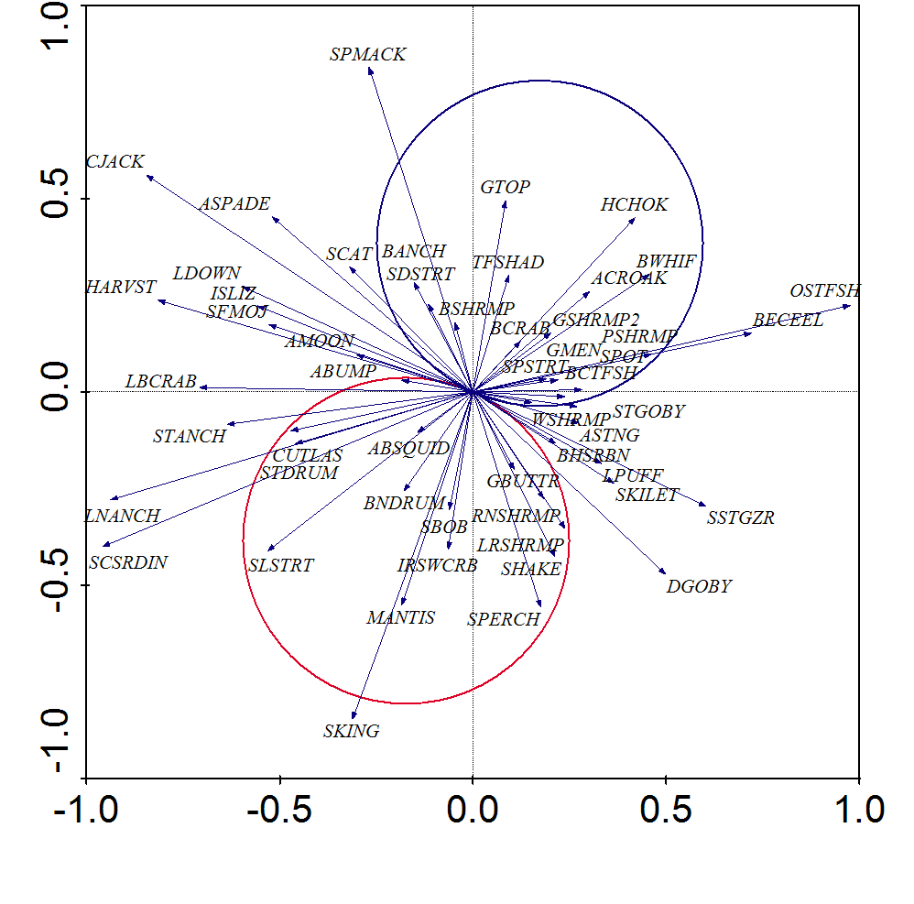

Figure 20. T-value biplots from a canonical correspondence analysis (CCA) depicting statistically significant (T>2.0, *P*≤0.05) relationships between species abundances and salinity from LDWF **16-ft. trawls sampled October-December 1991-2011**. Magnitude and direction of salinity-species relationships are represented by arrowheads. Arrows that point in the same direction and are close to each other represent species whose abundance trends are similar to each other. Only arrows within the van Dobben circles are statistically significant. Species in the red circle are those that are related positively to salinity, while those in the blue circle exhibit a negative relationship. T- and *P*-values were calculated from 1,000 randomized Monte Carlo simulations. Species abbreviations are explained in Appendix A.

Salinity levels that optimize species abundances: Marine gill nets

Species response curves for fall marine gill net samples yielded a wide diversity of optimal salinities for various species (Figure 21). Unlike the spring-summer CCA curve, temperature was the strongest relationship to community structure, followed by salinity. These two variables helped define the CCA axis 1 gradient, which was used as a predictor variable to generate the species response curves. Gulf butterfish and Crevalle jack were most abundant at the highest end of the temperature-salinity gradient. Spanish mackerel and Pinfish were optimized at the moderately high portion of the gradient. Species that were optimal at moderate levels of the temperature-salinity gradient were Gulf menhaden, Spotted seatrout, White shrimp, Spot, Sea catfish, and Atlantic croaker. At the moderately low level of the gradient, Striped mullet, Gizzard shad and optimized. Finally, Blue crab and Black drum were optimized at the freshest and coolest conditions along the gradient during the fall months.

The GAMs using actual salinity values as the predictor variable yielded a variety of species response curves (Figure 21), and they tended to agree with the results from curves generated from the multivariate predictor variable. Bluefish, Florida Pompano, and Southern kingfish had optimal abundances at a salinity of 32 ppt. Sea catfish, Spanish mackerel, and Sand seatrout were optimized at 19-21 ppt. Gulf menhaden was most abundant at approximately 15 ppt. White shrimp and Spotted seatrout were optimized at 6-7 ppt. Gizzard shad was optimized at 5 ppt, while Red drum, Blue crab, and Striped mullet were at their most abundant at 1 ppt. Finally, the salinity for Black drum was at 0 ppt, and it showed a very strong negative relationship with salinity. Gulf menhaden and Spotted seatrout also had relatively strong association with brackish waters.

See **Appendix C** for a more generalized, qualitative breakdown of optimal salinities for these species.

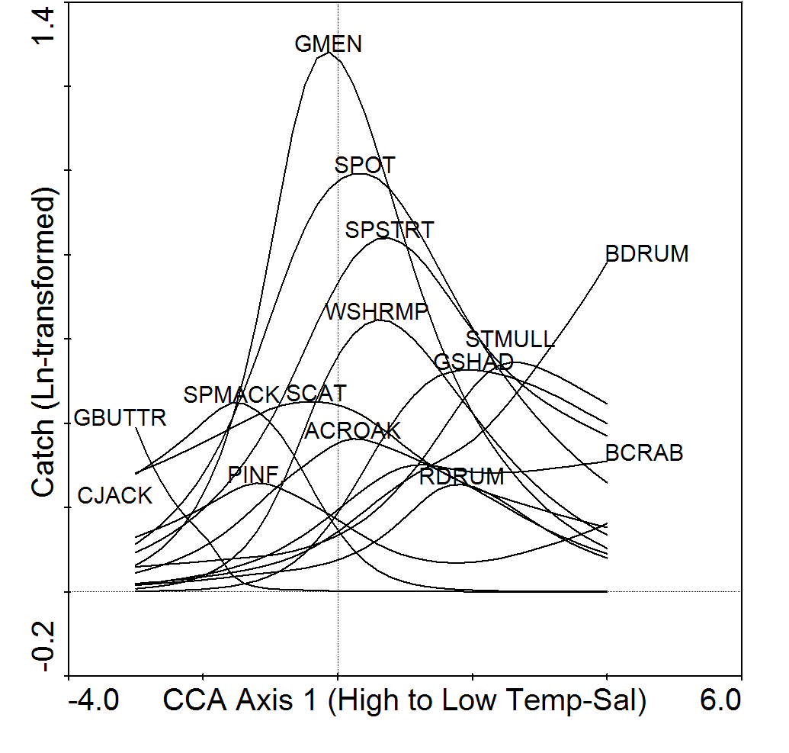

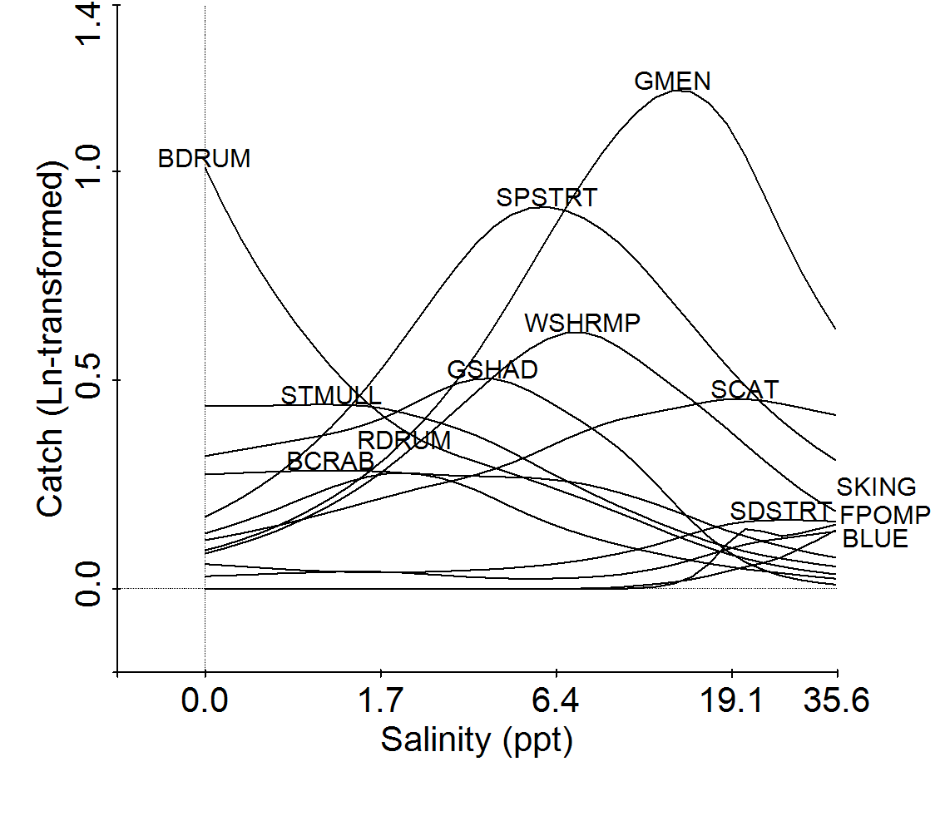

Figure 21. Results of generalized additive models (GAM) showing the optimal salinity conditions for species abundances in the Barataria Estuary (point where species name is). The top graph shows the optimal point on an environmental gradient (CCA axis 1 scores) that accounts for salinity and multivariate community structure. The bottom graph shows the optimal salinity level (ppt) for a species without the influence of multivariate community structure. Only species that were significantly related to the predictor variables are shown (*P*≤0.05). Catch and salinity data were log(x +1)-transformed prior to analysis. Data are from **marine gill nets sampled October-December 1991-2011**. Abbreviations for species names are explained in Appendix A.

Salinity levels that optimize species abundances: Inland gill nets

Temperature was the most important variable that influenced community structure for inland gill net fall samples (correlated with CCA axis 1). Salinity was the second most important variable in fall, and was correlated with axis 2. There were some similarities observed from the inland gill net and the marine gill net samples. For example, Spotted seatrout and Atlantic croaker were optimized at the moderate part of the salinity gradient, while Sea catfish was optimal at moderately high salinities. Red drum and Gizzard shad were optimized at moderately low end of the salinity gradient. Species that were optimized at near freshwater conditions were the Flathead catfish, Common carp, Southern flounder, and Sheepshead. Species optimized at the moderately low portion of the salinity gradient were the Alligator gar, Bull shark, and Gafftopsail catfish. Freshwater drum, Blue catfish, Gulf menhaden, Sand seatrout, and Ladyfish were optimized at moderate levels of the salinity gradient. Finally, Atlantic stingray was most abundant along the high end of the salinity gradient.

Species response curves for inland gill net samples were all in the general form of nonlinear peak curves. The GAMs suggested that Cownose ray and Sand seatrout abundances were optimized at 19-20 ppt. Sea catfish was optimized at 15 ppt, Gulf menhaden was optimal at 5 ppt, and Spotted seatrout was optimal at 4 ppt. Flathead catfish and Blue catfish abundances were optimal at salinities < 1 ppt.

See **Appendix C** for a more generalized, qualitative breakdown of optimal salinities for these species.

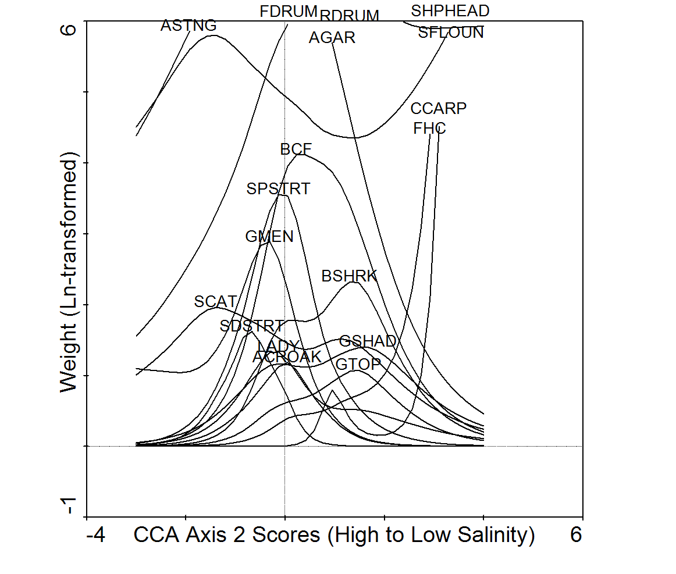

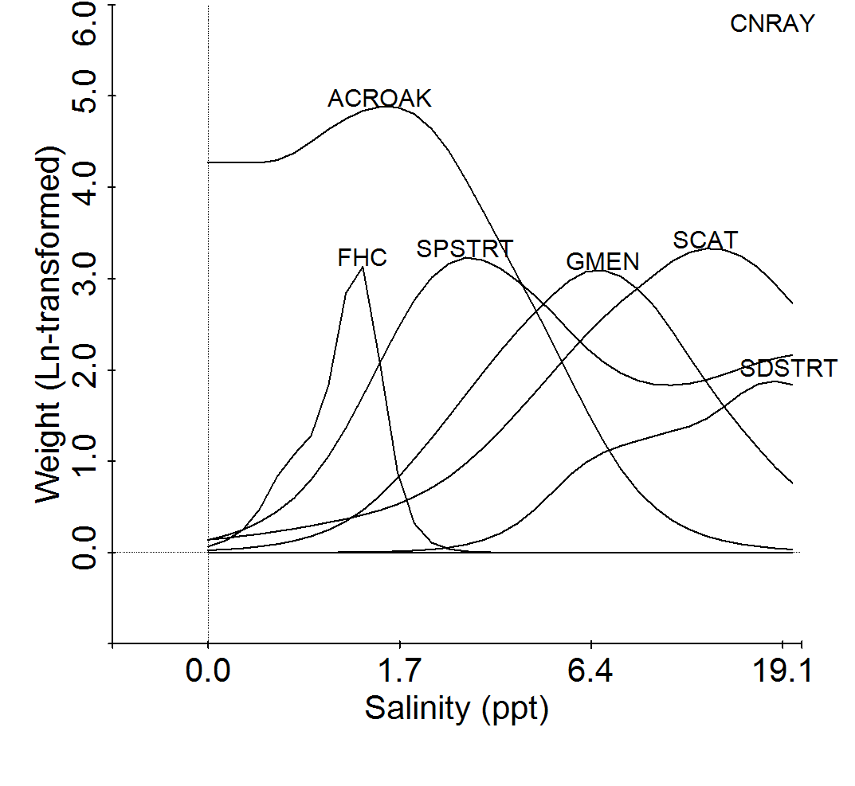

Figure 22. Results of generalized additive models (GAM) showing the optimal salinity conditions for species abundances in the Barataria Estuary (point where species name is). The top graph shows the optimal point on an environmental gradient (CCA axis 1 scores) that accounts for salinity and multivariate community structure. The bottom graph shows the optimal salinity level (ppt) for a species without the influence of multivariate community structure. Only species that were significantly related to the predictor variables are shown (*P*≤0.05). Weight and salinity data were log(x +1)-transformed prior to analysis. Data are from **inland gill nets sampled September-December 1998-2011**. Abbreviations for species names are explained in Appendix A.

Salinity levels that optimize species abundances: Seines

Species response curves for fall seine samples were generated using CCA axis 1 scores, which was a gradient that was defined primarily by temperature, followed by salinity. Species trhat were most abundant at high temperatures and salinities were the Gulf kingfish, Southern kingfish, and Florida pompano. Brown shrimp and White shrimp were optimized at moderately high levels on the temperature-salinity gradient. Bay anchovy and Rough silverside were most abundant at moderate temperatures and salinities, followed by Grass shrimp spp., Sheepshead minnow, Blue crab, Naked goby and Atlantic croaker at moderately low temperatures and salinities. Lastly, Inland silverside, Gulf killifish, and Spot abundances were optimal at low temperatures and salinities.

Species response curves for fall seine samples were consistent with the CCA T-value biplots (Figure 23). Species that had optimal catches at 32 ppt were the Southern kingfish, White mullet, Striped mullet, Silver perch, Florida pompano, and Spot. White shrimp catch was optimized at 15 ppt during fall, while, Rough silverside and Spotted seatrout were optimal at salinities of 11 ppt. Brown shrimp was most abundant at 7 ppt. Bay anchovy, Inland silverside, Blue crab, Sailfin molly, Gulf killifish and Naked goby catches were optimized at 3-4 ppt. Finally, Grass shrimp spp. and Sheepshead minnow abundances were optimal at near freshwater conditions (<1 ppt) during fall.

See **Appendix C** for a more generalized, qualitative breakdown of optimal salinities for these species.

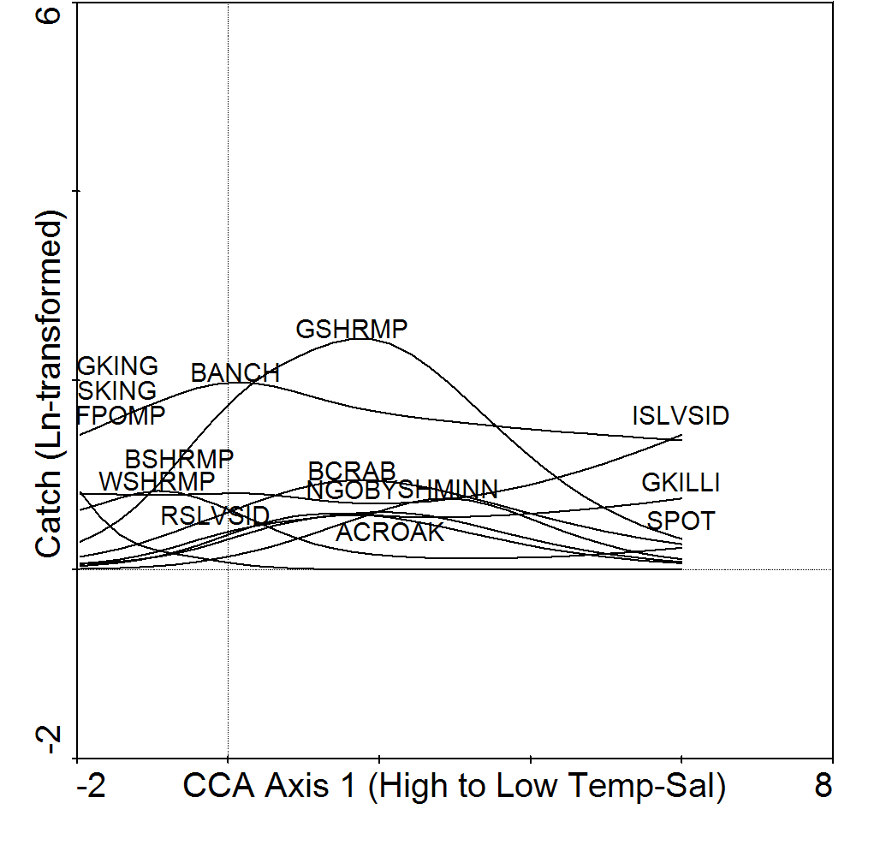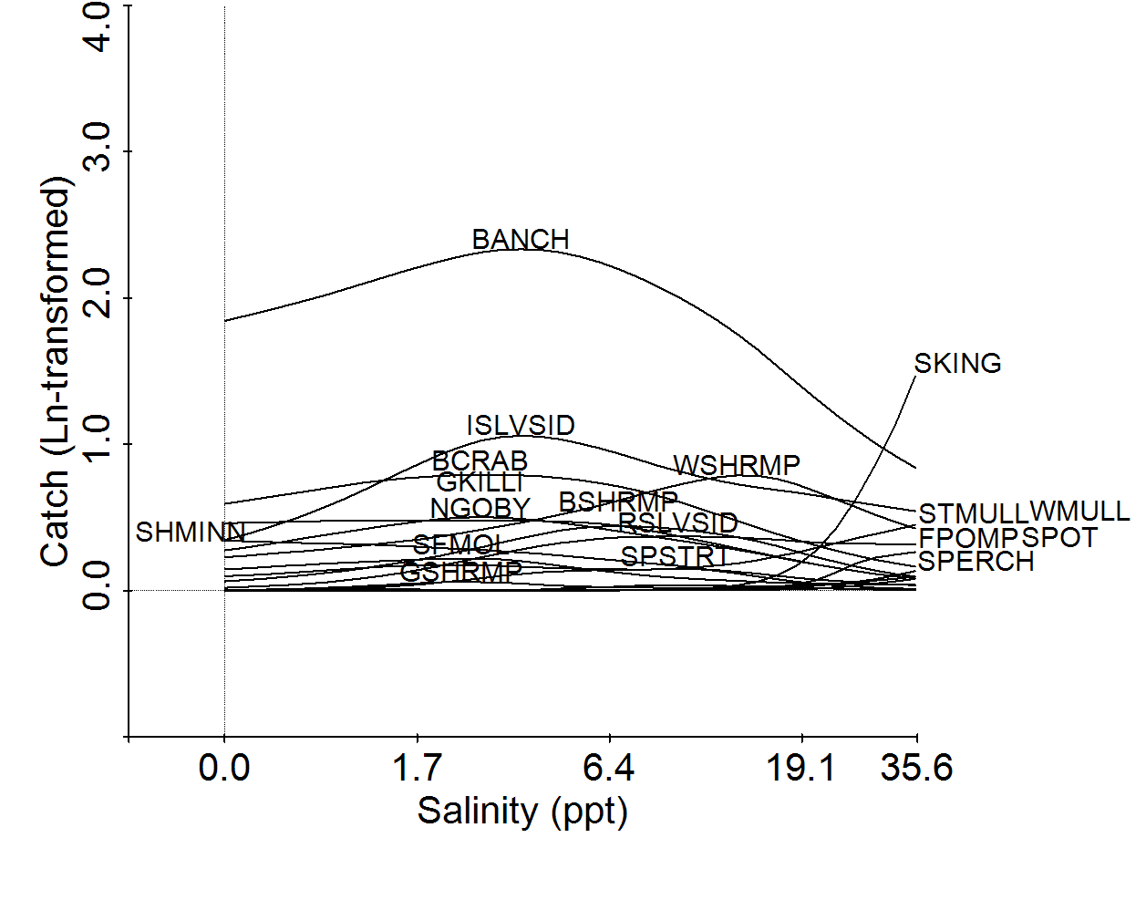

Figure 23. Results of generalized additive models (GAM) showing the optimal salinity conditions for species abundances in the Barataria Estuary (point where species name is). The top graph shows the optimal point on an environmental gradient (CCA axis 1 scores) that accounts for salinity and multivariate community structure. The bottom graph shows the optimal salinity level (ppt) for a species without the influence of multivariate community structure. Only species that were significantly related to the predictor variables are shown (*P*≤0.05). Catch and salinity data were log(x +1)-transformed prior to analysis. Data are from **seines sampled September-December 1991-2011**. Abbreviations for species names are explained in Appendix A.

Salinity levels that optimize species abundances: 16-ft. Trawls

Like the other gear type CCAs for fall, temperature was a more influential variable than salinity, but both helped to define axis 2. Nonetheless, species response curves for trawl sample taken during fall yielded similar results to the CCA T-value biplot (Figure 24). Species that had optimal abundances at the high end of the temperature-salinity gradient were the Gulf menhaden, Spot, White shrimp, and Seabob. Atlantic brief squid and Banded drum were optimized at moderate to moderately high temperatures and salinities. Brown shrimp had optimal abundance at moderately low levels of the temperature-salinity gradient. Species that were optimized at the coolest temperatures and lowest salinities were Bay anchovy, Atlantic croaker, Spotted seatrout, Sand seatrout, Blue crab, Sea catfish, Gafftopsail catfish, and Threadfin shad.

Species response curves using actual salinity values as the predictor showed similar relationships to the CCA gradient curves (Figure 24). Species that had optimal catches at 32 ppt are known to prefer higher salinity levels in estuaries, including the Striped anchovy, Seabob, Atlantic brief squid, Banded drum, Gulf butterfish, Silver perch, and Atlantic bumper. Species that were optimal in more brackish conditions (6 ppt) during fall were mostly economically important fishery species and forage for predators, including Brown shrimp, White shrimp, Bay anchovy, Blue crab, and Gulf menhaden. Species that had optimal catches in near freshwater habitats (<1 ppt) during fall were economically important benthic species, including Atlantic croaker, Spotted seatrout, and Southern flounder.

See **Appendix C** for a more generalized, qualitative breakdown of optimal salinities for these species.

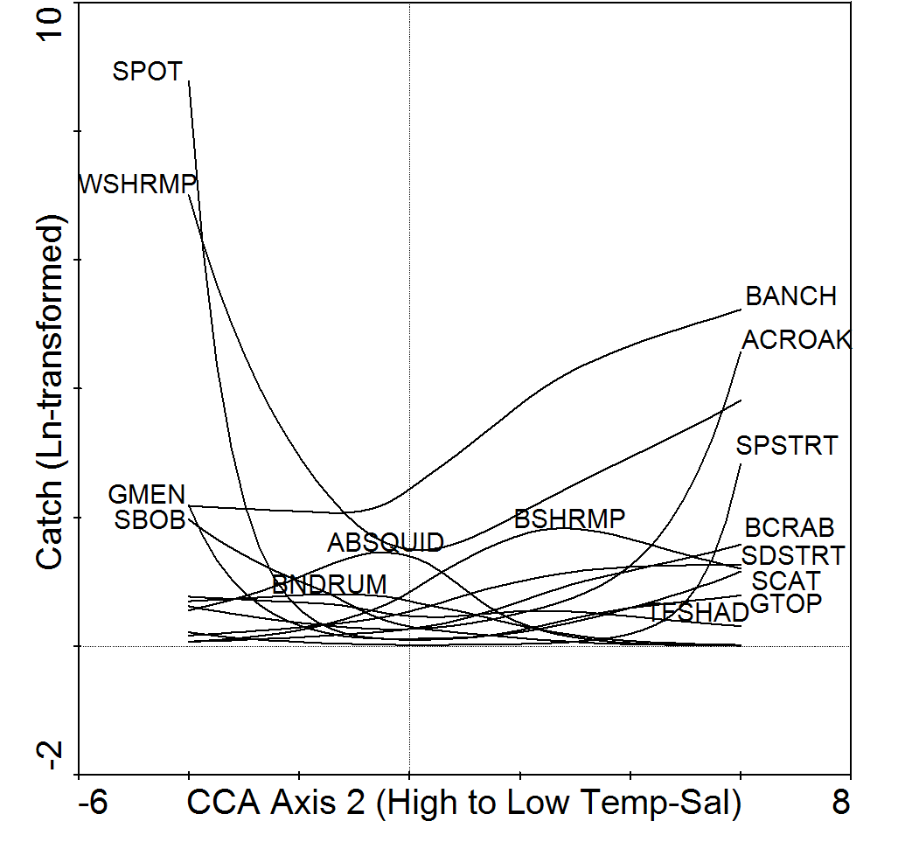

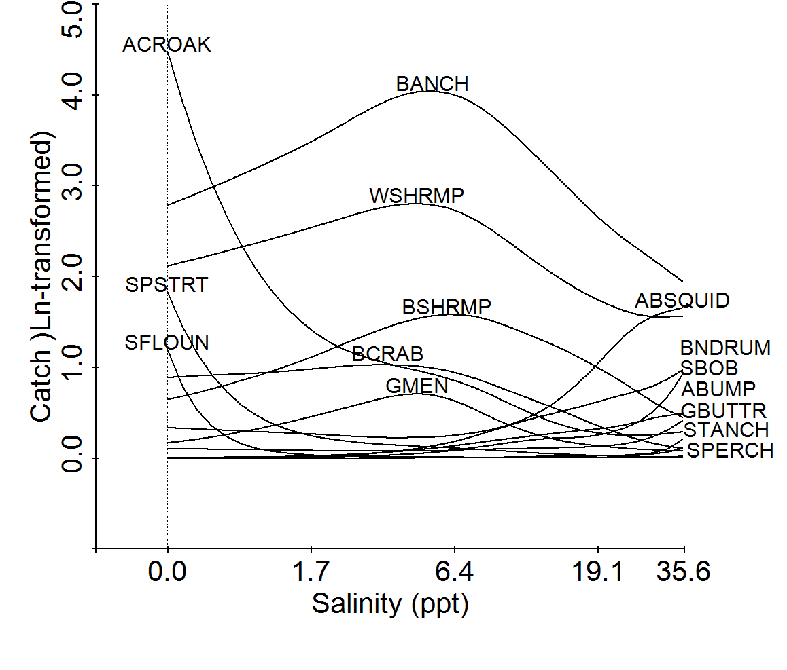

Figure 24. Results of generalized additive models (GAM) showing the optimal salinity conditions for species abundances in the Barataria Estuary (point where species name is). The top graph shows the optimal point on an environmental gradient (CCA axis 1 scores) that accounts for salinity and multivariate community structure. The bottom graph shows the optimal salinity level (ppt) for a species without the influence of multivariate community structure. Only species that were significantly related to the predictor variables are shown (*P*≤0.05). Catch and salinity data were log(x +1)-transformed prior to analysis. Data are from **16-ft. trawls sampled October-December 1991-2011**. Abbreviations for species names are explained in Appendix A.

Salinity levels that optimize biodiversity

Unlike with the spring-summer samples, richness and diversity indices for fall samples for each gear type had optimal salinities that were nearly the same. For marine gill nets (Figure 25), richness and diversity were optimized at low salinities (7 ppt and 3 ppt, respectively). Inland gill net richness and diversity were optimal at 17-18 ppt (Figure 26). Seine richness and diversity during fall were optimized at much lower salinities (3-4 ppt) compared to the spring-summer seine community (Figure 27). Optimal salinities for fall trawl samples (Figure 28), on the other hand, were considerably higher (20-22 ppt) compared to the spring-summer trawl community.

Shannon-Wiener diversity tends to be a more informative index of biodiversity, compared to richness, because it takes into account the evenness of the species abundances. For any given richness value, if one or a few species dominate the species composition of the community, then this dominance will be reflected by lower Shannon-Wiener index values. In contrast, if all species have equal abundances, then Shannon-Wiener values will be higher. In the case of the fall lower Barataria estuary nekton community, Shannon-Wiener diversity tends to be optimal at low salinity or brackish salinities (3-22 ppt). However, the relationship between salinity and diversity is extremely weak. In all gear types examined for this project, as salinity increased, the Shannon-Wiener diversity trend essentially remained a straight line.

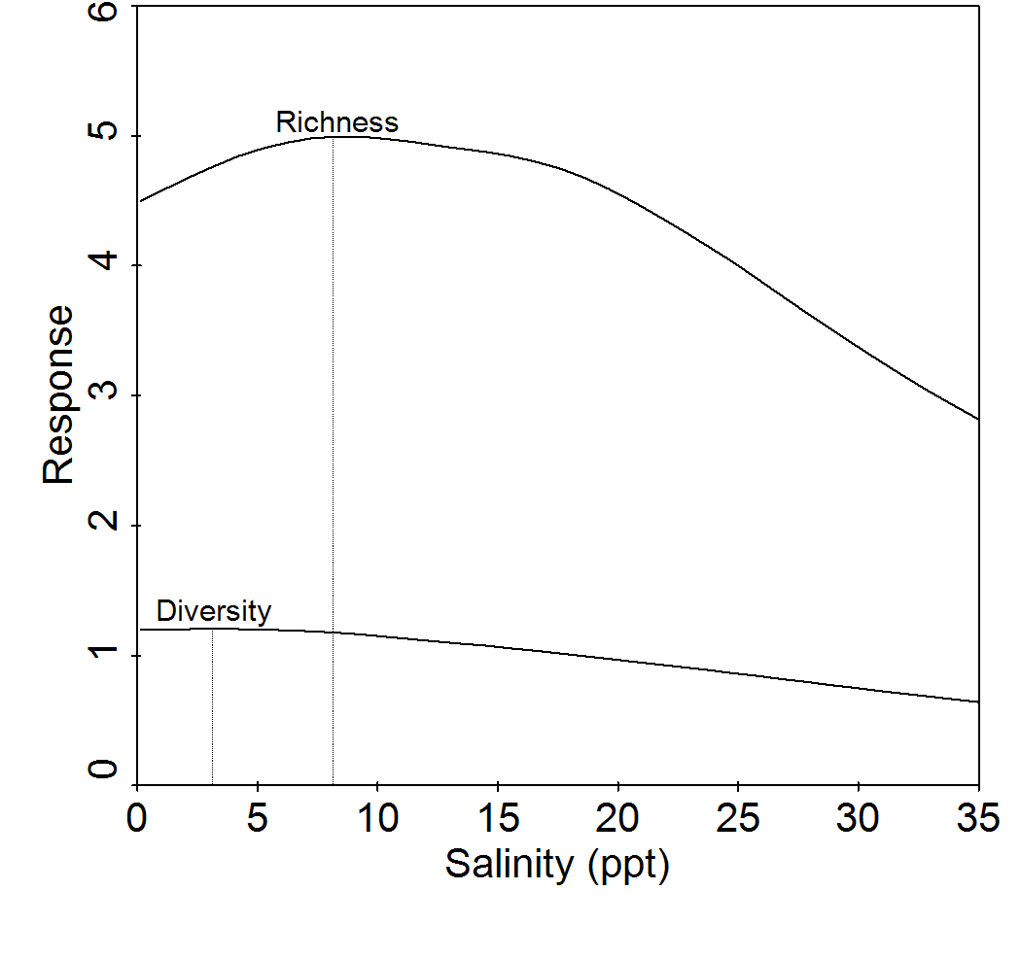

Figure 25. Results of generalized additive models (GAM) showing the salinity level that optimizes nekton biodiversity in the Barataria Estuary (vertical line). Diversity is the Shannon-Wiener uncertainty index, which is unitless, and richness is the number of species. Data are from **marine gill nets sampled during October-December 1991-2011**.

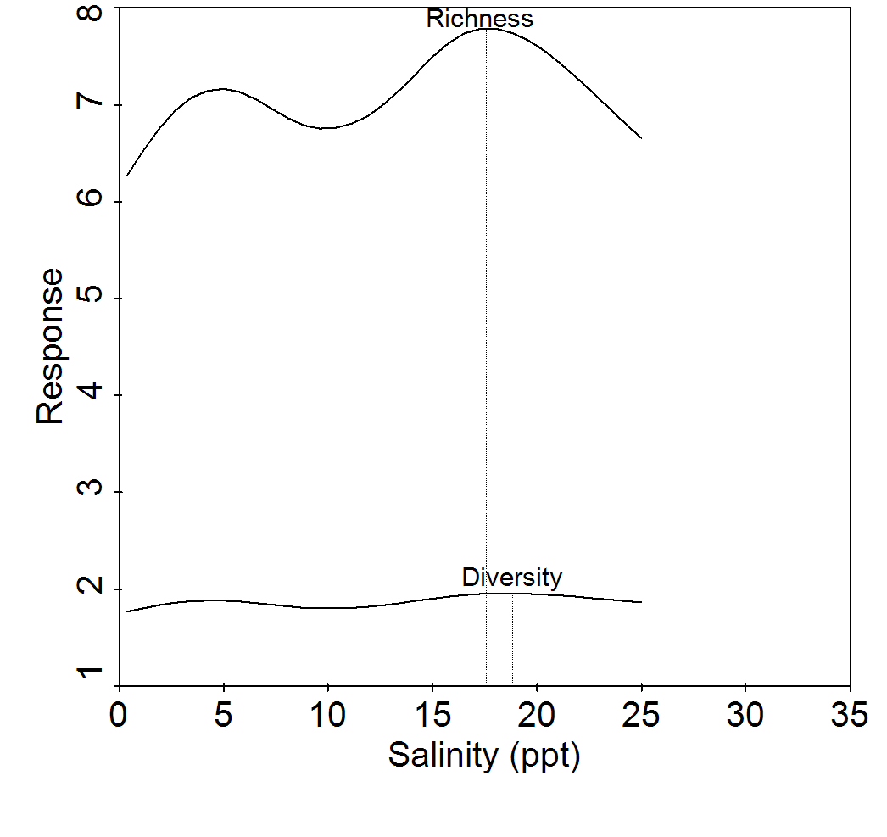

Figure 26. Results of generalized additive models (GAM) showing the salinity level that optimizes nekton biodiversity in the Barataria Estuary (vertical line). Diversity is the Shannon-Wiener uncertainty index, which is unitless, and richness is the number of species. Data are from **inland gill nets sampled during September-December 1998-2011**.

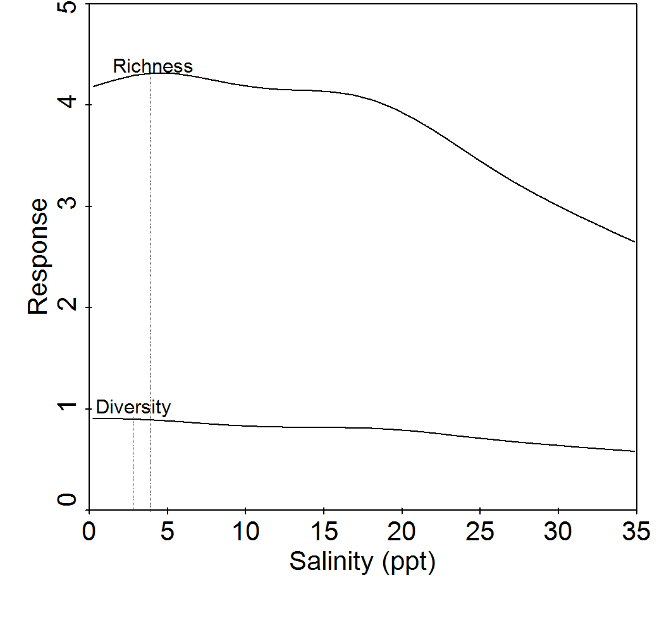

Figure 27. Results of generalized additive models (GAM) showing the salinity level that optimizes nekton biodiversity in the Barataria Estuary (vertical line). Diversity is the Shannon-Wiener uncertainty index, which is unitless, and richness is the number of species. Data are from **seines sampled during September-December 1991-2011**.

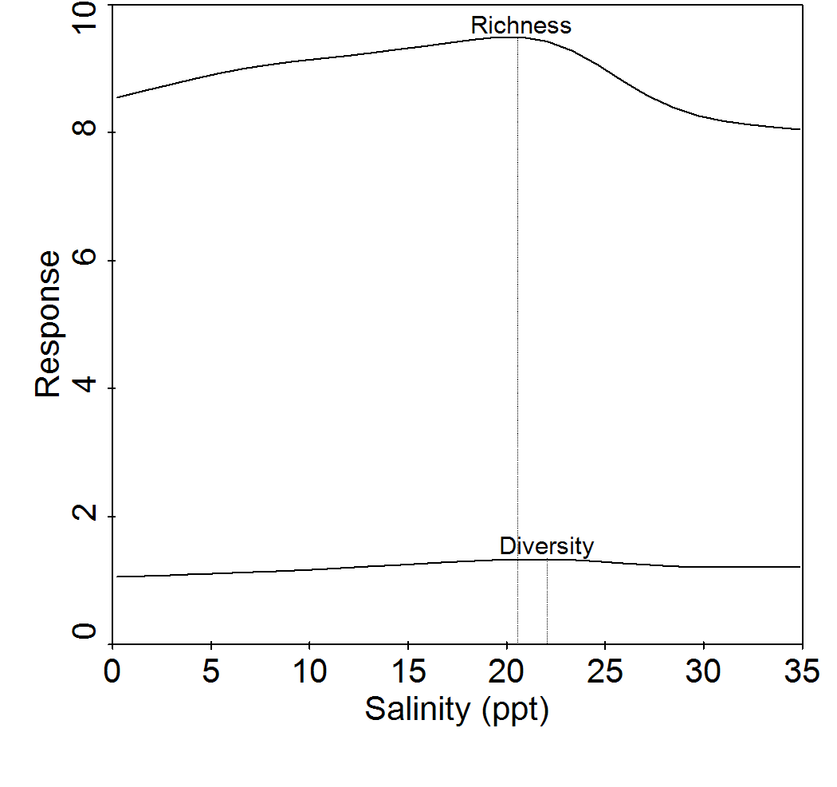

Figure 28. Results of generalized additive models (GAM) showing the salinity level that optimizes nekton biodiversity in the Barataria Estuary (vertical line). Diversity is the Shannon-Wiener uncertainty index, which is unitless, and richness is the number of species. Data are from **16-ft. trawls sampled during October-December 1991-2011**.

Changes in community structure following Davis Pond freshwater diversion

Following the Davis Pond diversion, there were statistically significant shifts in nekton community structure during fall months in the lower Barataria estuary (MRPP; T > 23.0; *P* < 0.0001 for all gear types). However, the strength of the changes in species composition was very weak (MRPP; A < 0.01 for all gear types). These relatively minor but significant changes likely result from having large samples sizes for each gear type (inland gill net samples were excluded from this analysis because there were so few samples for each treatment group). Pairwise comparisons of community structure by year indicated that the Davis Pond diversion likely had a very weak effect on changes in the marine gill net assemblage during fall. For all gear types, the number of pre-diversion years that were significantly different from each other, as well as post-diversion years compared to one another, was approximately the same as the number of pre- versus post-diversion comparisons.

A few species were significantly responsible for the observed, but weak, changes in community structure following the diversion during fall months. The species are those on the CCA joint plots (Figures 29-31) that are at the extreme ends of axes 1 and 2. Similar to the spring-summer CCA, marine gill nets showed the most obvious changes in community structure following the diversion at Davis Pond (Figure 29). For example, Channel catfish and Largemouth bass increased in gill net abundance following the diversion during fall, and were associated with lower salinity conditions. Conversely, there were slight decreases in Bluefish, Atlantic bumper, and Florida pompano as salinity decreased after the diversion. Skipjack herring also declined in abundance following the diversion, but it was not related to changes in salinity.

Very minor changes in community structure were observed with seine and trawl assemblages following the diversion. For seines, Xanthid mud crab species increased in post-diversion samples, while Florida pompano and Southern kingfish decreased (Figure 30). For trawls, Daggerblade grass shrimp increased followed the diversion, and Southern hake decreased in post-diversion samples (Figure 31).

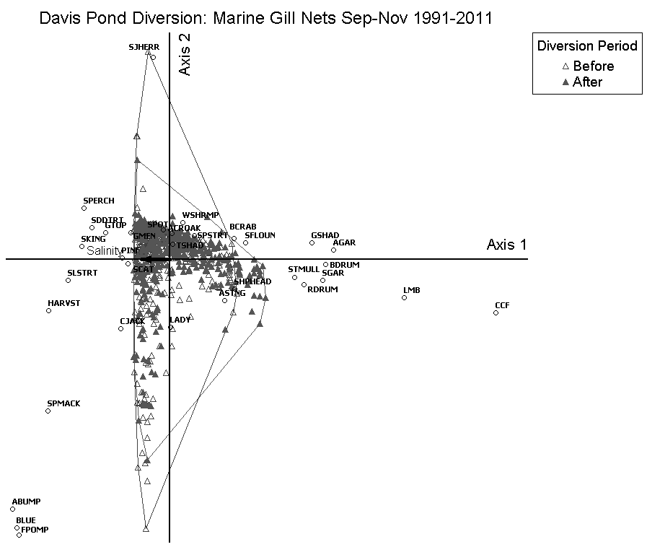

Figure 29. A CCA joint plot with convex hulls outlining the distributions of sample scores on axes 1 and 2. The two distributions shown (open and closed trangles) are samples taken before and after the operation of the Davis Pond freshwater diversion structure (March 2002) in the upper Barataria estuary. Salinity was the independent variable (black arrow).

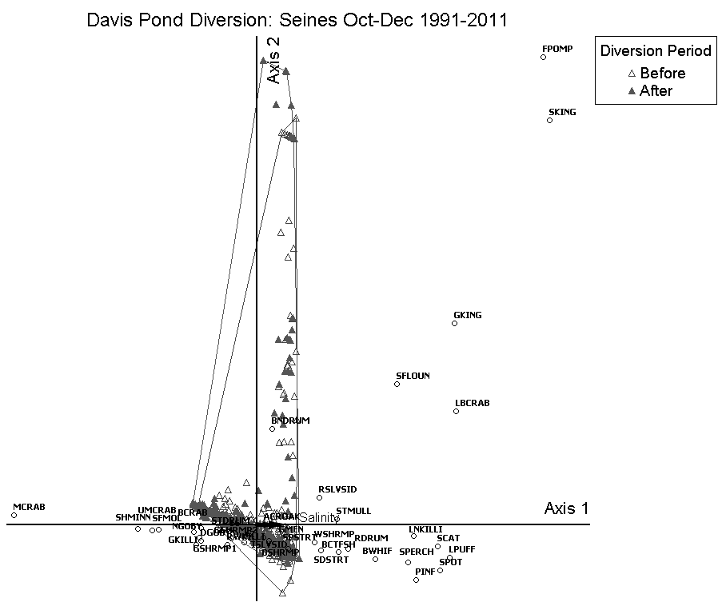

Figure 30. A CCA joint plot with convex hulls outlining the distribution of sample scores on axes 1 and 2. The two distributions shown (open and closed triangles) are samples taken before and after the operation of the Davis Pond freshwater diversion structure (March 2002) in the upper Barataria estuary. Salinity was the independent variable (purple arrow).

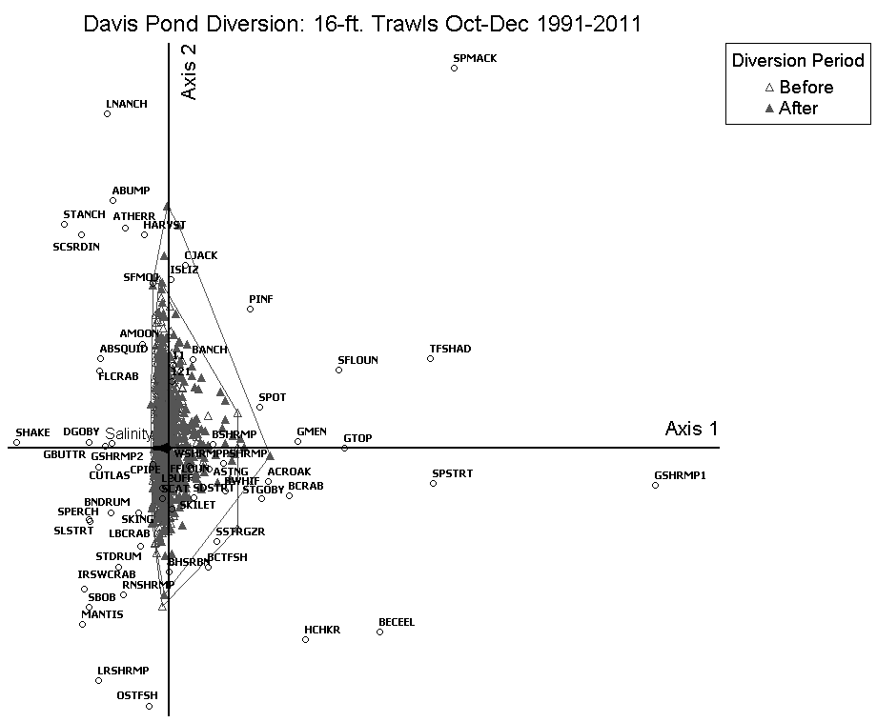

Figure 31. A CCA joint plot with convex hulls outlining the distributions of sample scores on axes 1 and 2. The two distributions shown (open and closed triangles) are samples taken before and after the operation of the Davis Pond freshwater diversion structure (March 2002) in the upper Barataria estuary. Salinity was the independent variable (black arrow).

ADDENDUM: Influence of hard and soft bottom substrate on nekton community structure

During spring-summer months, there were significant, albeit slight, differences in nekton assemblages from hard substrates compared to those from soft substrates (MRPP; A = 0.006; T = -13.84.0; *P* < 0.001, see Figure 32). Species that contributed most to the differences between the two habitat types were juvenile White mullet, Striped anchovy, Gulf kingfish, Southern kingfish, Banded drum, Spanish sardine, Spanish mackerel, and Florida pompano. These species were most associated with hard substrates, higher salinities and warmer water temperatures (Figure 32). Species most associated with softer substrates, lower salinities and cooler temperatures were juvenile White shrimp, Grass shrimp, Mud crabs, juvenile Gulf menhaden, Naked goby, Rainwater killifish, juvenile Atlantic croaker, Chain pipefish, and juvenile Southern flounder. Further analysis using CCA indicated that there were two stations that were responsible for the observed differences in community structure in spring-summer, while species compositions from the other stations did not appear to be significantly different from each other. Approximately 75% of the seine samples taken at the Grand Terre Island beach station, which is composed of hard substrates (i.e., sand), had a different nekton assemblage compared to the Turtle Bay station, which is the second-most inland station, located up-estuary and composed of mud substrate (Figure 33).

During the fall months, nekton community was again significantly different between seine sites comprised of hard and soft substrates (MRPP; A = 0.009; T = -26.55; *P* < 0.001; see Figure 34). Species most associated with hard substrates, high salinities and turbidity levels were Longnose killifish, Least puffer, Pinfish, Lesser blue crab, Spot, Sea catfish, juvenile Florida pompano, juvenile Striped mullet, and Southern kingfish (Figure 34). Species that were most associated with softer substrates, lower salinities and turbidity levels were Mud crabs, Bayou killifish, Star drum, and Bay anchovy. There were two stations that contributed to most of these observed difference, while the other stations did not appear to have significantly different species compositions. The Pen is the most inland seine station, located up-estuary, and consisted of mud bottom (Figure 35). Approximately 90% of the samples from this site were different from the Grand Terre beach station, which is located at the mouth of the estuary and composed of sand substrate.

Separate T-value biplots were constructed for seine samples collected during spring-summer months from each substrate type. Species from hard bottom stations that were associated significantly (T>2.0; *P* <0.05) with salinity were Florida pompano, Banded drum, Gulf kingfish, Southern kingfish, Striped anchovy, Sea catfish, and Blue crab (Figure 36, top graph). In contrast, species from hard bottom sites that were associated significantly with lower salinities were Silver seatrout, Gulf menhaden, Naked goby, Atlantic croaker, and Grass shrimp. From the soft bottom samples (Figure 36, bottom graph), species that were more abundant in higher salinities were Brown shrimp, Lesser blue crab, Least puffer, Blackcheek tonguefish, Spot and Bay anchovy. Species most associated with lower salinity sites over soft substrate were Mud crabs, Blue crab, Gulf menhaden, Sand seatrout, Gulf killifish, and Inland silverside.

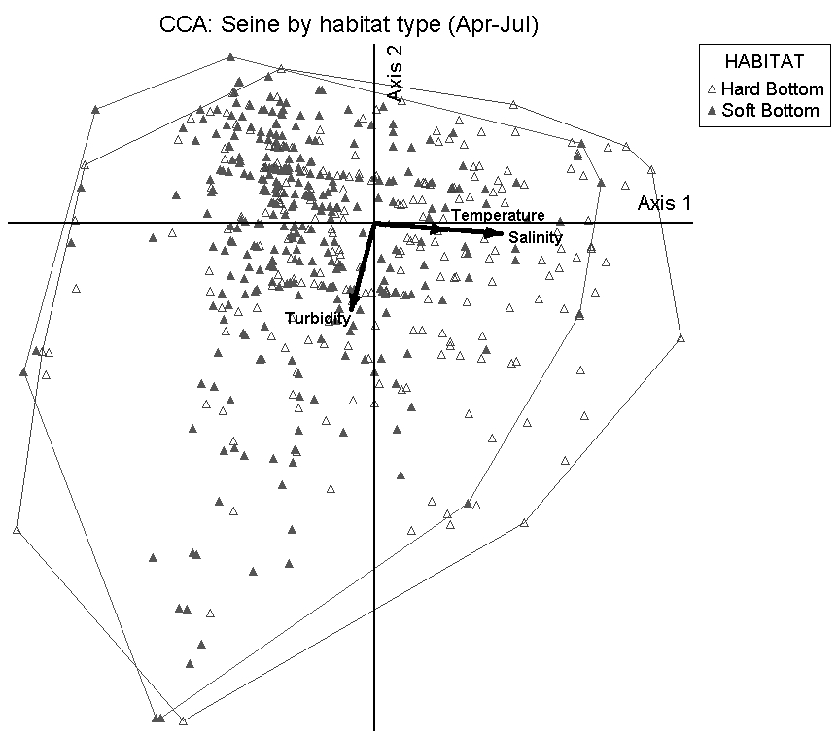

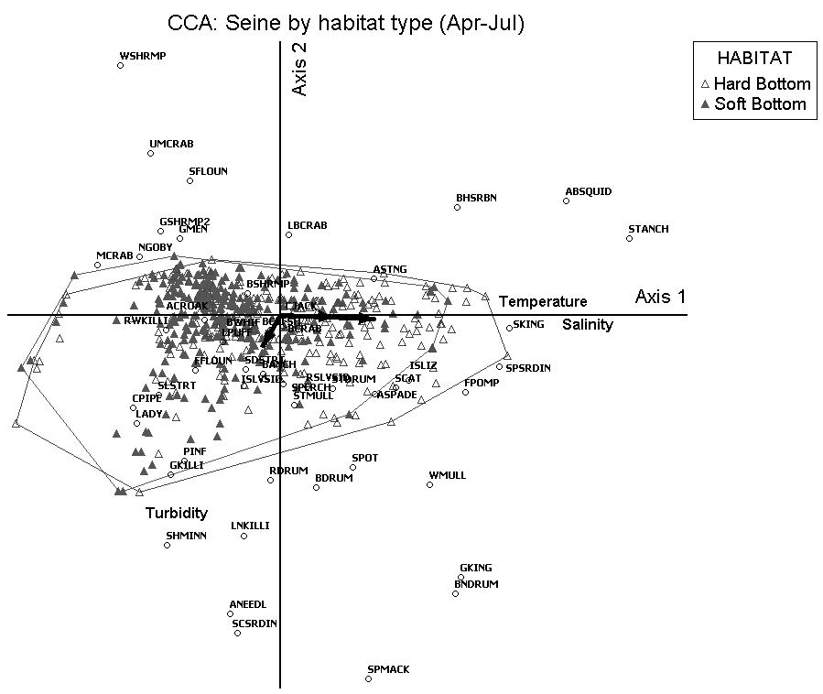

Figure 32. CCA joint plots with convex hulls outlining the distribution of sample scores on axes 1 and 2. The two distributions shown represent nekton assemblages from seine samples taken over hard (i.e., clam shell and sand substrate) and soft (i.e., mud) bottom habitats in the Barataria estuary during spring-summer 1991-2011. Salinity, water temperature and turbidity were the independent variables (black arrows). The top figure is a plot of the sample scores only, while the bottom figure is a plot of the species and sample scores together.

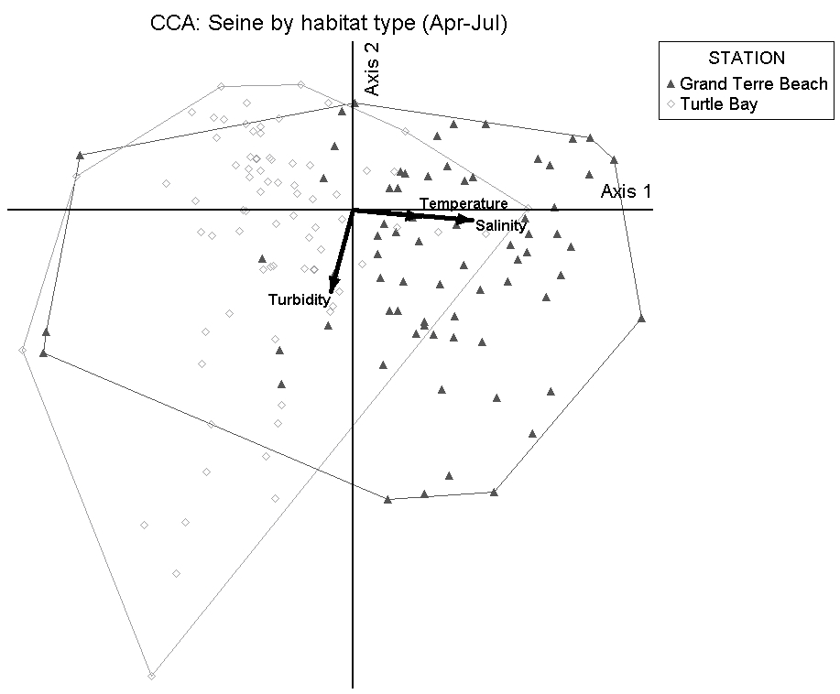

Figure 33. A CCA joint plot with convex hulls outlining the distribution of sample scores on axes 1 and 2. The two distributions shown represent nekton assemblages from seine samples taken at two seine stations in the Barataria estuary during spring-summer 1991-2011. Grand Terre Beach represents a station composed of hard substrate (i.e., clam shell and sand substrate), while Turtle Bay indicates a station consisting of soft substrates (i.e., mud). Salinity, water temperature and turbidity were the independent variables (black arrows). Turtle Bay is the second-most inland site in the study area, and Grand Terre Beach is located on the Gulf side of the estuary.

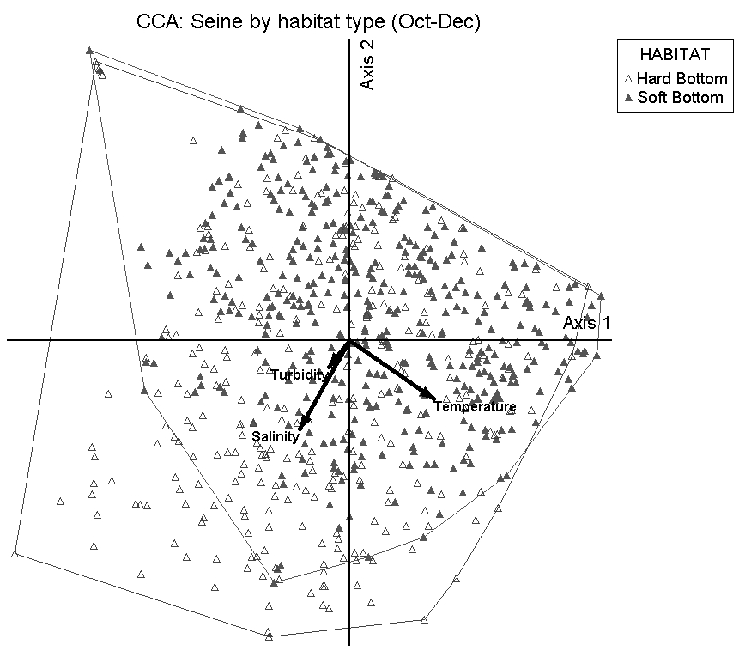

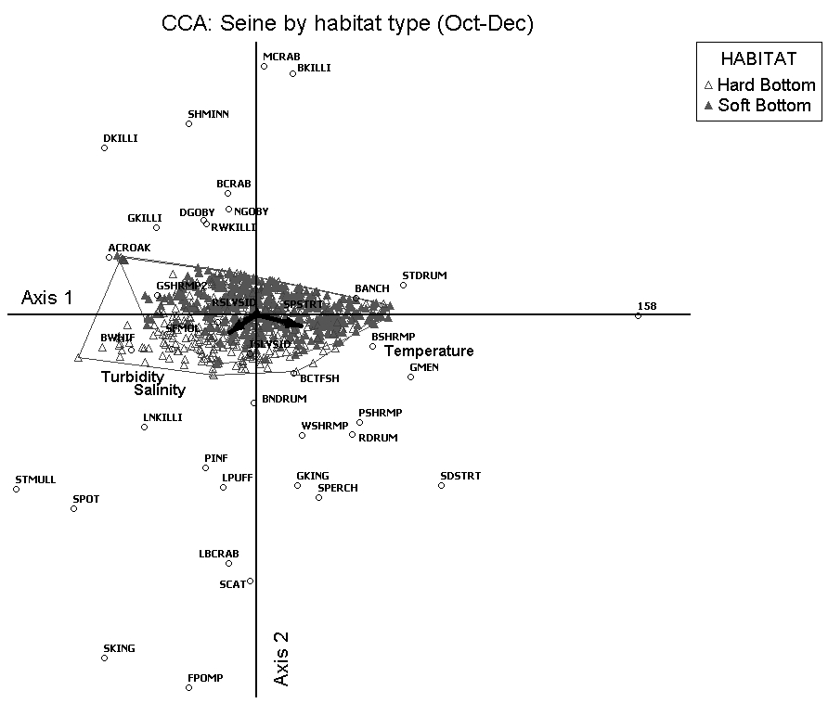

Figure 34. CCA joint plots with convex hulls outlining the distribution of sample scores on axes 1 and 2. The two distributions shown represent nekton assemblages from seine samples taken over hard (i.e., clam shell and sand substrate) and soft (i.e., mud) bottom habitats in the Barataria estuary during fall-winter 1991-2011. Salinity, water temperature and turbidity were the independent variables (black arrows). The top figure is a plot of the sample scores only, while the bottom figure is a plot of the species and sample scores together.

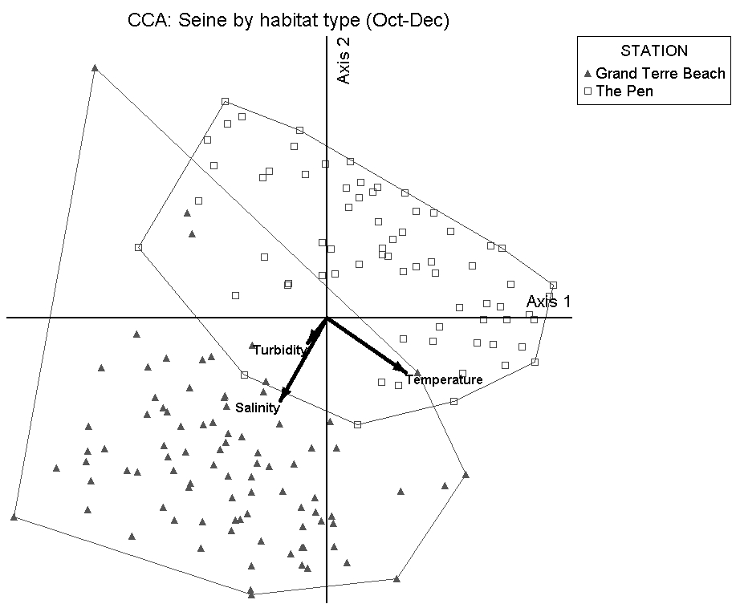

Figure 35. A CCA joint plot with convex hulls outlining the distribution of sample scores on axes 1 and 2. The two distributions shown represent nekton assemblages from seine samples taken at two seine stations in the Barataria estuary during fall-winter 1991-2011. Grand Terre Beach represents a station composed of hard substrate (i.e., clam shell and sand substrate), while The Pen indicates a station consisting of soft substrates (i.e., mud). Salinity, water temperature and turbidity were the independent variables (black arrows). The Pen is the most inland site in the study area, and Grand Terre Beach is located on the Gulf side of the estuary.





Figure 36. T-value biplots from a canonical correspondence analysis (CCA) depicting statistically significant (T>2.0, *P*≤0.05) relationships between species abundances and salinity from LDWF seines sampled **April-July 1991-2011**. Seine sample were categorized and analyzed separately by habitat type; specifically, those collected over hard substrates (i.e., clam shells and sand; **Top figure**) and soft substrates (i.e., mud; **Bottom figure**). Magnitude and direction of salinity-species relationships are represented by arrowheads. Arrows that point in the same direction and are close to each other represent species whose abundance trends are similar to each other. Only arrows within the van Dobben circles are statistically significant. Species in the red circle are those that are related positively to salinity, while those in the blue circle exhibit a negative relationship. T- and *P*-values were calculated from 1,000 randomized Monte Carlo simulations. Species abbreviations are explained in Appendix A.

Optimal salinities for species relative abundances during spring-summer months were estimated using species response curves (i.e., GAM assuming Poisson error distribution) for each substrate type. Species catch (log[x+1]-transformed) for each sample was regressed against salinity (log[x+1]-transformed). For hard bottom sites, species that were optimized at near seawater conditions (i.e., salinity >32 ppt) were juvenile Southern kingfish, Banded drum, juvenile Blue crab, juvenile Florida pompano, and juvenile Sea catfish. Gulf menhaden and Silver seatrout abundances were optimized at approximately 6-7 ppt, Atlantic croaker and Grass shrimp were optimal at 4-5 ppt, and Naked goby was most abundant at 2 ppt (Figure 37, top graph). At the soft bottom seine stations, Spot, Bay anchovy, Least puffer, and Pinfish were optimized at salinities >32 ppt (Figure 37, bottom graph). Brown shrimp, Lesser blue crab, and Blackcheek tonguefish were optimal at about 6 ppt. However, for Brown shrimp, the line for the curve essentially flattens out at salinities >6 ppt, while dropping off sharply at salinities below this value. This indicates a very broad affinity for brackish and saline waters, but an aversion to fresh waters. Juvenile Gulf menhaden and White shrimp, Blue crab, and Sand seatrout abundances from soft substrates were optimized at salinities at approximately 0-3 ppt, while adult Longnose killifish, Gulf killifish and Mud crabs were also optimized at salinities ≤3 ppt.

During the fall months, species that were positively associated with salinity (T-value biplot; T>2.0; P<0.05) over hard substrates were Southern kingfish, Longnose killifish, and Bay whiff (Figure 38, top graph). Species that had significantly greater abundances in lower salinity waters included juvenile Blue crab, Bay anchovy, Sailfin molly, Naked goby and Bayou killifish. For the soft substrate sites, there was no relationship between salinity and community structure (Figure 38, bottom graph).

Species response curves for the fall seine samples indicated that, for the hard bottom sites, Florida pompano and Southern kingfish juveniles were optimized at salinities 27 ppt (Figure 39, top graph). White shrimp and Sea catfish juveniles were optimal at about 19 ppt, while Blue crab. Bay anchovy, Naked goby, and Diamond killifish were optimized at 3-5 ppt.

During the fall months, species response curves indicated that Silver perch and Pink shrimp had optimal abundances near seawater at soft bottom sites (Figure 39, bottom graph). White shrimp and Red drum juveniles were optimized at approximately 11-12 ppt over soft substrates, while Brown shrimp juveniles were optimized at 7 ppt. Mud crabs, Sailfin molly and Star drum abundances were optimal at 3-5 ppt. Darter goby and Bayou killifish were optimized at freshwater, soft bottom sites.





Figure 37. Results of generalized additive models (GAM) showing the optimal salinity conditions for species abundances in the Barataria Estuary (point where species name is). Only species that were significantly related to the predictor variables are shown (*P*≤0.05). Catch and salinity data were log(x +1)-transformed prior to analysis. Data are from seines sampled **April-July 1991-2011** that were analyzed separately for samples collected over hard substrates (i.e., clay shells and sand; **Top figure**) and soft substrates (i.e., mud; **Bottom figure**). Abbreviations for species names are explained in Appendix A.





Figure 38. T-value biplots from a canonical correspondence analysis (CCA) depicting statistically significant (T>2.0, *P*≤0.05) relationships between species abundances and salinity from LDWF seines sampled **October-December 1991-2011**. Seine sample were categorized and analyzed separately by habitat type; specifically, those collected over hard substrates (i.e., clam shells and sand; **Top figure**) and soft substrates (i.e., mud; **Bottom figure**). Magnitude and direction of salinity-species relationships are represented by arrowheads. Arrows that point in the same direction and are close to each other represent species whose abundance trends are similar to each other. Only arrows within the van Dobben circles are statistically significant. Species in the red circle are those that are related positively to salinity, while those in the blue circle exhibit a negative relationship. T- and *P*-values were calculated from 1,000 randomized Monte Carlo simulations. Species abbreviations are explained in Appendix A.





Figure 39. Results of generalized additive models (GAM) showing the optimal salinity conditions for species abundances in the Barataria Estuary (point where species name is). Only species that were significantly related to the predictor variables are shown (*P*≤0.05). Catch and salinity data were log(x +1)-transformed prior to analysis. Data are from seines sampled **October-December 1991-2011** that were analyzed separately for samples collected over hard substrates (i.e., clay shells and sand; **Top figure**) and soft substrates (i.e., mud; **Bottom figure**). Abbreviations for species names are explained in Appendix A.

ADDENDUM: Inland gill net and electrofishing analysis with Lake Cataouatche and Lake Salvador stations

Partial CCA (pCCA) was used to assess the relationship between salinity, Davis Pond diversion discharge, and diversion period (before = 1998-March 2002; after = April 2002-2009), with the addition of sample sites from Lake Cataouatche and Lake Salvador (see Figure 1b for sample locations). The pCCA differs from the CCA in that it removes potential interactions between covariables and the independent variables of interest (e.g., salinity). Covariables were season (fall-winter months and spring-summer months), year, and station location. Inland electrofishing and gill net standard sampling data were analyzed.

The T-value biplots from the pCCA results showed that abundances (fish/electrofishing-h) of Southern flounder and Warmouth (a type of sunfish) were positively associated with salinity, while Largemouth bass abundance increased in fresh waters (Figure 40). This relationship with salinity was congruent with that of Davis Pond discharge. Southern flounder and Warmouth were associated significantly with the lower discharges, while Largemouth bass abundance tended to increase with Davis Pond discharge, although this was not statistically significant. Largemouth bass also had significantly greater abundances after the diversion began (Figure 40, bottom graph), suggesting that the lowering of salinity, caused by the diversion of river water from the Davis Pond, led to the increase in Largemouth bass abundance. Conversely, Black crappie, Striped mullet, Gulf killifish, and Inland silverside tended to decrease in abundance after the diversion began. It is difficult to say that freshwater influx and subsequent freshening caused the decline in abundance of these species after the diversion. Physical habitat changes resulting from increased submerged aquatic vegetation coverage, turbidity changes, or other factors (changes in food resources or predators, perhaps) not addressed in this study could have brought about these abundance shifts. Alternatively, there could have been a lag between the response of the fish and discharge on the day of the sample.





Figure 40. T-value biplots from a partial CCA using **Inland electrofishing** data with Lake Cataouatche and Lake Salvador included (1998-2009). Covariables were season (fall-winter months and spring-summer months), year, and station location. Species arrows located in the red Van Dobben circle are those whose relative abundance is positively related to the independent variable. Species in the blue circle are negatively related to the independent variable. “Flow” is the mean daily discharge from the Davis Pond diversion structure for a sample period. “Diversion” was categorized as before (blue circle) and after (red circle) for the analysis.

Species response curves were generated using the actual salinity values and electrofishing catch rates of each species (Figure 41). The statistically significant GAMs shown in Figure 41 suggested that Largemouth bass (sub-adult to adult stage) was optimized at 0 ppt, but abundance did not fall off substantially till about 4 ppt. Warmouth and Bluegill had optimal abundances at 3-4 ppt. At moderate salinities, Spotted seatrout (sub-adult to adult stage), Southern flounder (adult stage), Inland silverside, Striped mullet, and Gulf killifish were optimized at 9-10 ppt, while Gulf menhaden (adult stage) was most abundant at 12 ppt. Red drum (juvenile stage) was optimized at the highest salinities recorded, at about 20 ppt.



Figure 41. Results of generalized additive models (GAM) showing the optimal salinity conditions for species abundances in the Barataria Estuary (point where species name is). The graph shows the optimal salinity level for a species. Only species that were significantly related to salinity are shown (*P*≤0.05). Catch and salinity data were log(x +1)-transformed prior to analysis. Data are from **Inland electrofishing samples taken quarterly during 1998-2009**. Abbreviations for species names are explained in Appendix A.

A pCCA was also conducted on the Inland gill net data, with Lake Cataouatche and Lake Salvador stations included in the dataset. No species abundances (weight/gill net set) were significantly associated with increases in salinity or Davis Pond discharge. However, Blue catfish and Gizzard shad weight were associated with lower flows, but not lower salinities. In contrast to the electrofishing pCCA results, adult Southern flounder weight/net set was greater after the diversion. Juvenile Black drum and adult Spotted seatrout weight/net set was lower following the diversion. The negative trend for Spotted seatrout post-diversion is consistent with the CCA results from the Marine gill nets, which also sample adult stage Spotted seatrout. Similar to the electrofishing pCCA, however, there appears to be factors other than diversion-induced salinity changes that lead to shifts in the abundance of some species sampled with gill nets. Electrofishing and gill nets showed opposite results for Southern flounder with regard to diversion period, and salinity was not an important influence on its abundance for either gear type. No Southern flounder were captured in the spring-summer Inland gill nets (see Table 2), the primary time period during which the diversion structure is operating. In the earlier Inland gill net CCAs without Lake Cataouatche and Lake Salvador data, Southern flounder showed no significant relationship to salinity in the for either spring-summer or fall months. Thus, there is evidence to suggest that features of these two water bodies influence the abundance of adult Southern flounder, perhaps as some indirect consequence of Davis Pond diversion.





Figure 42. T-value biplots from a partial CCA using **Inland gill net** data with Lake Cataouatche and Lake Salvador included (1998-2009). Covariables were season (fall-winter months and spring-summer months), year, and station location. Species arrows located in the red Van Dobben circle are those whose relative abundance is positively related to the independent variable. Species in the blue circle are negatively related to the independent variable. “Flow” is the mean daily discharge from the Davis Pond diversion structure for a sample period. “Diversion” was categorized as before (blue circle) and after (red circle) for the analysis.

**References**

CPRA (Coastal Protection and Restoration Authority). 2012. Louisiana’s comprehensive plan for a sustainable coast. Coastal Protection and Restoration Authority of Louisiana. Baton Rouge. 190 pp.

de Mutsert, K. and J. H. cowan. 2012. A Before–After–Control–Impact Analysis of the Effects of a Mississippi River Freshwater Diversion on Estuarine Nekton in Louisiana, USA. Estuaries and Coasts *On-line version*. DOI: 10.1007/s12237-012-9522-y.

Grimes, C. B. 2001. Fishery production and the Mississippi River discharge. Fisheries 26(8):17-26.

McCune, B. and J. B. Grace. 2002. Analysis of ecological communities. [MjM Software, Gleneden Beach, Oregon, USA](http://www.pcord.com/). 304 pp.

Odum, W. E., E. P. Odum, and H. T. Odum. 1995. Nature's pulsing paradigm. Estuaries 18: 547–555.

Piazza, B. P. and M. K. La Peyre. 2011. Nekton community response to a large-scale Mississippi River discharge: examining spatial and temporal response to river management. Estuarine, Coastal and Shelf Science 91:379–387.

ter Braak, C. J. F. and P. Smilauer 2002. CANOCO reference manual and CanoDraw for Windows user’s guide: software for canonical community ordination (version 4.5). Microcomputer Power, Ithaca, New York, 500 pp.

APPENDIX A. Common names for species abbreviations as seen in the figures. Alphabetical order by common name.

|  |  |  |  |
| --- | --- | --- | --- |
| Abbreviation | Common name | Abbreviation | Common name |
| AGAR | Alligator gar | LPUFF | Least puffer |
| ABSQUID | Atlantic brief squid | LJACK | Leatherjacket |
| ABUMP | Atlantic bumper | LBCRAB | Lesser blue crab |
| ACROAK | Atlantic croaker | LRSHRMP | Lesser rock shrimp |
| AMOON | Atlantic moonfish | LNANCH | Longnose anchovy |
| ATNEEDL | Atlantic needlefish | LGAR | Longnose gar |
| ASPADE | Atlantic spadefish | LNKILLI | Longnose killifish |
| ASTNG | Atlantic stingray | LDOWN | Lookdown |
| ATHERR | Atlantic thread Herring | MANTIS | Mantis shrimp |
| BNDRUM | Banded drum | MCRAB | Mud crab spp. (Xanthidae) |
| BANCH | Bay anchovy | NGOBY | Naked goby |
| BKILLI | Bayou killifish | OSTFSH | Offshore tongue fish |
| BWHIF | Bay whiff | ORSPSUN | Orangespotted sunfish |
| BHSRBN | Bighead searobin | PINF | Pinfish |
| BMBUFF | Bigmouth buffalo | PSHRMP | Pink shrimp |
| BCTFSH | Blackcheek tongue fish | RWKILLI | Rainwater killifish |
| BCRAPPI | Black crappie | RDRUM | Red drum |
| BDRUM | Black drum | REDEAR | Redear sunfish |
| BECEEL | Blackedge cuskeel | RNSHRMP | Roughneck shrimp |
| BCF | Blue catfish | RSLVSID | Rough silverside |
| BCRAB | Blue crab | SFMOLL | Sailfin molly |
| BLUE | Bluefish | SDSTRT | Sand seatrout |
| BG | Bluegill | SCSRDIN | Scaled sardine |
| BSHRMP | Brown shrimp | SBOB | Seabob |
| BSHRK | Bull shark | SCAT | Sea catfish |
| CPIPE | Chain pipefish | SHPSHEAD | Sheepshead |
| CCF | Channel catfish | SHMINN | Sheepshead minnow |
| CCARP | Common carp | SLSTRT | Silver seatrout |
| CNRAY | Cownose ray | SKILET | Skilletfish |
| CJACK | Crevalle jack | SJHERR | Skipjack herring |
| CUTLAS | Cutlass fish | SMBUFF | Smallmouth buffalo |
| DGOBY | Darter goby | SHAKE | Southern hake |
| DKILLI | Diamond killifish | SKING | Southern kingfish |
| FHC | Flathead catfish | SSTRGZR | Southern stargazer |
| FPOMP | Florida pompano | SPMACK | Spanish mackerel |
| FDRUM | Freshwater drum | SPOT | Spot |
| FFLOUN | Fringed flounder | SFMOJ | Spotfin mojarra |
| GTOP | Gafftopsail catfish | SGAR | Spotted gar |
| GSHAD | Gizzard shad | SPSTRT | Spotted seatrout |
| GSHRMP1 | Daggerblade grass shrimp (*P. pugio*) | SPSUNF | Spotted sunfish |
| GSHRMP2 | Unid. Grass shrimp spp. | STDRUM | Star drum |
| GBUTTR | Gulf butterfish | STANCH | Striped anchovy |
| GKING | Gulf kingfish | STMULL | Striped mullet |
| GMEN | Gulf menhaden | TFSHAD | Threadfin shad |
| HRVST | Harvest fish | UMCRAB | Unid. non-xanthid mud crab |
| HCHKR | Hogchoker | WMULL | White mullet |
| ISLVSID | Inland silverside | WSHRMP | White shrimp |
| ISLIZ | Inshore lizardfish |  |  |
| IRSWCRB | Iridescent swimming crab |  |  |
| LADY | Ladyfish |  |  |

APPENDIX B. Qualitative likelihood of a species reaching optimal (i.e., maximum) relative abundance at a given salinity range (ppt) during spring-summer (April-July). Salinity categories were arbitrarily chosen. Species designations (High, Medium, Low) are based on a combination of univariate species response curves (GAM models with salinity as predictor) and multivariate species response curves (GAM models with CCA sample scores as predictor). MG = marine gill net, IG = inland gill net, S = seine, T = 16ft. otter trawl. Data used are from standard samples taken in the lower Barataria estuary (MG, S, and T during 1991-2011; IG during 1998-2011). Adu. = primarily adults sampled by the respective gear type, Juv. = primarily juveniles sampled by the respective gear type. Dashes mean that results were not assessed because IG samples did not exceed 20 ppt.

|  |  |  |  |  |  |  |
| --- | --- | --- | --- | --- | --- | --- |
| Species | 0-5 | 6-11 | 12-17 | 18-23 | 24-29 | 30-35 |
| Alligator gar (IG) | HIGH | LOW | LOW | LOW | -- | -- |
| Atlantic brief squid (T) | LOW | LOW | LOW | LOW | HIGH | MEDIUM |
| Atlantic bumper (T) | LOW | LOW | LOW | LOW | MEDIUM | HIGH |
| Atlantic croaker (MG, IG, S) | HIGH | MEDIUM | MEDIUM | LOW | LOW | LOW |
| Atlantic croaker (T) | HIGH | HIGH | MEDIUM | MEDIUM | LOW | LOW |
| Atlantic spadefish (T) | LOW | LOW | LOW | LOW | MEDIUM | HIGH |
| Banded drum (S, T) | LOW | LOW | LOW | LOW | MEDIUM | HIGH |
| Bay anchovy (S, T) | LOW | MEDIUM | HIGH | MEDIUM | LOW | LOW |
| Bay whiff (T) | LOW | LOW | LOW | LOW | MEDIUM | HIGH |
| Bighead searobin (T) | LOW | LOW | MEDIUM | HIGH | HIGH | MEDIUM |
| Black drum (MG) | HIGH | MEDIUM | LOW | LOW | LOW | LOW |
| Blue catfish (IG) | HIGH | LOW | LOW | LOW | -- | -- |
| Blue crab (MG; Adu, S; Juv.) | LOW | LOW | MEDIUM | LOW | MEDIUM | HIGH |
| Blue crab (T; Juv.) | HIGH | MEDIUM | MEDIUM | MEDIUM | LOW | LOW |
| Bluefish (MG) | LOW | LOW | LOW | LOW | LOW | HIGH |
| Brown shrimp (S; Juv.) | LOW | HIGH | MEDIUM | MEDIUM | LOW | LOW |
| Brown shrimp (T; Juv.) | LOW | HIGH | HIGH | MEDIUM | MEDIUM | LOW |
| Bull shark (IG) | LOW | MEDIUM | HIGH | HIGH | MEDIUM | LOW |
| Channel catfish (IG) | HIGH | LOW | LOW | LOW | -- | -- |
| Common carp (IG) | HIGH | LOW | LOW | LOW | -- | -- |
| Cownose ray (IG) | LOW | MEDIUM | HIGH | MEDIUM | -- | -- |
| Darter goby (S) | LOW | LOW | LOW | LOW | LOW | HIGH |
| Flathead catfish (IG) | HIGH | LOW | LOW | LOW | -- | -- |
| Florida pompano (MG, S) | LOW | LOW | LOW | MEDIUM | MEDIUM | HIGH |
| Gafftopsail catfish (T) | LOW | LOW | LOW | LOW | MEDIUM | HIGH |
| Gizzard shad (MG, IG) | HIGH | HIGH | HIGH | HIGH | LOW | LOW |
| Grass shrimp (S) | MEDIUM | HIGH | HIGH | MEDIUM | LOW | LOW |
| Gulf kingfish (S) | LOW | LOW | LOW | LOW | LOW | HIGH |
| Gulf menhaden (MG; Adu.) | LOW | LOW | MEDIUM | HIGH | HIGH | HIGH |
| Gulf menhaden (S; Juv.) | MEDIUM | HIGH | HIGH | MEDIUM | LOW | LOW |
| Inland silverside (S) | HIGH | MEDIUM | MEDIUM | MEDIUM | LOW | LOW |
| Appendix B cont. |  |  |  |  |  |  |
|  |  |  |  |  |  |  |
| Ladyfish (MG, IG) | HIGH | MEDIUM | LOW | LOW | LOW | LOW |
| Least puffer (T) | MEDIUM | HIGH | HIGH | MEDIUM | LOW | LOW |
| Leatherjacket (T) | LOW | LOW | MEDIUM | MEDIUM | HIGH | HIGH |
| Lesser blue crab (T) | LOW | LOW | LOW | MEDIUM | MEDIUM | HIGH |
| Longnose gar (IG) | HIGH | LOW | LOW | LOW | -- | -- |
| Mud crab spp. (S) | HIGH | LOW | LOW | LOW | LOW | LOW |
| Pinfish (MG) | LOW | LOW | LOW | LOW | MEDIUM | HIGH |
| Red drum (MG, IG; Juv.) | HIGH | HIGH | MEDIUM | MEDIUM | LOW | LOW |
| Rough silverside (S) | LOW | LOW | LOW | LOW | MEDIUM | HIGH |
| Sand seatrout (MG; Adu., IG; Adu., S; Juv.) | LOW | LOW | LOW | MEDIUM | HIGH | HIGH |
| Sand seatrout (T; Juv.) | HIGH | HIGH | MEDIUM | MEDIUM | LOW | LOW |
| Sea catfish (IG, T) | LOW | LOW | LOW | MEDIUM | HIGH | HIGH |
| Seabob (T) | LOW | LOW | LOW | LOW | MEDIUM | HIGH |
| Southern kingfish (MG, IG, S) | LOW | LOW | LOW | LOW | MEDIUM | HIGH |
| Spanish mackerel (MG) | LOW | LOW | MEDIUM | HIGH | HIGH | HIGH |
| Spot (MG) | LOW | LOW | MEDIUM | MEDIUM | HIGH | HIGH |
| Spot (S) | LOW | LOW | LOW | LOW | MEDIUM | HIGH |
| Spot (T) | LOW | MEDIUM | HIGH | HIGH | MEDIUM | LOW |
| Spotted gar (IG) | HIGH | MEDIUM | LOW | LOW | -- | -- |
| Spotted seatrout (MG; Adu., IG; Adu.) | LOW | MEDIUM | HIGH | HIGH | HIGH | HIGH |
| Star drum (T) | LOW | LOW | MEDIUM | MEDIUM | HIGH | HIGH |
| Striped anchovy (S, T) | LOW | LOW | LOW | LOW | MEDIUM | HIGH |
| Striped mullet (S; Juv.) | LOW | LOW | LOW | LOW | MEDIUM | HIGH |
| White mullet (S; Juv.) | LOW | LOW | LOW | LOW | MEDIUM | HIGH |
| White shrimp (MG; Adu.) | LOW | MEDIUM | HIGH | HIGH | MEDIUM | LOW |
| White shrimp (S; Juv.) | LOW | LOW | LOW | LOW | MEDIUM | HIGH |
| White shrimp (T; Juv.) | HIGH | HIGH | MEDIUM | MEDIUM | LOW | LOW |
|  |  |  |  |  |  |  |

APPENDIX C. Qualitative likelihood of a species reaching optimal (i.e., maximum) relative abundance at a given salinity range (ppt) during fall (September-December). Salinity categories were arbitrarily chosen. Species designations (High, Medium, Low) were based on a combination of univariate species response curves (GAM models with salinity as predictor) and multivariate species response curves (GAM models with CCA sample scores as predictor). MG = marine gill net, IG = inland gill net, S = seine, T = 16ft. otter trawl. Data used are from standard samples taken in the lower Barataria estuary (MG, S, and T during 1991-2011; IG during 1998-2011). Adu. = primarily adults sampled by the respective gear type, Juv. = primarily juveniles sampled by the respective gear type. Dashes mean that results were not assessed because IG samples did not exceed 20 ppt.

|  |  |  |  |  |  |  |
| --- | --- | --- | --- | --- | --- | --- |
|  |  | | | | | |
| Species | 0-5 | 6-11 | 12-17 | 18-23 | 24-29 | 30-35 |
| Atlantic brief squid (T) | LOW | LOW | LOW | MEDIUM | HIGH | HIGH |
| Atlantic bumper (T) | LOW | LOW | LOW | LOW | MEDIUM | HIGH |
| Atlantic croaker (MG, IG, S) | LOW | MEDIUM | HIGH | HIGH | MEDIUM | LOW |
| Atlantic croaker (T) | HIGH | MEDIUM | LOW | LOW | LOW | LOW |
| Atlantic stingray (IG) | LOW | LOW | HIGH | MEDIUM | -- | -- |
| Banded drum (T) | LOW | LOW | LOW | MEDIUM | MEDIUM | HIGH |
| Bay anchovy (S, T) | MEDIUM | HIGH | MEDIUM | LOW | LOW | LOW |
| Black drum (MG) | HIGH | HIGH | MEDIUM | MEDIUM | LOW | LOW |
| Blue catfish (IG) | HIGH | MEDIUM | MEDIUM | LOW | -- | -- |
| Blue crab (MG; Adu.) | HIGH | MEDIUM | LOW | LOW | LOW | LOW |
| Blue crab (S; Juv., T; Juv.) | HIGH | HIGH | MEDIUM | LOW | LOW | LOW |
| Brown shrimp (S; Juv.) | MEDIUM | HIGH | MEDIUM | MEDIUM | LOW | LOW |
| Brown shrimp (T; Juv.) | MEDIUM | HIGH | MEDIUM | MEDIUM | LOW | LOW |
| Bull shark (IG) | LOW | MEDIUM | HIGH | LOW | -- | -- |
| Common carp (IG) | HIGH | LOW | LOW | LOW | -- | -- |
| Cownose ray (IG) | LOW | LOW | LOW | LOW | -- | -- |
| Flathead catfish (IG) | HIGH | LOW | LOW | LOW | -- | -- |
| Florida pompano (MG, S) | LOW | LOW | LOW | LOW | LOW | HIGH |
| Freshwater drum (IG) | HIGH | LOW | LOW | LOW | -- | -- |
| Gafftopsail catfish (T) | HIGH | MEDIUM | LOW | LOW | LOW | LOW |
| Gizzard shad (MG, IG) | HIGH | MEDIUM | LOW | LOW | LOW | LOW |
| Grass shrimp (S) | HIGH | HIGH | HIGH | MEDIUM | LOW | LOW |
| Gulf butterfish (T) | LOW | LOW | LOW | LOW | LOW | HIGH |
| Gulf killifish (S) | HIGH | HIGH | HIGH | MEDIUM | MEDIUM | LOW |
| Gulf kingfish (S) | LOW | LOW | LOW | MEDIUM | HIGH | HIGH |
| Gulf menhaden (MG; Adu.) | LOW | MEDIUM | HIGH | HIGH | MEDIUM | LOW |
| Inland silverside (S) | HIGH | MEDIUM | MEDIUM | LOW | LOW | LOW |
| Naked goby (S) | HIGH | HIGH | MEDIUM | LOW | LOW | LOW |
| Pinfish (MG) | LOW | LOW | LOW | MEDIUM | HIGH | MEDIUM |
| Red drum (MG; Juv., IG; Juv.) | HIGH | HIGH | MEDIUM | LOW | LOW | LOW |
| Rough silverside (S) | LOW | LOW | MEDIUM | HIGH | MEDIUM | LOW |
| Appendix C cont. |  |  |  |  |  |  |
|  |  |  |  |  |  |  |
| Sailfin molly (S) | HIGH | MEDIUM | LOW | LOW | LOW | LOW |
| Sand seatrout (MG; Adu., IG; Adu.) | LOW | LOW | LOW | LOW | MEDIUM | HIGH |
| Sand seatrout (T; Juv.) | HIGH | MEDIUM | LOW | LOW | LOW | LOW |
| Sea catfish (IG, T) | LOW | LOW | LOW | MEDIUM | HIGH | HIGH |
| Seabob (T) | LOW | LOW | LOW | LOW | LOW | HIGH |
| Sheepshead (IG) | HIGH | MEDIUM | LOW | LOW | -- | -- |
| Sheepshead minnow (S) | MEDIUM | HIGH | MEDIUM | LOW | LOW | LOW |
| Silver perch (T) | LOW | LOW | LOW | LOW | MEDIUM | HIGH |
| Southern flounder (IG; Juv., T; Juv.) | HIGH | MEDIUM | MEDIUM | LOW | LOW | LOW |
| Southern kingfish (S) | LOW | LOW | LOW | LOW | LOW | HIGH |
| Spanish mackerel (MG) | LOW | LOW | LOW | MEDIUM | HIGH | HIGH |
| Spot (MG) | LOW | MEDIUM | HIGH | HIGH | MEDIUM | LOW |
| Spot (S) | LOW | LOW | LOW | LOW | LOW | HIGH |
| Spot (T) | LOW | LOW | LOW | LOW | LOW | HIGH |
| Spotted seatrout (MG; Adu., T; Juv.) | HIGH | HIGH | MEDIUM | LOW | LOW | LOW |
| Spotted seatrout (S; Juv.) | MEDIUM | HIGH | MEDIUM | LOW | LOW | LOW |
| Striped anchovy (T) | LOW | LOW | LOW | LOW | LOW | HIGH |
| Striped mullet (S; Juv.) | LOW | LOW | LOW | LOW | MEDIUM | HIGH |
| White mullet (S; Juv.) | LOW | LOW | LOW | LOW | MEDIUM | HIGH |
| White shrimp (MG; Adu.) | MEDIUM | HIGH | MEDIUM | LOW | LOW | LOW |
| White shrimp (S; Juv.) | LOW | MEDIUM | HIGH | MEDIUM | LOW | LOW |
| White shrimp (T; Juv.) | MEDIUM | HIGH | MEDIUM | LOW | LOW | LOW |